YR11 MOCK REVISION
SECTION 1
Q1.
Adam saved these amounts.
£124 £79.50 £122.50 £96 £85
(a) Work out the range.
___________________________________________________________________
___________________________________________________________________
Answer £ ___________________________________
(2)
(b) Matthew saved half as much as Adam.
Work out the total amount that Matthew saved.
___________________________________________________________________
___________________________________________________________________
___________________________________________________________________
___________________________________________________________________
___________________________________________________________________
___________________________________________________________________
___________________________________________________________________
Answer £ ___________________________________
(3)
(Total 5 marks)
Q2.
Write these numbers in order starting with the smallest.
2.303 2.3 2.33 2.03
_______________________________________________________________________
_______________________________________________________________________
Answer _____________ _____________ _____________ _____________
(Total 1 mark)
Q3.
Circle the value of the digit 7 in 9.17
(Total 1 mark)
Q4.
The table shows how 25 students travel to school.

 | Walk | Bus | Car | Taxi
 | 9 | 8 | 7 | 1
Draw a bar chart to show this information.
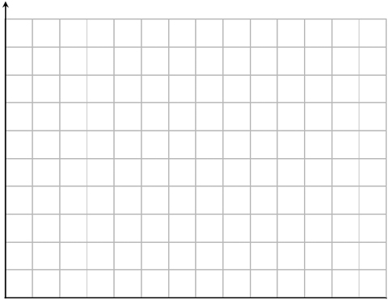
(Total 4 marks)
Q5.
How many minutes is 225 seconds?
Circle your answer.
(Total 1 mark)
Q6.
2 + 0 + 1 + 7 = 10
Make the following calculations correct.
Use only the symbols +, −, ×, ÷ and ( )
2 0 1 7 = −4
2 0 1 7 = 0
2 0 1 7 = 2⁴
(Total 3 marks)
Q7.
Work out (−3) + (−8)
Circle your answer.
–5 5 –11 11
(Total 1 mark)
Q8.
Solve 3x − 8 = 19
_______________________________________________________________________
_______________________________________________________________________
_______________________________________________________________________
_______________________________________________________________________
x = _________________________________________
(Total 2 marks)
Q9.
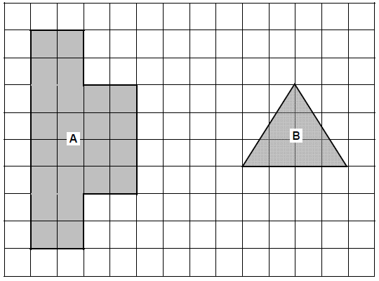
Work out area of shape A : area of shape B
Give your answer in its simplest form.
_______________________________________________________________________
_______________________________________________________________________
_______________________________________________________________________
_______________________________________________________________________
Answer _________________ : _________________
(Total 3 marks)
Q10.
Simplify 16a² ÷ a + 3a × 2
Circle your answer.
22a 8a 38a 2a
(Total 1 mark)
Q11.
(a) Work out 16.4 − 3.92 + 7.8
___________________________________________________________________
___________________________________________________________________
___________________________________________________________________
___________________________________________________________________
___________________________________________________________________
___________________________________________________________________
___________________________________________________________________
___________________________________________________________________
Answer _________________________________________
(2)
(b) Work out 2843.61 ÷ 7
___________________________________________________________________
___________________________________________________________________
___________________________________________________________________
___________________________________________________________________
Answer _________________________________________
(2)
(Total 4 marks)
Q12.
(a) Reflect the shape in the line x = 2
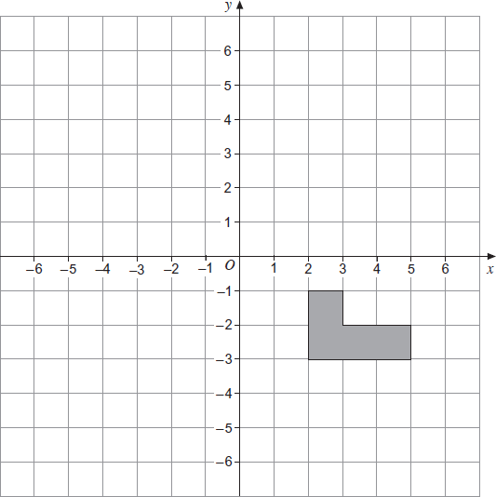
(2)
(b) Translate the shape by the vector 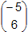.
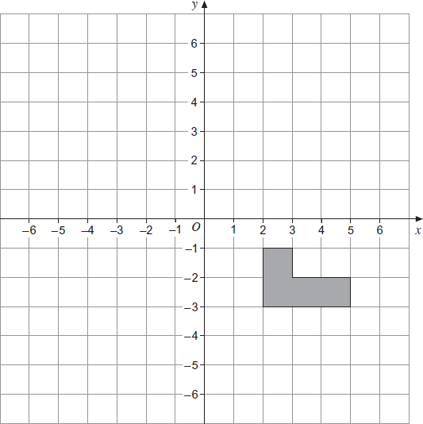
(2)
(Total 4 marks)
Q13.
(a) Write down the value of 10³
___________________________________________________________________
Answer _________________________________________
(1)
(b) Work out the value of 0.4 × 0.2
___________________________________________________________________
Answer _________________________________________
(1)
(Total 2 marks)
Q14.
50 students are asked if they study Geography or History.
The Venn diagram shows some information about their answers.
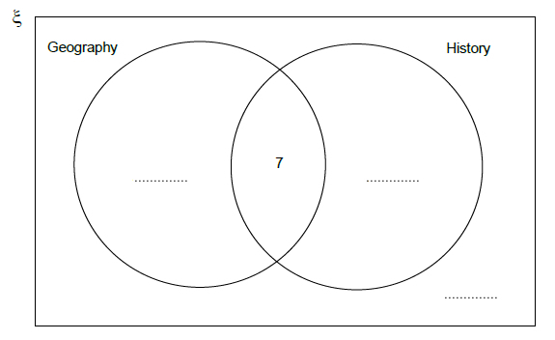
(a) What does the number 7 on the diagram represent?
___________________________________________________________________
___________________________________________________________________
(1)
(b) 20 students study Geography but not History.
19 students study History.
Complete the Venn diagram.
(3)
(Total 4 marks)
Q15.
A triangle has perimeter 32 cm
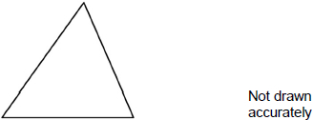
A square has perimeter 40 cm
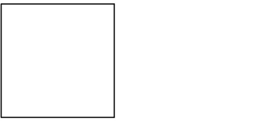
Two sides of the shapes are put together to make a pentagon.
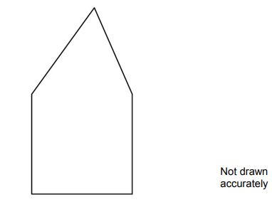
Work out the perimeter of the pentagon.
_______________________________________________________________________
_______________________________________________________________________
_______________________________________________________________________
_______________________________________________________________________
_______________________________________________________________________
_______________________________________________________________________
_______________________________________________________________________
_______________________________________________________________________
Answer _________________________________________ cm
(Total 4 marks)
Q16.
Ryan has an income of £ 52 300 a year.
(a) He does not pay tax on the first £ 9205 of his income.
Work out his taxable income.
___________________________________________________________________
£ _______________________________________
(1)
(b) He pays the following income tax.
• 20% on the first £ 32 245 of his taxable income
• 40% on the rest of his taxable income
Work out his income after income tax has been paid.
___________________________________________________________________
___________________________________________________________________
___________________________________________________________________
___________________________________________________________________
___________________________________________________________________
___________________________________________________________________
___________________________________________________________________
___________________________________________________________________
___________________________________________________________________
___________________________________________________________________
£ _______________________________________
(5)
(Total 6 marks)
Q17.
Eva owns a restaurant.
The table shows the number of customers on four days.

 | Tuesday | Wednesday | Thursday | Friday
Lunch | 25 | 22 | 27 | 31
Dinner | 50 | 48 | 70 | 89
Total | 75 | 70 | 97 | 120
(a) How many more customers in total were there on Friday than on Thursday?
___________________________________________________________________
Answer _________________________________________
(2)
(b) She keeps a tally of the number of customers who order pudding each day.
Complete the table.

Day | Tally | Frequency
Tuesday | IIII IIII IIII II | 17
Wednesday | IIII IIII IIII
Thursday | IIII IIII IIII IIII IIII
Friday | IIII IIII IIII IIII IIII IIII | 30
(2)
(c) What fraction of Friday’s customers ordered a pudding?
Give your answer in its simplest form.
___________________________________________________________________
___________________________________________________________________
Answer _________________________________________
(2)
(d) Here is some information about Saturday.

Number of customers | 150
Number who order pudding | 50
Eva thinks the fraction of customers who ordered puddings on Saturday is greater than on Friday.
Is she correct?
You must show your working.
___________________________________________________________________
___________________________________________________________________
___________________________________________________________________
___________________________________________________________________
(3)
(Total 9 marks)
Q18.
A number is picked at random from the first four prime numbers.
A number is picked at random from the first four square numbers.
The two numbers are added to get a score.
(a) Complete the table.

 |  | Square numbers
 | + | 1 | 4 | 9
Prime numbers | 2
Prime numbers | 3 |  |  | 12
Prime numbers | 7
(4)
(b) What is the probability that the score is a prime number?
Answer _________________________________________
(1)
(Total 5 marks)
Q19.
Circle the number that is 5 less than −2
−10 −7 −3 3
(Total 1 mark)
Q20.
Work out 80% of 300
_______________________________________________________________________
_______________________________________________________________________
_______________________________________________________________________
Answer _________________________________________
(Total 2 marks)
Q21.
A student draws three scatter diagrams.
She draws a line of best fit on each one.
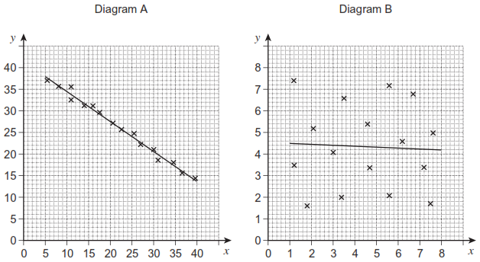
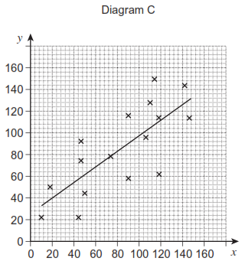
(a) Which diagram shows the strongest correlation?
Circle your answer.
A B C
(1)
(b) Which line of best fit should not have been drawn?
Give a reason for your answer.
___________________________________________________________________
___________________________________________________________________
(1)
(Total 2 marks)
Q22.
Which of these is a geometric progression?
Circle your answer.

1 3 5 7 9 | 1 3 6 10 15
1 4 9 16 25 | 1 3 9 27 81
(Total 1 mark)
Q23.
Match each sequence to its description.
One has been done for you.
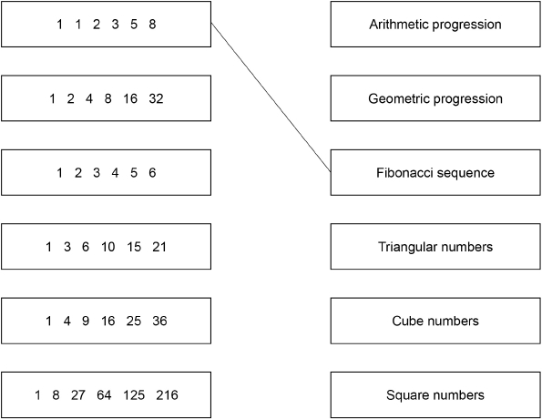
(Total 4 marks)
Q24.
Divide 405 in the ratio 4 : 11
_______________________________________________________________________
_______________________________________________________________________
_______________________________________________________________________
_______________________________________________________________________
_______________________________________________________________________
_______________________________________________________________________
_______________________________________________________________________
_______________________________________________________________________
Answer ___________________ and ___________________
(Total 3 marks)
Q25.
Theo starts with savings of £18
James starts with no savings.
Each week from now,
Theo will save £4.50 and James will save £4
In how many weeks will Theo and James have savings in the ratio 15 : 8?
_______________________________________________________________________
_______________________________________________________________________
_______________________________________________________________________
_______________________________________________________________________
_______________________________________________________________________
_______________________________________________________________________
_______________________________________________________________________
_______________________________________________________________________
_______________________________________________________________________
Answer _________________________________________
(Total 3 marks)
Q26.
What is as a decimal?
Circle your answer.
1.05 1.1 1.5 3.2
(Total 1 mark)
Q27.
This formula works out the tax you pay.
T = 0.2(E − 10 600)
T is the tax you pay in pounds.
E is the amount you earn in pounds.
(a) How much tax do you pay if you earn £20 000?
___________________________________________________________________
___________________________________________________________________
Answer £......................................................
(2)
(b) What is the most you can earn without paying tax?
Answer £......................................................
(1)
(c) Alison pays £5200 tax.
Work out the amount she earns.
___________________________________________________________________
___________________________________________________________________
___________________________________________________________________
___________________________________________________________________
Answer £......................................................
(3)
(Total 6 marks)
Q28.
One of these graphs is a sketch of y = 1 – 2x
Which one?
Circle the correct letter.
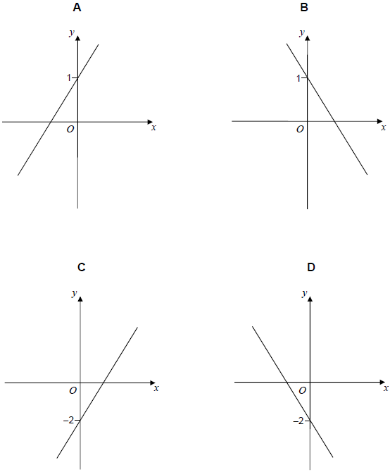
(Total 1 mark)
Q29.
Rearrange p = r + 3 to make r the subject.
Circle your answer.
r = p + 3 r = p − 3 r = 3 − p r =
(Total 1 mark)
Q30.
(a) Write in standard form 12 500
Answer _________________________________________
(1)
(b) Write as an ordinary number 3.4 × 10⁻²
Answer _________________________________________
(1)
(Total 2 marks)
Q31.
(a) The radius of this circle is 2.5 cm
Not drawn accurately
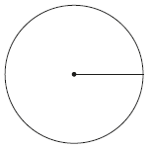
Work out the area.
Give your answer to 1 significant figure.
___________________________________________________________________
___________________________________________________________________
Answer ______________________________________ cm³
(3)
(b) The diameter of this semicircle is 16 cm
Not drawn accurately
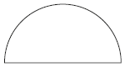
Work out the perimeter of the semicircle.
___________________________________________________________________
___________________________________________________________________
___________________________________________________________________
___________________________________________________________________
___________________________________________________________________
Answer _________________________________________
(3)
(Total 6 marks)
Q32.
Use trigonometry to work out the size of angle x.
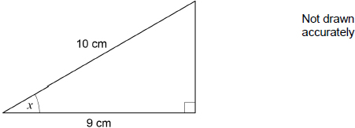
_______________________________________________________________________
_______________________________________________________________________
_______________________________________________________________________
_______________________________________________________________________
_______________________________________________________________________
_______________________________________________________________________
Answer _________________________________________ degrees
(Total 2 marks)
Q33.
Factorise fully 9a² − 6a
_______________________________________________________________________
_______________________________________________________________________
Answer _________________________________________
(Total 2 marks)

Mark schemes
Q1.
(a) Subtracting two amounts with one correct
124 − 79.5
or
124 and 79.5 chosen
79.5 + 44.5 = 124
M1
44.50
Condone 44.5
A1
(b) 124 + 79.5(0) + 122.5(0) + 96 + 85 or 507
Allow one error or omission
M1
their total ÷ 2
Condone bracket error ie
124 + 79.5(0) + 122.5(0) + 96 + 85 ÷ 2 or 464.5(0) for M2
M1
253.50
Strand (i) Correct notation
253.5 is M2Q0
SC2 760.50
SC1 760.5
Q1
Alternative method
At least two of these divisions

124 ÷ 2 | or 62
79.5(0) ÷ 2 | or 39.75
122.5(0) ÷ 2 | or 61.25
96 ÷ 2 | or 48
85 ÷ 2 | or 42.5(0)
M1
their 62 + their 39.75 + their 61.25 + their 48 + their 42.50
Allow one omission
M1
253.50
Strand (i) Correct notation
253.5 is M2Q0
SC2 760.50
SC1 760.5
Q1
Additional Guidance
If they do further division, mark the whole method eg 507 ÷ 2 ÷ 2 M1M0
[5]
Q2.
2.03 2.3 2.303 2.33
B1
[1]
Q3.
B1
[1]
Q4.
Linear scale from zero used for frequency
B1
Bars at correct heights and equal widths with equal gaps
B1
Bars labelled
B1
Vertical axis labelled
eg Number of students, frequency
Vertical axis can be horizontal for a horizontal bar chart
B1
[4]
Q5.
B1
[1]
Q6.
2 + 0 + 1 – 7 = – 4
or 2 – 0 + 1 – 7 = – 4
B1
2 × 0 × 1 × 7 = 0
or 2 × 0 ÷ 1 × 7 = 0
or 2 × 0 × 1 ÷ 7 = 0
or 2 × 0 ÷ 1 ÷ 7 = 0
Allow any brackets in pairs for first four
or 2 × 0 × (1 + 7) = 0
or 2 × 0 ÷ (1 + 7) = 0
Allow – instead of + for last two
B1
(2 + 0) × (1 + 7) = 2⁴
or (2 – 0) × (1 + 7) = 2⁴
or 2 × (0 + 1 + 7)
B1
Additional Guidance
In all cases, allow extra pairs of brackets which do not alter the result of the calculation
e.g. in 3rd calculation ((2 + 0) × (1 + 7)) = 2⁴
B1
Brackets can be used in the place of a multiplication sign
e.g. in 2nd calculation 2 × 0(1 + 7) = 0
B1
Each gap must have a bracket or an operator in
Allow additional + or - signs in any gap, if correct
e.g. in 1st calculation 2 + 0 + 1 + – 7 = – 4
B1
[3]
Q7.
-11
B1
[1]
Q8.
Alternative method 1
3x = 19 + 8 or 3x = 27
or
(19 + 8) ÷ 3 or
accept in ‘flow chart’
eg (x ⟶) × 3 ⟶ -8 ⟶ 8 ⟶ 19
and ⟵ ÷ 3 ⟵ +8 ⟵ 19 enough for M1
M1
9
A1
Alternative method 2
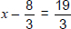
M1
9
A1
Additional Guidance
3 × 9 − 8 (= 19)
M1A0
[2]
Q9.
area A = 24(cm²) or
area B = 6 (cm²)
M1
24 : 6
A1
4 : 1
ft simplifying their ratio
B1ft
[3]
Q10.
22a
B1
[1]
Q11.
(a) (16.4 − 3.92 =) 12.48
or
(16.4 + 7.8 =) 24.2
or
(7.8 − 3.92 =) 3.88
B1
20.28
ft their 12.48 + 7.8
or their 24.2 − 3.92
or their 3.88 + 16.4
SC1 4.68
B1ft
Additional Guidance
Answer of 20.28
B1B1
4.68 comes from 16.4 − (3.92 + 7.8)
SC1
− 4.68
SC0
Follow through must have at least 1 decimal place
eg 16.4 − 3.92 = 12 then 12 + 7.8 = 19.8
eg 16.4 − 3.92 = 12.58 then 12.58 + 7.8 = 20.38
B0B0ft
B0B1ft
(b) 406.23
Ignore further work e.g rounding
B1 400 ≤ answer < 410
B1 digits 40 623 (not 406.23)
B2
Additional Guidance
0406.23
B2
Ignore trailing zeros eg 406.230000
B2
406.23 in division calculation and 406 on answer line
B2
406.23 in division calculation and 46.23 on answer line cannot be considered a transcription error and cannot be ignored as further work
B1
[4]
Q12.
(a)
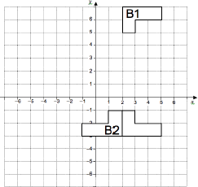
B1 for line x = 2 shown
B1 for reflection in y = 2
B1 for any reflection in a line of form x = a where a is less than 2.
B2
(b)
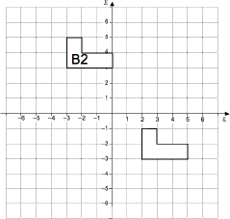
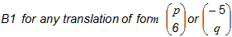
B1 for correct shape with top left corner at (−5, 6)
B2
[4]
Q13.
(a) 1000
B1
(b) 0.08
oe
B1
Additional Guidance
Accept use of comma eg 0,08
Accept or 0.080 or 0.0800
[2]
Q14.
(a) Both Geography and History
oe
eg 7 do both
B1
Additional Guidance
They are in both sets
B1
(b) 20 Geography only
B1
12 History only
B1
11 Neither
Must ft from their Geography and History
B1ft
Additional Guidance
20, 19, 4
B1B0B1
[4]
Q15.
Alternative method 1
40 ÷ 4 or 10 or 30
Accept evidence on diagram
M1
32 – their 10 or 22
Accept evidence on diagram
M1dep
3 × their 10 + their 22
Dep on M2
M1dep
52
A1
Alternative method 2
40 ÷ 4 or 10 or 30
Accept evidence on diagram
M1
2 × their 10 or 20
M1dep
32 + 40 – their 20
Dep on M2
M1dep
52
A1
Additional Guidance
The two top sides on the triangle given values adding to 22 can be accepted as evidence of 22
Beware of appearance of 20 for reasons that are not worth the second mark e.g. 10, 20, 30, 40
M1 earned at that point
Beware - wrong working can lead to the appearance of 52 (after rounding)
[4]
Q16.
(a) 43095
B1
(b) 32245 × 0.2
M1
(their 43095 − 32245) × 0.4
10850 × 0.4
M1
6449 and 4340
ft their (a)
A1ft
52300 – (their 6449 + their 4340)
M1
41511
ft their (a)
SC3 for 32306 with no working.
A1ft
Alternative
32245 × 0.8
M1
(their 43095 – 32245) × 0.6
M1
25796 and 6510
ft their (a)
A1
Their 25796 + their 6510 + 9205
M1
41511
ft their (a)
SC3 for 32306 with no working.
A1
[6]
Q17.
(a) 120 − 97 or 89 − 70 + 31 − 27
oe or 19 or 4 seen
M1
23
SC1 answer 46
A1
(b) 15
for Wednesday
B1
24
for Thursday
B1
(c) seen
oe fraction, decimal, percentage
M1
SC1
SC1 any seen fraction correctly cancelled to simplest form
A1
(d) or attempts to make a comparison
Seen or implied
M1
or 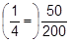 or both values correct in appropriate comparison
Fraction/decimal/percentage
A1
Their yes with fractions with either same numerator (oe)
or same denominator
or with both values as decimals or both values as percentages
or appropriate diagrams
Strand (iii)
Supporting answers with explanations and evidence
ft their from 3c and their
Q1
Alternative method
May be implied by diagram
M1
37.5
A1
Yes (50 > 37.5)
Q1
[9]

Q18.
(a) 16 in top row
B1
5 in left column
B1
All totals correct or all totals correct including for their 16 and their 5
B1ft for seven or more correct totals for the given numbers and their 16 and their 5 (if present)
If their 16 is 0, 1, 4 or 9, do not consider those totals
If their 5 is 0, 2, 3 or 7, do not consider those totals
B2ft
Additional Guidance
Fully correct table
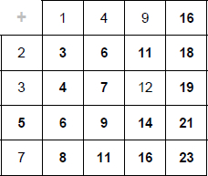
B4
(b) their correct number of primes
their number of completed cells
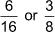 if (a) fully correct
oe
ft their table even if incomplete but must be attempted
B1ft
Additional Guidance
Correct decimal and percentage values are 0.375 and 37.5%
Do not accept truncated or rounded values unless the correct value has been seen
Do not accept ratios or words
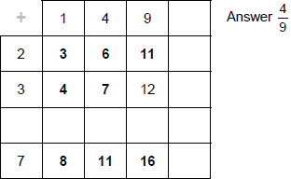
B1ft
[5]
Q19.
-7
B1
[1]
Q20.
0.8 × 300
oe
eg Complete build-up
M1
240
SC1 Answer 60
A1
[2]
Q21.
(a) A
B1
(b) B and says there is no correlation
oe
B1
[2]
Q22.
1 3 9 27 81
B1
[1]
Q23.
All 5 correct
B3 for 4 correct
B2 for 3 correct
B1 for 1 or 2 correct
B4
Additional Guidance
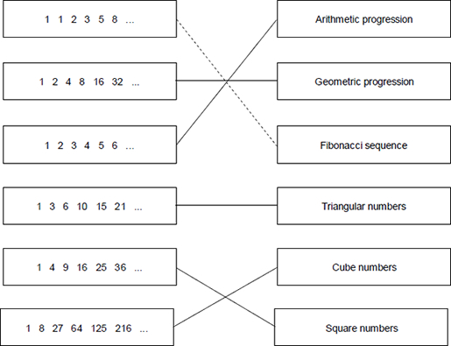
B4
Two connections from a LH box is choice so is incorrect for that box
Connections do not have to be straight lines
[4]
Q24.
405 ÷ (4 + 11) or 405 ÷ 15 or 27
or build up in 15s to 405
Clear intention to divide
Do not accept 15 ÷ 405 unless clearly recovered
M1
their 27 × 4 or 108
or
their 27 × 11 or 297
M1dep
108 and 297
A1
Additional Guidance
297 and 108
M1M1A0
Answer 108 : 297
M1M1A1
Partial build up using ratios from 4 : 11 (eg 104 : 286) is 0 marks unless correct answer achieved
M0M0A0
If 405 is divided by 10 and then divided by 5 this is M0 unless 405 ÷ 15 was clearly seen first, then it is M1M0A0
[3]
Q25.
Alternative method 1
22.5(0) and 4
or
27 and 8
or
31.5(0) and 12
or
36 and 16
or
40.5(0) and 20
or
45 and 24
or
30 : 16
or
45 : 24
M1
45 and 24 chosen
eg 45 : 24 is the final ratio seen
A1
6
A1
Alternative method 2
18 + 4.5x and 4x seen
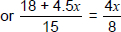
any letter
oe
sets up correct equation
M1
8(18 + 4.5x) = 60x
or 144 + 36x = 60x
or 24x = 144
eliminates denominators
oe
M1dep
6
A1
Additional Guidance
Answer 6 that is not from incorrect method
M1A1A1
45 and 24 followed by eg 49.5(0) and 28 (answer not 6)
M1A0A0
Equivalent ratio to 15 : 8 that is not 30 : 16 or 45 : 24 eg 60 : 32 (answer not 6)
M0A0A0
Final calculation × 24 = 45 (answer not 6)
M1A1A0
[3]
Q26.
1.5
B1
[1]
Q27.
(a) 0.2(20 000 − 10 600)
or 0.2 × 9400
oe
M1
1880
A1
(b) 10 600
B1
Additional Guidance
Accept 10 600.01 or 10 600.02 or 10 600.03 or 10 600.04
(c) Alternative method 1
5200 = 0.2(E − 10 600)
oe
M1
5200 ÷ 0.2
or 26 000
oe 5200 × 5
M1dep
36 600
A1
Alternative method 2
5200 = 0.2(E − 10 600)
oe
M1
5200 + 0.2 × 10600
or 5200 + 2120
or 7320
M1dep
36 600
A1
[6]
Q28.
B
B1
[1]
Q29.
r = p − 3
B1
[1]
Q30.
(a) 1.25 × 10⁴
accept 10⁴ × 1.25
B1
Additional Guidance
1.2 × 10⁴ or 1.3 × 10⁴
B0
(b) 0.034
accept (oe fraction)
B1
Additional Guidance
If fraction given, ignore attempts to cancel
[2]
Q31.
(a) π × 2.5²
oe
M1
19.6(...)
A1
20
ft their 2 sf or more answer
B1ft
Additional Guidance
20.0
B0
(b) π × 16
or 50.(...)
oe
M1
π ×
or π × 8
or 25.(...)
oe
M1dep
41.(...)
Accept 16 + 8π
Accept 40 if working shown
A1
[6]
Q32.
cos x =
oe
eg
sin x = 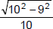
tan x = 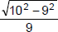
M1
25.8... or 26
A1
Additional Guidance
cos = x = 25.8 (recovered)
M1A1
cos =
M0A0
[2]
Q33.
3a(3a − 2)
B1 a(9a − 6) or 3(3a² − 2 a)
B2
[2]
SECTION 2
Q1.
x : y = 7 : 4
x + y = 88
Work out the value of x − y
_______________________________________________________________________
_______________________________________________________________________
_______________________________________________________________________
_______________________________________________________________________
_______________________________________________________________________
_______________________________________________________________________
Answer _________________________________________
(Total 3 marks)
Q2.
120 adults complete a survey.
45 are men.
Write the ratio men : women in its simplest form.
_______________________________________________________________________
_______________________________________________________________________
Answer _________________________________________
(Total 2 marks)
Q3.
(a) Work out the size of angle x.
Not drawn accurately
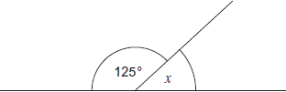
___________________________________________________________________
___________________________________________________________________
Answer ___________________________________ degrees
(1)
(b) Work out the size of angle y.
Not drawn accurately
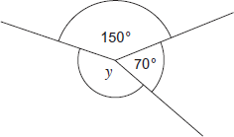
___________________________________________________________________
___________________________________________________________________
___________________________________________________________________
Answer ___________________________________ degrees
(2)
(Total 3 marks)
Q4.
Circle the equation which has the solution x = 6
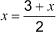 3x = 36
(Total 1 mark)
Q5.
(a) Here is a linear sequence.
21 23 25 27 ....
Circle the expression for the nth term of the sequence.
23 − 2n 19n + 2 21 − 2n 2n + 19
(1)
(b) A different sequence starts
a 2a − 3 ....
The term-to-term rule for this sequence is

multiply by 2 and subtract 3
The fourth term of this sequence is 35
Work out the value of a.
___________________________________________________________________
___________________________________________________________________
___________________________________________________________________
___________________________________________________________________
___________________________________________________________________
___________________________________________________________________
___________________________________________________________________
___________________________________________________________________
Answer _________________________________________
(3)
(Total 4 marks)
Q6.
(a) Solve n + 7 = 103
___________________________________________________________________
___________________________________________________________________
n = _________________________________________
(1)
(b) Solve = 12
___________________________________________________________________
___________________________________________________________________
m = _________________________________________
(1)
(Total 2 marks)
Q7.

What is the mode of these numbers?
3 4 6 6 7 8 9 13
Circle your answer.
6 6.5 7 10
(Total 1 mark)
Q8.
Line AB is shown on the grid.
A is the point (0, 2)
B is the point (6, 5)
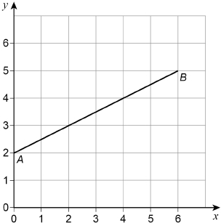
(a) Work out the coordinates of the midpoint of the line AB.
Answer ( ________ , ________ )
(1)
(b) C is another point on AB.
C is closer to B than to A.
The coordinates of C are whole numbers.
Work out the coordinates of C.
Answer ( ________ , ________ )
(1)
(c) On the grid, draw a line from point (0, 0) that is
parallel to AB
and
two thirds as long as AB.
(2)
(Total 4 marks)
Q9.
(a) Circle the value of 2⁴
6 8 16 24
(b) Circle the value of 5³
(1)
15 25 53 125
(c) Circle the value of
(1)
13 14 16 98
(1)
(Total 3 marks)
Q10.
Circle the number that is not a multiple of 6
24 76 108 144
(Total 1 mark)
Q11.
(a) Work out 11% of 1400
___________________________________________________________________
___________________________________________________________________
___________________________________________________________________
___________________________________________________________________
Answer _________________________________________
(2)
(b) Work out of 295
___________________________________________________________________
___________________________________________________________________
___________________________________________________________________
___________________________________________________________________
Answer _________________________________________
(2)
(Total 4 marks)
Q12.
Circle the cube number.
9 10 000 333 729
(Total 1 mark)
Q13.
Here is a list of numbers.
21 17 23 21 29 32 21 25 36
Work out the median.
_______________________________________________________________________
_______________________________________________________________________
Answer _________________________________________
(Total 2 marks)
Q14.
Simplify 3 × a × 3 × a
Circle your answer.
9a 6a² 9a² 6a
(Total 1 mark)
Q15.
Circle the expression which does not simplify to y³
y × y × y y⁴ ÷ y y² × y y⁶ ÷ y²
(Total 1 mark)
Q16.
Draw the following on the circles below.
(a) Radius.
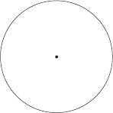
(1)
(b) Chord.
(1)
(c) Tangent.
(1)
(Total 3 marks)
Q17.
Here are six words that are used with circles.

arc | chord | diameter | sector | segment | tangent
Put the correct word from the list in each box.
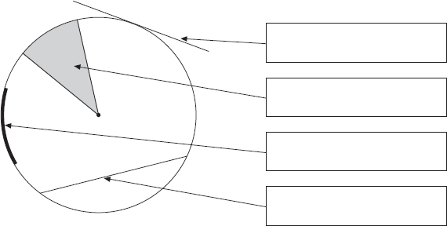
(Total 4 marks)
Q18.
Circle the expression that can be written as 2y
y + y y² 2 + y y × y
(Total 1 mark)
Q19.
Simplify 8x − 3 + 6x
Circle your answer.
2x − 3 11x 5 + 6x 14x − 3
(Total 1 mark)
Q20.
Which of these is used to work out density?
Tick a box.

mass × volume | 
mass² × volume
mass ÷ volume
volume ÷ mass
(Total 1 mark)
Q21.
Work out
_______________________________________________________________________
_______________________________________________________________________
_______________________________________________________________________
_______________________________________________________________________
_______________________________________________________________________
_______________________________________________________________________
_______________________________________________________________________
Answer _________________________________________
(Total 3 marks)
Q22.
Reflect shape A in the x-axis.
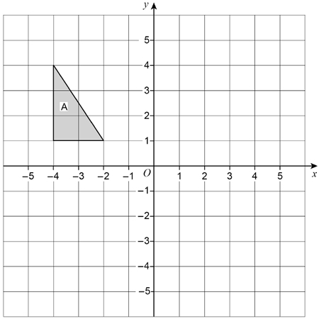
(Total 2 marks)
Q23.
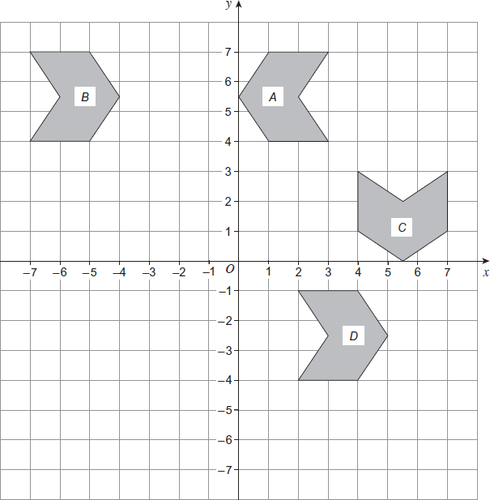
(a) On the grid draw the mirror line that reflects shape A to shape B.
(1)
(b) On the grid draw the mirror line that reflects shape A to shape C.
(1)
(c) Describe fully the single transformation that takes shape B to shape D.
___________________________________________________________________
___________________________________________________________________
___________________________________________________________________
(2)
(Total 4 marks)
Q24.
Describe fully the single transformation that maps shape A to shape B.
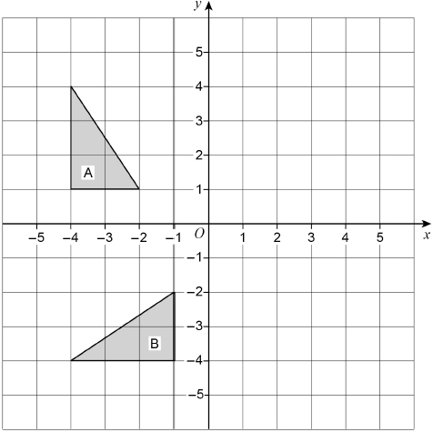
_______________________________________________________________________
_______________________________________________________________________
_______________________________________________________________________
(Total 3 marks)
Q25.
A dry cleaning shop has the following offers.

Suit  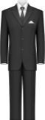  Normal price £12.50  1st suit normal price  2nd suit half price |  | Dress  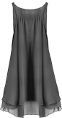  Normal price £9.75  Three for the price of two
Work out the total price for 2 suits and 6 dresses.
_______________________________________________________________________
_______________________________________________________________________
_______________________________________________________________________
_______________________________________________________________________
_______________________________________________________________________
_______________________________________________________________________
_______________________________________________________________________
_______________________________________________________________________
Answer £ _________________________________________
(Total 4 marks)
Q26.
2.5 kg of carrots cost £1.70
Work out the cost of 3.25 kg of carrots.
_______________________________________________________________________
_______________________________________________________________________
_______________________________________________________________________
_______________________________________________________________________
_______________________________________________________________________
Answer £ _________________________________________
(Total 3 marks)
Q27.
Here is a map showing two towns, P and Q.
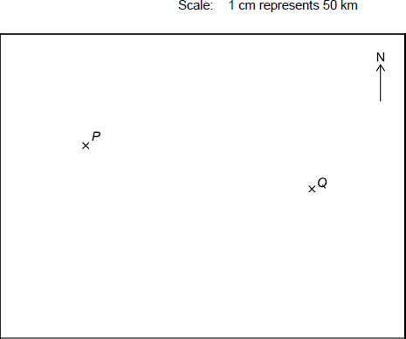
(a) Work out the actual distance between towns P and Q.
___________________________________________________________________
___________________________________________________________________
___________________________________________________________________
Answer _________________________________________ km
(2)
(b) Town R is 200 km due South of town P.
Mark R on the map.
___________________________________________________________________
___________________________________________________________________
(2)
(Total 4 marks)
Q28.
Three people share £180.
Billy gets twice as much as Amy.
Chloe gets three times as much as Billy.
Is Chloe’s share enough to buy a bike costing £115?
You must show your working.
_______________________________________________________________________
_______________________________________________________________________
_______________________________________________________________________
_______________________________________________________________________
_______________________________________________________________________
_______________________________________________________________________
(Total 5 marks)
Q29.
(a) w and x are whole numbers.
w > 40
x < 30
Work out the smallest possible value of w − x
___________________________________________________________________
___________________________________________________________________
___________________________________________________________________
Answer _________________________________________
(2)
(b) y and z are whole numbers.
y < 60
z ≤ 50
Work out the largest possible value of y + z
___________________________________________________________________
___________________________________________________________________
___________________________________________________________________
Answer _________________________________________
(2)
(Total 4 marks)
Q30.
Each shape below has an area of 24 cm²
Complete the missing lengths.
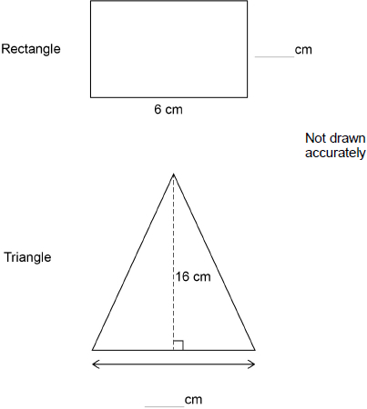
(Total 3 marks)
Q31.
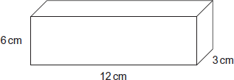
(a) Calculate the volume of the cuboid.
State the units of your answer.
___________________________________________________________________
___________________________________________________________________
Answer _________________________________________
(3)
(b) A cube has a surface area of 54 cm².
How many of these cubes will fit inside the cuboid?
___________________________________________________________________
___________________________________________________________________
___________________________________________________________________
___________________________________________________________________
___________________________________________________________________
Answer _________________________________________
(4)
(Total 7 marks)
Q32.
The graph shows the temperature in a garden over 24 hours.
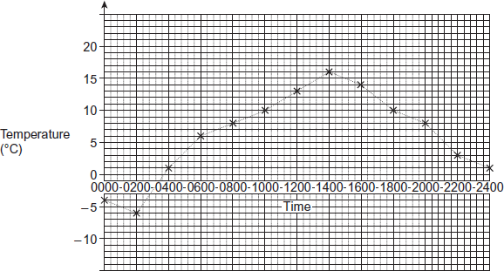
(a) Write down the temperature at 0200.
Answer ________________________________ °C
(1)
(b) A heater in the greenhouse switches on when the temperature in the garden is
below 10 °C.
For how many hours was the heater switched on?
___________________________________________________________________
___________________________________________________________________
Answer ______________________________ hours
(2)
(c) Work out the temperature range in the garden.
___________________________________________________________________
Answer ________________________________ °C
(2)
(Total 5 marks)
Q33.

The table shows the savings for 30 students in one week.

 | Savings, £s | Number of students
 | 0 < s ≤ 5 | 2
 | 5 < s ≤ 10 | 14
 | 10 < s ≤ 15 | 9
 | More than 15 | 5
(a) How many students saved more than £5?
___________________________________________________________________
___________________________________________________________________
Answer _________________________________________
(1)
(b) How many students did not save anything?
Circle your answer.
0 1 2 cannot tell
(1)
(Total 2 marks)
Q34.
There are some boys and girls at a bus stop.
11 girls get on the first bus to arrive.
The number of boys and girls at the bus stop is now the same.
16 boys get on the second bus to arrive.
The ratio of the number of boys to the number of girls at the bus stop is now 1 : 3
How many girls were at the bus stop to start with?
_______________________________________________________________________
_______________________________________________________________________
_______________________________________________________________________
_______________________________________________________________________
_______________________________________________________________________
_______________________________________________________________________
_______________________________________________________________________
Answer _________________________________________
(Total 4 marks)
Q35.
Here is a number machine.
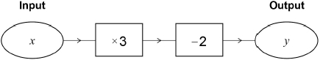
(a) Work out the output when the input is 4
___________________________________________________________________
___________________________________________________________________
___________________________________________________________________
Answer _________________________________________
(1)
(b) Work out the output when the input is −4
___________________________________________________________________
___________________________________________________________________
___________________________________________________________________
Answer _________________________________________
(1)
(Total 2 marks)

Mark schemes
Q1.
Alternative method 1
88 ÷ (7 + 4) or 88 ÷ 11 or 8
oe 11 × 8 = 88
M1
their 8 × 7 and their 8 × 4
or their 8 × 7 and 88 − their value
or their 8 × 4 and 88 − their value
or 56 and 32
or their 8 × (7 − 4)
or their 8 × 3
oe
eg 8 × 7 = 63 and 88 − 63
eg 8 × 4 = 30 and 88 − 30
M1dep
24
A1
Alternative method 2
One correctly evaluated trial for two numbers, other than 7 and 4, in the ratio 7 : 4
eg 70 + 40 = 110
M1
56 and 32
eg 56 + 32 = 88
M1dep
24
A1
Alternative method 3 using x : y = 7 : 4 (correct)
4x = 7y and 4x + 4y = 352
4x = 7y and 7x + 7y = 616
oe
forming equation from ratio and equating coefficients
M1
11y = 352 or y = 32
11x = 616 or x = 56
oe
equation in one variable
M1dep
24
A1
Alternative method 4 using x : y = 4 : 7 (incorrect)
7x = 4y and 4x + 4y = 352
7x = 4y and 7x + 7y = 616
oe
forming equation from ratio and equating coefficients
M1
11x = 352 or x = 32
11y = 616 or y = 56
oe
equation in one variable
M1dep
their answer
A0
Alternative method 5 using x : y = 7 : 4 (correct)
or x = 88 − y or y = 88 − x
oe
making one variable the subject
M1
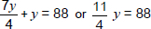
oe
equation in one variable
M1dep
24
A1
Alternative method 6 using x : y = 4 : 7 (incorrect)
or x = 88 − y or y = 88 − x
oe
making one variable the subject
M1
oe
equation in one variable
M1dep
their answer
A0
Additional Guidance
−24, with no incorrect working, implies 56 and 32
M1M1A0
x = 32 and y = 56
M1M1A0
[3]
Q2.
3 : 5
B1 equivalent of 3 : 5 eg 45 : 75
B1 5 : 3
B1 3 : 8
B2
[2]
Q3.
(a) 55°
B1
(b) 360 − (150 + 70)
Allow invisible brackets
M1
140
A1
[3]
Q4.
B1
[1]
Q5.
(a) 2n + 19
B1
(b) Alternative method 1
4a − 9
B1
8a − 21
ft 2 × their (4a − 9) − 3 correctly simplified
B1ft
7
7 scores B1B1B1
ft correct solution of their (8a − 21) = 35
B1ft
Alternative method 2
19
B1
11
ft (their 19 + 3) ÷ 2 correctly evaluated
B1ft
7
7 scores B1B1B1
ft (their 11 + 3) ÷ 2 correctly evaluated
B1ft
Additional Guidance
7 in working with a different final answer
e.g. 19, 11, 7, 5 with answer 5
B1B1B0
Accept embedded answers
[4]
Q6.
(a) 96
B1
(b) 72
B1
[2]
Q7.
6
B1
[1]
Q8.

(a) | (3, 3.5) or (3,3 |  | )
B1
Additional Guidance
A comma used as a decimal point ie (3, 3,5)
B1
(03, 03.5)
B1
(0,3, 0,3.5)
B0
(b) (4, 4)
B1
Additional Guidance
(04, 04)
B1
(0,4, 0,4)
B0
(c) Line from (0, 0) to (4, 2)
B1 line from (0, 0) to (4, 2) with slight inaccuracy
or
line parallel to AB from any point which extends across at least two horizontal squares
B2
Additional Guidance
Parallel line that extends beyond the grid
B1
Line drawn that is completely off the grid
B0
Use the full length of the line to judge accuracy – there should be no gap between their line and the relevant integer points
Mark intention for straightness
Ignore other lines that could be working for parts (a) and (b)
[4]
Q9.
(a) 16
B1
(b) 125
B1
(c) 14
B1
[3]
Q10.
76
B1
[1]
Q11.
(a) 1400 × 0.11
oe
M1
154
A1
(b) × 295
or 295 ÷ 5 or 59
oe
M1
236
A1
[4]
Q12.
729
B1
[1]
Q13.
17 21 21 21 23 25 29 32 36
or 36 32 29 25 23 21 21 21 17
or 17 21 21 21 23
or 36 32 29 25 23
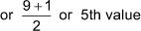
Puts list into order
Allow one omission, extra or transcription error in a full list
Allow one transcription error in a list of only the first or last five
or Works out the position of the median in the list
M1
23
A1
Additional Guidance
Answer 23 (from any or no list)
M1A1
Puts list into order then finds the mean
M1A0
Just circles or identifies 29 or gives answer 29
M0
States 5th and circles 29
M1A0
[2]
Q14.
9a²
B1
[1]
Q15.
y⁶ ÷ y²
B1
[1]
Q16.
(a)
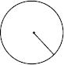
B1
(b)
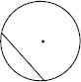
Allow diameter as special case of chord
B1
(c)
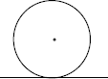
Allow radius to be drawn in too as long as it touches the tangent
B1
[3]
Q17.
tangent
B1
sector
B1
arc
B1
chord
B1
[4]
Q18.
y + y
B1
[1]
Q19.
14x − 3
B1
[1]
Q20.
mass ÷ volume
B1
[1]
Q21.
=) 11 or − 11
or 121 = 11² or 121 = 11 × 11 seen
oe
B1
13 − 10 or 3
or (13 − 10)² or 3² or 3 × 3 or 9
M1
2 or – 20
ft their 11
A1ft
Additional Guidance
Accept 2 and –20
B1M1A1ft
11 − 16² or 11 − 256 or –245
B1M0A0
11 × 9 = 99
B1M1A0
= 60.5, 60.5 − 3² = 51.5
B0M1A1ft
60.5 − 3² = 51.5
B0M1A0ft
[3]
Q22.
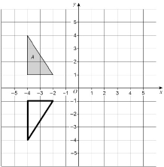
B1 reflection in any horizontal line eg
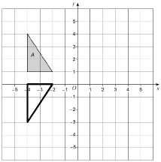
or reflection in y-axis ie
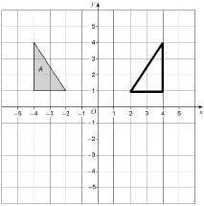
or (–4, –1), (–4, –4) and (–2, –1) plotted with no incorrect points
B2
Additional Guidance
Mark intention
[2]
Q23.
(a) Line x = −2 drawn
B1
Additional Guidance
Line does not need to be full length of grid.
Line can be solid or dashed.
(b) Line y = x drawn
B1
Additional Guidance
Line does not need to be full length of grid.
Line can be solid or dashed.
(c) Translation
Accept Translate
B1
9 right and 8 down
or 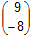
Accept (9, −8)
B1
Additional Guidance
(y = −8, x = 9) is B0 B0
[4]
Q24.
Rotation
B1
90° anticlockwise
or 270° clockwise
or turn anticlockwise
or turn clockwise
B1
Origin or (0, 0) or O
B1
Additional Guidance
Accept rotate etc for rotation
Do not accept turn for first B1
Combined transformations
B0B0B0
[3]
Q25.
12.5(0) + 12.5(0) ÷ 2
or
12.5(0) + 6.25
or
12.5(0) × 1.5 or 18.75
oe
Cost of 2 suits
M1
9.75 × 4
or
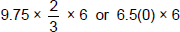
or 39(.00)
oe
eg 9.75 × 6 – 9.75 × 2 or 58.5(0) – 19.5
Cost of 6 dresses
M1
their 18.75 + their 39(.00)
dep on at least M1 awarded
Must be adding their suit(s) and their dress(es)
May be implied by final answer
M1dep
57.75
Accept £57.75p
A1
Additional Guidance
6.25 + 9.75 × 6
M0M0M0dep
6.25 + 39
M0M1M1dep
12.50 × 2 + 39
M0M1M1dep
18.75 + 9.75 × 2
M1M0M1dep
[4]
Q26.
Alternative method 1 of 5
1.7(0) ÷ 2.5 or 0.68
or
170 ÷ 2.5 or 68
oe
0.51 or 51 implies M1
M1
their 0.68 × 3.25
or
their 68 × 3.25 or 221
oe
M1dep
2.21
A1
Alternative method 2 of 5
2.5 ÷ 1.7(0) or 1.47…
or
2.5 ÷ 170 or 0.0147…
oe
M1
3.25 ÷ their 1.47…
or
3.25 ÷ their 0.0147… or 221
oe
M1dep
2.21
A1
Alternative method 3 of 5
3.25 ÷ 2.5 or 1.3
oe
M1
their 1.3 × 1.7(0)
or
3.25 × 1.7(0) ÷ 2.5
oe
M1dep
2.21
A1
Alternative method 4 of 5
2.5 ÷ 3.25 or 0.769… or 0.77
oe
M1
1.7(0) ÷ their 0.769…
or
1.7(0) ÷ their 0.77
oe
M1dep
2.21
A1
Alternative method 5 of 5
1.7(0) ÷ 10 or 0.17
and
3.25 ÷ 0.25 or 13
oe
M1
their 0.17 × their 13
or
1.7(0) ÷ 10 × their 13
oe
M1dep
2.21
A1
Additional Guidance
Condone 2.21p unless the £ sign has been crossed out
M1M1A1
(£)0.51 or 51(p) is the cost of the extra 0.75 kg of carrots
This implies the first M1 on Alt 1 and achieves the second M1 if added to 1.7(0) or 170
Accept work in grams rather than kilograms
Do not allow a misread of 3.25 kg
[3]
Q27.
(a) [6.9, 7.1] (cm)
B1
[345, 355]
ft their [6.9, 7.1] × 50
B1ft
Additional Guidance
[345, 355] without sight of [6.9, 7.1]
B1B1
(b) R marked [3.9, 4.1] cm
due South of P
B1 for
R marked [3.9, 4.1] cm from P
or
R marked due South of P
or
4 (cm) seen
B2
[4]
Q28.
1 (+) 2 (+) 6 (= 9)
oe eg a (+) 2a (+) 6a (= 9a)
M1
180 ÷ their 9 (= 20)
oe a = 180 ÷ 9 (= 20)
M1
6 × their 20
M1
120
A1
120 and Yes
Strand (iii)
M3 awarded and a correct decision based on their 120
SC3 30, 60 and 90 with 90 and No
SC2 30, 60 and 90
Q1
Alternative method using T & I
ratio 1:2:6 seen or implied in any order
M1
Correctly evaluated trial
eg 10 + 20 + 60 = 90
M1
2nd trial in ratio 1:2:6 correctly evaluated
eg 15 + 30 + 90 = 135
M1
120
A1
120 and Yes
Strand (iii)
M3 awarded and a correct decision based on their 120
SC3 30, 60 and 90 with 90 and No
SC2 30, 60 and 90
Q1
[5]
Q29.
(a) 41 or 29 used
M1
12
A1
(b) 59 or 50 used
M1
109
A1
[4]
Q30.
Rectangle: 4
B1
Triangle: 0.5 × ? × 16 = 24
or (2 ×) 24 ÷ 16
or (2 ×) 1.5
or 2 × 24 or 48
oe
M1
3
A1
Additional Guidance
Ignore any units given
[3]
Q31.
(a) 6 × 3 × 12
M1
216
A1
cm³ or ml
SC2 2.16 m³ with no working
B1
(b) 54 ÷ 6 (= 9)
M1
3 × 3 = 9
M1
Allow (their 216)/27
M1
8
A1
[7]
Q32.
(a) −6
B1
(b) 8 seen or marks on the diagram
or 10 + 6 or 24 − 8
M1
16
A1
(c) 16 – –6
or 16 + 6
M1
22
SC1 for 10 if –6 and 16 seen
A1
[5]
Q33.
(a) 28
B1
(b) 0
B1
[2]
Q34.
3(x − 16) = x
oe
M1
3x − x = 48 or 2x = 48
M1 dep
x = 24
A1
Girls original number = 35
A1
Alternative method 1
1st trial with B + 11 = G
B − 16 checked against G − 11 for 1 : 3
Must be clearly shown eg B = 20, G = 31
M1
2nd trial with B + 11 = G, fully checked
M1 dep
B = 8 or G = 24
A1
Girls original number = 35
A1
Alternative method 2
16 boys = 2 parts of ratio 1 : 3
M1
1 part =
M1 dep
24 (+11)
A1
35
A1
Alternative method 3
x + 16 = 3x
x = Final number of boys at bus stop
M1
16 = 3x − x
M1 dep
(x =) 8
A1
Girls original number = 35
A1
Alternative method 4
G = B + 11
oe eg G − 11 = B
M1
3(B − 16) = G − 11
M1
B = 24
A1
G = 35
G = 35 scores both A marks
A1
Alternative method 5
1st trial using ratio 1 : 3, fully checked
eg B : G = 10 : 30
B + 16 = 26
26 ≠ 30
M1
2nd trial using ratio 1 : 3, fully checked
eg B : G = 7 : 21
B + 16 = 23
23 ≠ 21
M1
8 : 24
A1
35
A1
[4]
Q35.
(a) 10
B1
(b) −14
B1

