YR11 MOCK REVISION
SECTION 1
Q1.
Adam saved these amounts.
£124 £79.50 £122.50 £96 £85
(a) Work out the range.
___________________________________________________________________
___________________________________________________________________
Answer £ ___________________________________
(2)
(b) Matthew saved half as much as Adam.
Work out the total amount that Matthew saved.
___________________________________________________________________
___________________________________________________________________
___________________________________________________________________
___________________________________________________________________
___________________________________________________________________
___________________________________________________________________
___________________________________________________________________
Answer £ ___________________________________
(3)
(Total 5 marks)
Q2.
Write these numbers in order starting with the smallest.
2.303 2.3 2.33 2.03
_______________________________________________________________________
_______________________________________________________________________
Answer _____________ _____________ _____________ _____________
(Total 1 mark)
Q3.
Circle the value of the digit 7 in 9.17
(Total 1 mark)
Q4.
The table shows how 25 students travel to school.

 | Walk | Bus | Car | Taxi
 | 9 | 8 | 7 | 1
Draw a bar chart to show this information.
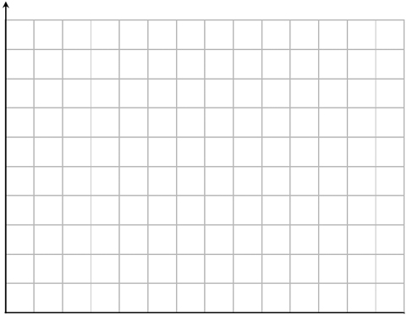
(Total 4 marks)
Q5.
How many minutes is 225 seconds?
Circle your answer.
(Total 1 mark)
Q6.
2 + 0 + 1 + 7 = 10
Make the following calculations correct.
Use only the symbols +, −, ×, ÷ and ( )
2 0 1 7 = −4
2 0 1 7 = 0
2 0 1 7 = 2⁴
(Total 3 marks)
Q7.
Work out (−3) + (−8)
Circle your answer.
–5 5 –11 11
(Total 1 mark)
Q8.
Solve 3x − 8 = 19
_______________________________________________________________________
_______________________________________________________________________
_______________________________________________________________________
_______________________________________________________________________
x = _________________________________________
(Total 2 marks)
Q9.
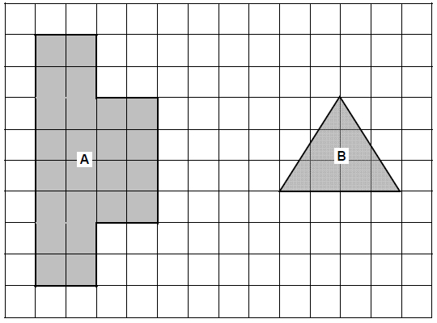
Work out area of shape A : area of shape B
Give your answer in its simplest form.
_______________________________________________________________________
_______________________________________________________________________
_______________________________________________________________________
_______________________________________________________________________
Answer _________________ : _________________
(Total 3 marks)
Q10.
Simplify 16a² ÷ a + 3a × 2
Circle your answer.
22a 8a 38a 2a
(Total 1 mark)
Q11.
(a) Work out 16.4 − 3.92 + 7.8
___________________________________________________________________
___________________________________________________________________
___________________________________________________________________
___________________________________________________________________
___________________________________________________________________
___________________________________________________________________
___________________________________________________________________
___________________________________________________________________
Answer _________________________________________
(2)
(b) Work out 2843.61 ÷ 7
___________________________________________________________________
___________________________________________________________________
___________________________________________________________________
___________________________________________________________________
Answer _________________________________________
(2)
(Total 4 marks)
Q12.
(a) Reflect the shape in the line x = 2
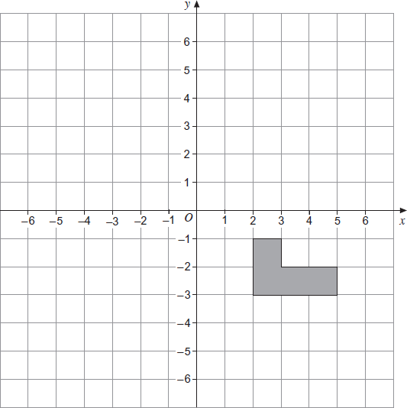
(2)
(b) Translate the shape by the vector 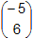.
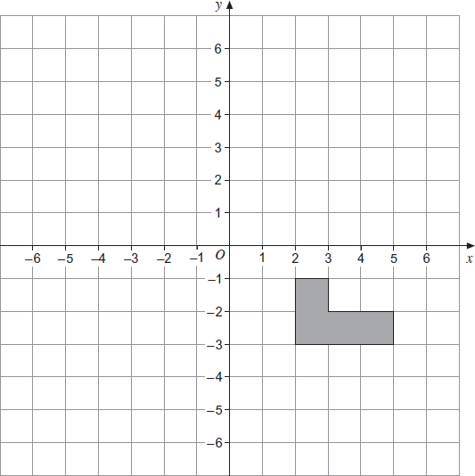
(2)
(Total 4 marks)
Q13.
(a) Write down the value of 10³
___________________________________________________________________
Answer _________________________________________
(1)
(b) Work out the value of 0.4 × 0.2
___________________________________________________________________
Answer _________________________________________
(1)
(Total 2 marks)
Q14.
50 students are asked if they study Geography or History.
The Venn diagram shows some information about their answers.
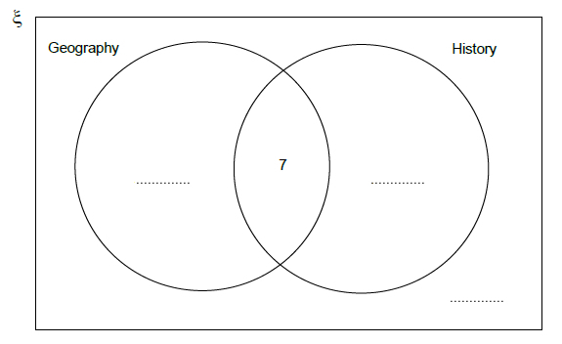
(a) What does the number 7 on the diagram represent?
___________________________________________________________________
___________________________________________________________________
(1)
(b) 20 students study Geography but not History.
19 students study History.
Complete the Venn diagram.
(3)
(Total 4 marks)
Q15.
A triangle has perimeter 32 cm
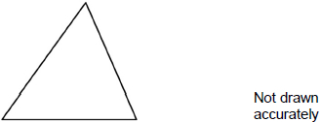
A square has perimeter 40 cm
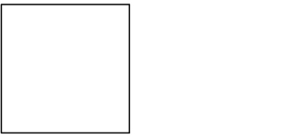
Two sides of the shapes are put together to make a pentagon.
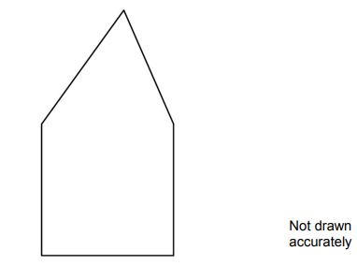
Work out the perimeter of the pentagon.
_______________________________________________________________________
_______________________________________________________________________
_______________________________________________________________________
_______________________________________________________________________
_______________________________________________________________________
_______________________________________________________________________
_______________________________________________________________________
_______________________________________________________________________
Answer _________________________________________ cm
(Total 4 marks)
Q16.
Ryan has an income of £ 52 300 a year.
(a) He does not pay tax on the first £ 9205 of his income.
Work out his taxable income.
___________________________________________________________________
£ _______________________________________
(1)
(b) He pays the following income tax.
• 20% on the first £ 32 245 of his taxable income
• 40% on the rest of his taxable income
Work out his income after income tax has been paid.
___________________________________________________________________
___________________________________________________________________
___________________________________________________________________
___________________________________________________________________
___________________________________________________________________
___________________________________________________________________
___________________________________________________________________
___________________________________________________________________
___________________________________________________________________
___________________________________________________________________
£ _______________________________________
(5)
(Total 6 marks)
Q17.
Eva owns a restaurant.
The table shows the number of customers on four days.

 | Tuesday | Wednesday | Thursday | Friday
Lunch | 25 | 22 | 27 | 31
Dinner | 50 | 48 | 70 | 89
Total | 75 | 70 | 97 | 120
(a) How many more customers in total were there on Friday than on Thursday?
___________________________________________________________________
Answer _________________________________________
(2)
(b) She keeps a tally of the number of customers who order pudding each day.
Complete the table.

Day | Tally | Frequency
Tuesday | IIII IIII IIII II | 17
Wednesday | IIII IIII IIII
Thursday | IIII IIII IIII IIII IIII
Friday | IIII IIII IIII IIII IIII IIII | 30
(2)
(c) What fraction of Friday’s customers ordered a pudding?
Give your answer in its simplest form.
___________________________________________________________________
___________________________________________________________________
Answer _________________________________________
(2)
(d) Here is some information about Saturday.

Number of customers | 150
Number who order pudding | 50
Eva thinks the fraction of customers who ordered puddings on Saturday is greater than on Friday.
Is she correct?
You must show your working.
___________________________________________________________________
___________________________________________________________________
___________________________________________________________________
___________________________________________________________________
(3)
(Total 9 marks)
Q18.
A number is picked at random from the first four prime numbers.
A number is picked at random from the first four square numbers.
The two numbers are added to get a score.
(a) Complete the table.

 |  | Square numbers
 | + | 1 | 4 | 9
Prime numbers | 2
Prime numbers | 3 |  |  | 12
Prime numbers | 7
(4)
(b) What is the probability that the score is a prime number?
Answer _________________________________________
(1)
(Total 5 marks)
Q19.
Circle the number that is 5 less than −2
−10 −7 −3 3
(Total 1 mark)
Q20.
Work out 80% of 300
_______________________________________________________________________
_______________________________________________________________________
_______________________________________________________________________
Answer _________________________________________
(Total 2 marks)
Q21.
A student draws three scatter diagrams.
She draws a line of best fit on each one.
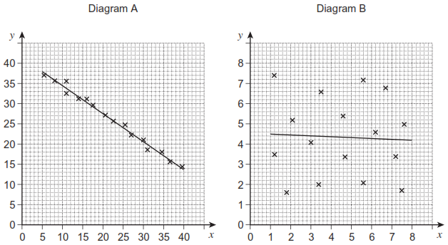
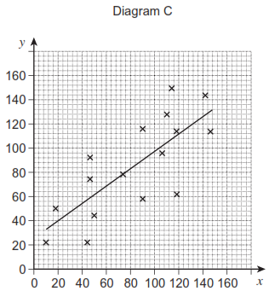
(a) Which diagram shows the strongest correlation?
Circle your answer.
A B C
(1)
(b) Which line of best fit should not have been drawn?
Give a reason for your answer.
___________________________________________________________________
___________________________________________________________________
(1)
(Total 2 marks)
Q22.
Which of these is a geometric progression?
Circle your answer.

1 3 5 7 9 | 1 3 6 10 15
1 4 9 16 25 | 1 3 9 27 81
(Total 1 mark)
Q23.
Match each sequence to its description.
One has been done for you.
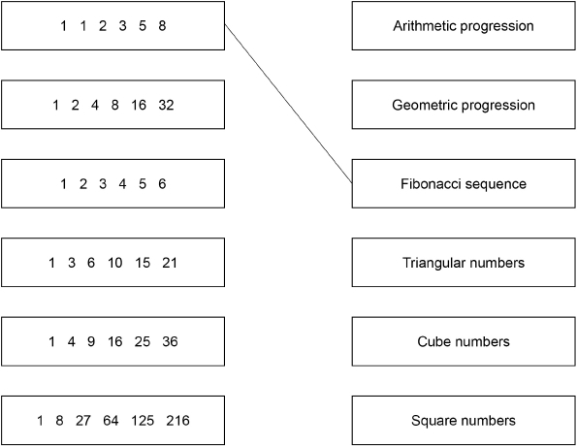
(Total 4 marks)
Q24.
Divide 405 in the ratio 4 : 11
_______________________________________________________________________
_______________________________________________________________________
_______________________________________________________________________
_______________________________________________________________________
_______________________________________________________________________
_______________________________________________________________________
_______________________________________________________________________
_______________________________________________________________________
Answer ___________________ and ___________________
(Total 3 marks)
Q25.
Theo starts with savings of £18
James starts with no savings.
Each week from now,
Theo will save £4.50 and James will save £4
In how many weeks will Theo and James have savings in the ratio 15 : 8?
_______________________________________________________________________
_______________________________________________________________________
_______________________________________________________________________
_______________________________________________________________________
_______________________________________________________________________
_______________________________________________________________________
_______________________________________________________________________
_______________________________________________________________________
_______________________________________________________________________
Answer _________________________________________
(Total 3 marks)
Q26.
What is as a decimal?
Circle your answer.
1.05 1.1 1.5 3.2
(Total 1 mark)
Q27.
This formula works out the tax you pay.
T = 0.2(E − 10 600)
T is the tax you pay in pounds.
E is the amount you earn in pounds.
(a) How much tax do you pay if you earn £20 000?
___________________________________________________________________
___________________________________________________________________
Answer £......................................................
(2)
(b) What is the most you can earn without paying tax?
Answer £......................................................
(1)
(c) Alison pays £5200 tax.
Work out the amount she earns.
___________________________________________________________________
___________________________________________________________________
___________________________________________________________________
___________________________________________________________________
Answer £......................................................
(3)
(Total 6 marks)
Q28.
One of these graphs is a sketch of y = 1 – 2x
Which one?
Circle the correct letter.
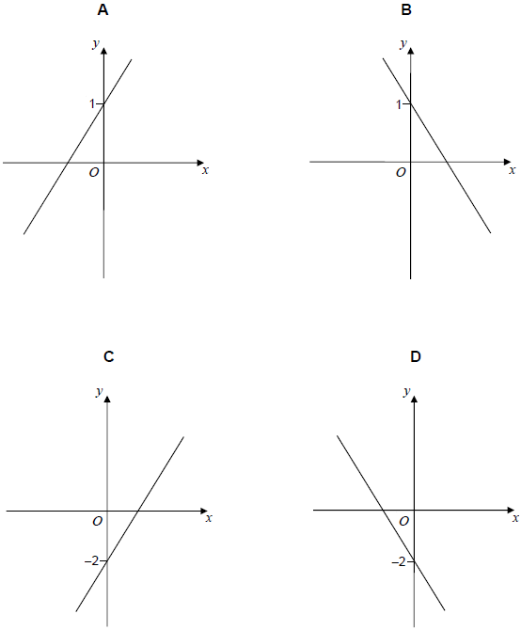
(Total 1 mark)
Q29.
Rearrange p = r + 3 to make r the subject.
Circle your answer.
r = p + 3 r = p − 3 r = 3 − p r =
(Total 1 mark)
Q30.
(a) Write in standard form 12 500
Answer _________________________________________
(1)
(b) Write as an ordinary number 3.4 × 10⁻²
Answer _________________________________________
(1)
(Total 2 marks)
Q31.
(a) The radius of this circle is 2.5 cm
Not drawn accurately
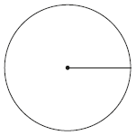
Work out the area.
Give your answer to 1 significant figure.
___________________________________________________________________
___________________________________________________________________
Answer ______________________________________ cm³
(3)
(b) The diameter of this semicircle is 16 cm
Not drawn accurately
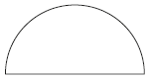
Work out the perimeter of the semicircle.
___________________________________________________________________
___________________________________________________________________
___________________________________________________________________
___________________________________________________________________
___________________________________________________________________
Answer _________________________________________
(3)
(Total 6 marks)
Q32.
Use trigonometry to work out the size of angle x.
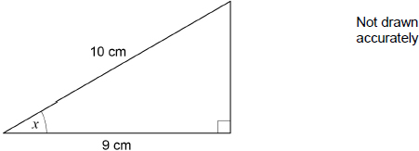
_______________________________________________________________________
_______________________________________________________________________
_______________________________________________________________________
_______________________________________________________________________
_______________________________________________________________________
_______________________________________________________________________
Answer _________________________________________ degrees
(Total 2 marks)
Q33.
Factorise fully 9a² − 6a
_______________________________________________________________________
_______________________________________________________________________
Answer _________________________________________
(Total 2 marks)

SECTION 2
Q1.
x : y = 7 : 4
x + y = 88
Work out the value of x − y
_______________________________________________________________________
_______________________________________________________________________
_______________________________________________________________________
_______________________________________________________________________
_______________________________________________________________________
_______________________________________________________________________
Answer _________________________________________
(Total 3 marks)
Q2.
120 adults complete a survey.
45 are men.
Write the ratio men : women in its simplest form.
_______________________________________________________________________
_______________________________________________________________________
Answer _________________________________________
(Total 2 marks)
Q3.
(a) Work out the size of angle x.
Not drawn accurately
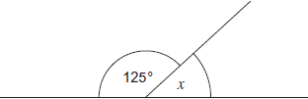
___________________________________________________________________
___________________________________________________________________
Answer ___________________________________ degrees
(1)
(b) Work out the size of angle y.
Not drawn accurately
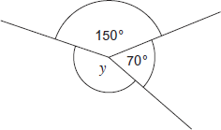
___________________________________________________________________
___________________________________________________________________
___________________________________________________________________
Answer ___________________________________ degrees
(2)
(Total 3 marks)
Q4.
Circle the equation which has the solution x = 6
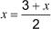 3x = 36
(Total 1 mark)
Q5.
(a) Here is a linear sequence.
21 23 25 27 ....
Circle the expression for the nth term of the sequence.
23 − 2n 19n + 2 21 − 2n 2n + 19
(1)
(b) A different sequence starts
a 2a − 3 ....
The term-to-term rule for this sequence is

multiply by 2 and subtract 3
The fourth term of this sequence is 35
Work out the value of a.
___________________________________________________________________
___________________________________________________________________
___________________________________________________________________
___________________________________________________________________
___________________________________________________________________
___________________________________________________________________
___________________________________________________________________
___________________________________________________________________
Answer _________________________________________
(3)
(Total 4 marks)
Q6.
(a) Solve n + 7 = 103
___________________________________________________________________
___________________________________________________________________
n = _________________________________________
(1)
(b) Solve = 12
___________________________________________________________________
___________________________________________________________________
m = _________________________________________
(1)
(Total 2 marks)
Q7.

What is the mode of these numbers?
3 4 6 6 7 8 9 13
Circle your answer.
6 6.5 7 10
(Total 1 mark)
Q8.
Line AB is shown on the grid.
A is the point (0, 2)
B is the point (6, 5)
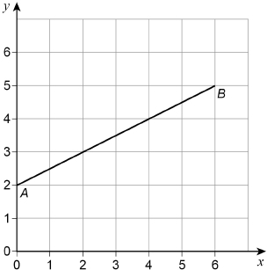
(a) Work out the coordinates of the midpoint of the line AB.
Answer ( ________ , ________ )
(1)
(b) C is another point on AB.
C is closer to B than to A.
The coordinates of C are whole numbers.
Work out the coordinates of C.
Answer ( ________ , ________ )
(1)
(c) On the grid, draw a line from point (0, 0) that is
parallel to AB
and
two thirds as long as AB.
(2)
(Total 4 marks)
Q9.
(a) Circle the value of 2⁴
6 8 16 24
(b) Circle the value of 5³
(1)
15 25 53 125
(c) Circle the value of
(1)
13 14 16 98
(1)
(Total 3 marks)
Q10.
Circle the number that is not a multiple of 6
24 76 108 144
(Total 1 mark)
Q11.
(a) Work out 11% of 1400
___________________________________________________________________
___________________________________________________________________
___________________________________________________________________
___________________________________________________________________
Answer _________________________________________
(2)
(b) Work out of 295
___________________________________________________________________
___________________________________________________________________
___________________________________________________________________
___________________________________________________________________
Answer _________________________________________
(2)
(Total 4 marks)
Q12.
Circle the cube number.
9 10 000 333 729
(Total 1 mark)
Q13.
Here is a list of numbers.
21 17 23 21 29 32 21 25 36
Work out the median.
_______________________________________________________________________
_______________________________________________________________________
Answer _________________________________________
(Total 2 marks)
Q14.
Simplify 3 × a × 3 × a
Circle your answer.
9a 6a² 9a² 6a
(Total 1 mark)
Q15.
Circle the expression which does not simplify to y³
y × y × y y⁴ ÷ y y² × y y⁶ ÷ y²
(Total 1 mark)
Q16.
Draw the following on the circles below.
(a) Radius.
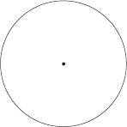
(1)
(b) Chord.
(1)
(c) Tangent.
(1)
(Total 3 marks)
Q17.
Here are six words that are used with circles.

arc | chord | diameter | sector | segment | tangent
Put the correct word from the list in each box.
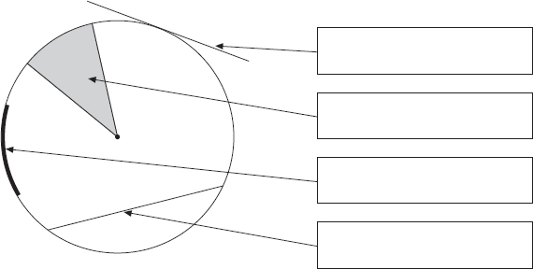
(Total 4 marks)
Q18.
Circle the expression that can be written as 2y
y + y y² 2 + y y × y
(Total 1 mark)
Q19.
Simplify 8x − 3 + 6x
Circle your answer.
2x − 3 11x 5 + 6x 14x − 3
(Total 1 mark)
Q20.
Which of these is used to work out density?
Tick a box.

mass × volume | 
mass² × volume
mass ÷ volume
volume ÷ mass
(Total 1 mark)
Q21.
Work out
_______________________________________________________________________
_______________________________________________________________________
_______________________________________________________________________
_______________________________________________________________________
_______________________________________________________________________
_______________________________________________________________________
_______________________________________________________________________
Answer _________________________________________
(Total 3 marks)
Q22.
Reflect shape A in the x-axis.
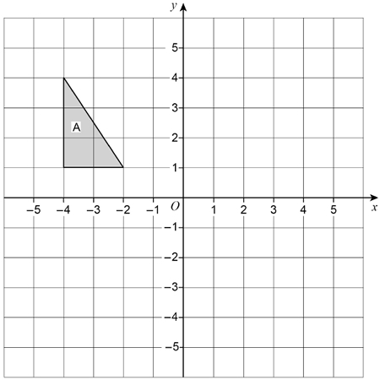
(Total 2 marks)
Q23.
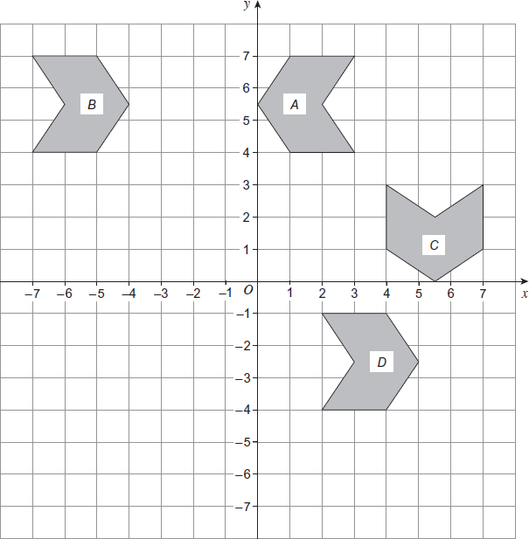
(a) On the grid draw the mirror line that reflects shape A to shape B.
(1)
(b) On the grid draw the mirror line that reflects shape A to shape C.
(1)
(c) Describe fully the single transformation that takes shape B to shape D.
___________________________________________________________________
___________________________________________________________________
___________________________________________________________________
(2)
(Total 4 marks)
Q24.
Describe fully the single transformation that maps shape A to shape B.
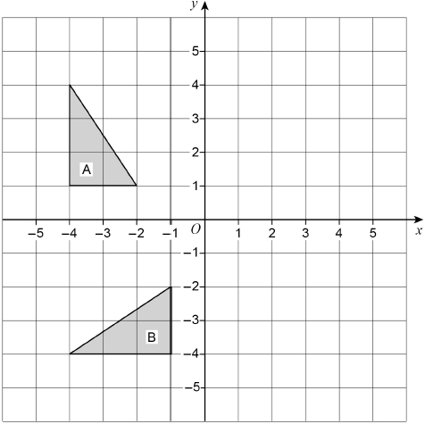
_______________________________________________________________________
_______________________________________________________________________
_______________________________________________________________________
(Total 3 marks)
Q25.
A dry cleaning shop has the following offers.

Suit  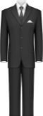  Normal price £12.50  1st suit normal price  2nd suit half price |  | Dress  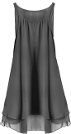  Normal price £9.75  Three for the price of two
Work out the total price for 2 suits and 6 dresses.
_______________________________________________________________________
_______________________________________________________________________
_______________________________________________________________________
_______________________________________________________________________
_______________________________________________________________________
_______________________________________________________________________
_______________________________________________________________________
_______________________________________________________________________
Answer £ _________________________________________
(Total 4 marks)
Q26.
2.5 kg of carrots cost £1.70
Work out the cost of 3.25 kg of carrots.
_______________________________________________________________________
_______________________________________________________________________
_______________________________________________________________________
_______________________________________________________________________
_______________________________________________________________________
Answer £ _________________________________________
(Total 3 marks)
Q27.
Here is a map showing two towns, P and Q.
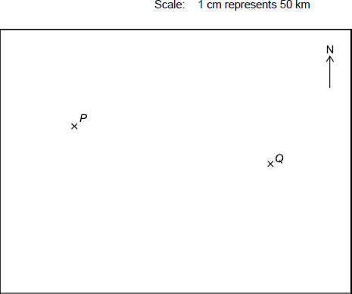
(a) Work out the actual distance between towns P and Q.
___________________________________________________________________
___________________________________________________________________
___________________________________________________________________
Answer _________________________________________ km
(2)
(b) Town R is 200 km due South of town P.
Mark R on the map.
___________________________________________________________________
___________________________________________________________________
(2)
(Total 4 marks)
Q28.
Three people share £180.
Billy gets twice as much as Amy.
Chloe gets three times as much as Billy.
Is Chloe’s share enough to buy a bike costing £115?
You must show your working.
_______________________________________________________________________
_______________________________________________________________________
_______________________________________________________________________
_______________________________________________________________________
_______________________________________________________________________
_______________________________________________________________________
(Total 5 marks)
Q29.
(a) w and x are whole numbers.
w > 40
x < 30
Work out the smallest possible value of w − x
___________________________________________________________________
___________________________________________________________________
___________________________________________________________________
Answer _________________________________________
(2)
(b) y and z are whole numbers.
y < 60
z ≤ 50
Work out the largest possible value of y + z
___________________________________________________________________
___________________________________________________________________
___________________________________________________________________
Answer _________________________________________
(2)
(Total 4 marks)
Q30.
Each shape below has an area of 24 cm²
Complete the missing lengths.
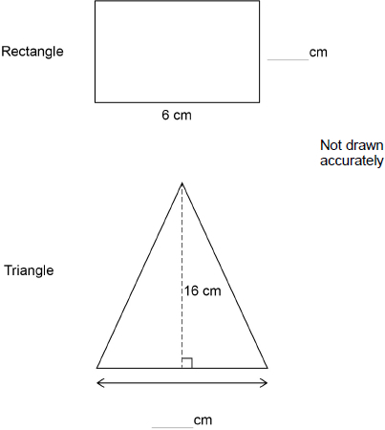
(Total 3 marks)
Q31.
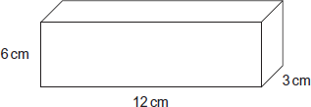
(a) Calculate the volume of the cuboid.
State the units of your answer.
___________________________________________________________________
___________________________________________________________________
Answer _________________________________________
(3)
(b) A cube has a surface area of 54 cm².
How many of these cubes will fit inside the cuboid?
___________________________________________________________________
___________________________________________________________________
___________________________________________________________________
___________________________________________________________________
___________________________________________________________________
Answer _________________________________________
(4)
(Total 7 marks)
Q32.
The graph shows the temperature in a garden over 24 hours.
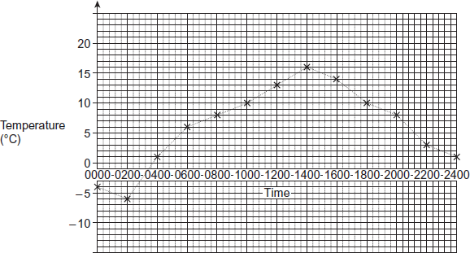
(a) Write down the temperature at 0200.
Answer ________________________________ °C
(1)
(b) A heater in the greenhouse switches on when the temperature in the garden is
below 10 °C.
For how many hours was the heater switched on?
___________________________________________________________________
___________________________________________________________________
Answer ______________________________ hours
(2)
(c) Work out the temperature range in the garden.
___________________________________________________________________
Answer ________________________________ °C
(2)
(Total 5 marks)
Q33.

The table shows the savings for 30 students in one week.

 | Savings, £s | Number of students
 | 0 < s ≤ 5 | 2
 | 5 < s ≤ 10 | 14
 | 10 < s ≤ 15 | 9
 | More than 15 | 5
(a) How many students saved more than £5?
___________________________________________________________________
___________________________________________________________________
Answer _________________________________________
(1)
(b) How many students did not save anything?
Circle your answer.
0 1 2 cannot tell
(1)
(Total 2 marks)
Q34.
There are some boys and girls at a bus stop.
11 girls get on the first bus to arrive.
The number of boys and girls at the bus stop is now the same.
16 boys get on the second bus to arrive.
The ratio of the number of boys to the number of girls at the bus stop is now 1 : 3
How many girls were at the bus stop to start with?
_______________________________________________________________________
_______________________________________________________________________
_______________________________________________________________________
_______________________________________________________________________
_______________________________________________________________________
_______________________________________________________________________
_______________________________________________________________________
Answer _________________________________________
(Total 4 marks)
Q35.
Here is a number machine.
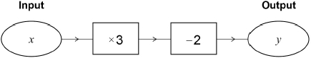
(a) Work out the output when the input is 4
___________________________________________________________________
___________________________________________________________________
___________________________________________________________________
Answer _________________________________________
(1)
(b) Work out the output when the input is −4
___________________________________________________________________
___________________________________________________________________
___________________________________________________________________
Answer _________________________________________
(1)
(Total 2 marks)

