Year 11 Higher Homework 2
Total out of 50 marks: Name:
How do you calculate the PERIMETER of a shape?
Sketch a BOXPLOT and label its key features
Give an example of a GEOMETRIC progression
What is PYTHAGORAS THEOREM?
Which of the following numbers is a SQUARE number?

$2$ $4$ $12$ $30$
Expand $9(2x-3)$

$9x-3$ $18x-3$ $9x-27$ $18x-27$
A line has equation $y = 4-9x$. What is the value of its gradient?

$4$ $5$ $-4$ $-9$
Circle the correct value of ${100}^{0.5}$

$0$ $1$ $-1$ $10$

Q1.
A and B are similar shapes.
B is an enlargement of A with scale factor 1.5
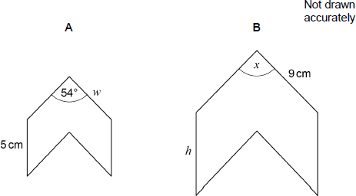
Work out the values of x, h and w.
_______________________________________________________________________
_______________________________________________________________________
_______________________________________________________________________
_______________________________________________________________________
_______________________________________________________________________
_______________________________________________________________________
x = _________________________________________ degrees
h = _________________________________________ cm
w = _________________________________________ cm
(Total 3 marks)

Q2.

Here is a box plot.
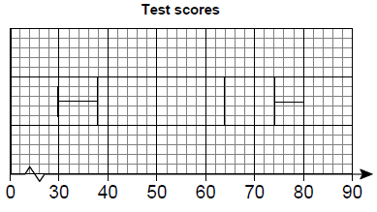
(a) Circle the value of the range.
33 36 50 80
(1)
(b) Circle the value of the median.
38 55 62 64
(1)
(c) Circle the value of the interquartile range.
34 36 38 50 62
(1)
(Total 3 marks)

Q3.
Some girls and boys take an examination.
(a) Here is some information about the marks for the girls.
Lowest is 16
Highest is 78
Lower quartile is 24
Upper quartile is 66
Median is 48
Draw a box plot for this information.
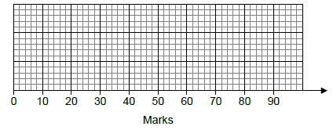
(3)
(b) Here is some information about the marks for the boys.
Median is 45
Interquartile range is 39
Whose marks were more consistent?
Tick a box.
girls |  | boys
You must show your working.
___________________________________________________________________
(2)
(Total 4 marks)
Q4.
A line has the equation y = 4x − 5
(a) What is the gradient of the line?
Circle your answer.
−5 −4 4 5
(1)
(b) What is the y-intercept of the line?
Circle your answer.
−5 −4 4 5
(1)
Q5.
Here is a straight-line graph.
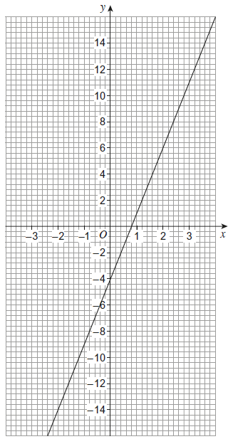
(a) Use the graph to work out the value of x when x = 8
___________________________________________________________________
Answer __________________________________________
(1)
(b) Work out the gradient of the line.
___________________________________________________________________
___________________________________________________________________
Answer _________________________________________
(3)
(Total 4 marks)
Q6.
What does (A ∩ B) represent in P(A ∩ B)?
Circle your answer.

A or B or both | A but not B
not A and not B | A and B
(Total 1 mark)
Q7.
A school has 86 teachers.
42 are male and 44 are female.
of the male teachers have blue eyes.
of the female teachers have blue eyes.
(a) ξ = teachers in the school
M = male teachers
B = teachers who have blue eyes
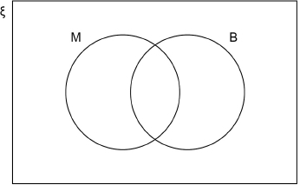
Complete the Venn diagram.
___________________________________________________________________
___________________________________________________________________
___________________________________________________________________
(3)
(b) One teacher who has blue eyes is chosen at random.
Work out the probability that the teacher is male.
Answer _________________________________________
(1)
(Total 4 marks)
Q8.
A spinner lands on red, blue or green.
The relative frequencies after 400 spins are shown.

 | Colour | red | blue | green
 | Relative frequency | 0.35 | 0.5 | 0.15
How many more times did it land on red than green?
_______________________________________________________________________
_______________________________________________________________________
_______________________________________________________________________
Answer _________________________________________
(Total 2 marks)
Q9.
Solve 5(x + 3) < 60
_______________________________________________________________________
_______________________________________________________________________
_______________________________________________________________________
_______________________________________________________________________
Answer _________________________________________
(Total 2 marks)
Q10.
(a) Factorise x² − 100
___________________________________________________________________
Answer _________________________________________
(1)
(b) Solve 7x + 6 > 1 + 2x
___________________________________________________________________
___________________________________________________________________
___________________________________________________________________
___________________________________________________________________
Answer _________________________________________
(2)
(Total 3 marks)
Q11.
Work out the three inequalities that describe the shaded region.
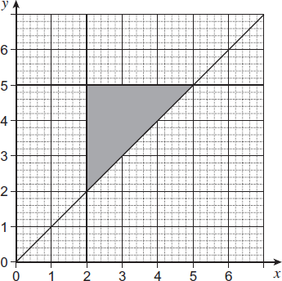
Answer _________________________________________
_________________________________________
_________________________________________
(Total 3 marks)
Q12.
Purple paint is made by mixing red paint and blue paint in the ratio 5 : 2
Yan has 30 litres of red paint and 9 litres of blue paint.
What is the maximum amount of purple paint he can make?
_______________________________________________________________________
_______________________________________________________________________
_______________________________________________________________________
_______________________________________________________________________
_______________________________________________________________________
_______________________________________________________________________
Answer _________________________________________ litres
(Total 3 marks)

Q13.
An approximate solution to an equation is found using the iterative formula
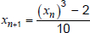 with x₁ = -1
(a) Work out the values of x₂ and x₃
___________________________________________________________________
___________________________________________________________________
___________________________________________________________________
___________________________________________________________________
x₂ = _________________________________________
x₃ = _________________________________________
(2)
(b) Work out the solution to 5 decimal places.
___________________________________________________________________
___________________________________________________________________
___________________________________________________________________
___________________________________________________________________
x = _________________________________________
(1)
(Total 3 marks)

Q14.
Here is the graph of a straight line.
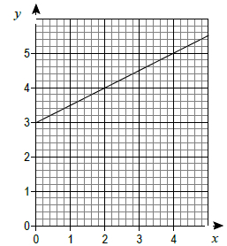
(a) Work out the equation of the line.
___________________________________________________________________
___________________________________________________________________
___________________________________________________________________
Answer _________________________________________
(2)
(b) Work out the coordinates of the y-intercept of the line that
is parallel to the line in part (a)
and passes through (4, 1)
___________________________________________________________________
___________________________________________________________________
Answer (........................... , ...........................)
(2)

