Mark schemes
Q1.
5⁸
B1
[1]
Q2.
1
B1
[1]
Q3.
15 000 mm³
B1
[1]
Q4.
segment
B1
[1]
Q5.
16
B1
[1]
Q6.
cos x =
oe
eg
sin x = 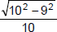
tan x = 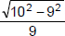
M1
25.8... or 26
A1
Additional Guidance
cos = x = 25.8 (recovered)
M1A1
cos =
M0A0
[2]
Q7.
(a) 2.5 × 12 or 30
and
7.5 × 7 or 52.5
and
12.5 (× 1)
or
95
allow one incorrect midpoint
or
[2, 3] × 12 and [7, 8] × 7
and [12, 13] (× 1)
ignore t ≥ 15 row
M1
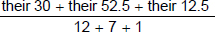
or 95 ÷ 20
t ≥ 15 product must be 0 if seen
condone bracket error seen eg 30 + 52.5 + 12.5 ÷ 20
M1dep
4.75
accept 4.8 or 5 if full working shown using correct midpoints
A1
Additional Guidance
Two correct from 30, 52.5 and 12.5 implies the first mark and could be used to score up to M2
M1
Midpoints used in the ranges [2, 3], [7, 8] and [12, 13] must be seen
eg
2.5 × 12 and 7 × 7 and 12 (× 1)
or 3 × 12 and 7 × 7 and 13 (× 1)
NB These could be used to score up to M2
M1
Correct products seen in the table but a different method shown in the working lines eg 20 ÷ 4 = 5
M0
(b) Lower than part (a)
B1
[4]
Q8.
(a) 2400 × 3.8
or = 2400 or = 3.8
oe equation
allow mass for m
allow any letter apart from v or d
M1
9120
A1
(b) πr² h = 3.8
or
π × 0.5² × h or 0.25πh
or [0.78, 0.79]h
or
3.8 ÷ (π × 0.5²) or 3.8 ÷ 0.25π
or 3.8 ÷ [0.78, 0.79]
oe eg πr² =
M1
[4.8, 4.841]
A1
Additional Guidance
π 0.5² h
M1
[4]
Q9.
(a) π × 9.2 × 9.2 or 265.(...)
oe
M1
× π × 9.2 × 9.2
oe
M1dep
[92, 92.5]
A1
(b) ½ × 9.2 × 9.2 × sin 125
oe
M1
[34.6, 34.7]
A1
[57, 58]
ft their (a) − [34.6, 34.7]
Allow rounding of final answer
A1ft
[6]
Q10.
a = 2
May be embedded
B1
b = 5
May be embedded
B1
Additional Guidance
(2r⁵)⁴
B1B1
(r⁵)⁴
B1
2⁴ = 16 on its own is not enough
B0
a = 5 and b = 2
B0B0
[2]
Q11.
(a) Joins (0, 0) to (30, 20)
Line does not need to be straight but must start and finish at correct points and not be decreasing
Mark intention
B1
Horizontal line for 15 minutes from their (30, 20)
Mark intention
B1ft
Line with gradient 1 or a curve from their (45, 20)
and stops at 60 minutes
or stops at top edge of grid or higher but not beyond 60 minutes
A curve must not be decreasing and must start and finish at two points that could be joined by a line with gradient 1
Condone a horizontal or vertical line from 60 minutes
Mark intention
B1ft
Additional Guidance
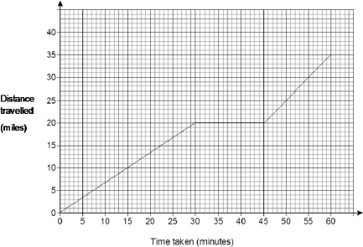
B3
Allow any horizontal line between 30 minutes and 45 minutes if first part of journey is blank
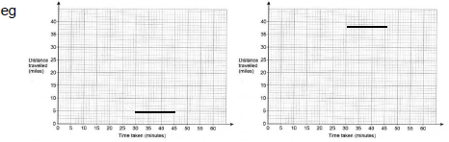
B0B1
Do not allow second mark if their first line is followed by a drop back towards the horizontal axis before she stops
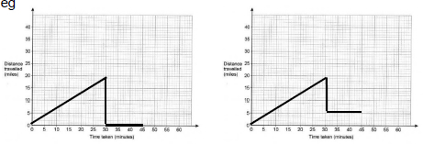
B1B0
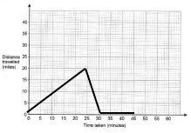
B0B0
If there are more than 3 lines or curves assume the last part is the part where she completes her journey.
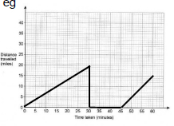
B1B0B1ft
If their (45, 20) is too high to fit a line of gradient 1 ending at 60 minutes, allow the final line to stop at the top of the grid or higher, but not beyond 60 minutes
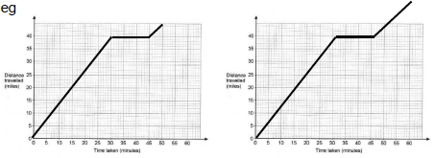
B0B1ftB1ft
Points but no lines
B0
Ignore any lines that could be working for part (a) or part (b)
(b) 35
Correct or ft total distance travelled for their graph at 60 minutes
B1ft
Additional Guidance
35 from any or no graph
B1
If their graph extends beyond 60 minutes, read off at 60 minutes for ft
Follow through total distance travelled
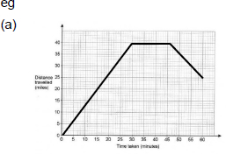
(b) answer 25
B0ft
(b) answer 55
B1ft
Ignores the stationary parts
B0
Do not follow through a graph above the grid at 60
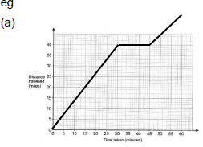
(b) answer 55
B0ft
[4]
Q12.
19 × 82 or 1558
M1
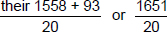
oe
M1dep
82.55 or 82.6
A1
[3]
Q13.
Alternative method 1
π × 30³ or 36 000π
or [112 757, 113 112]
or
× π × 30³ or 18 000π
or [55 954, 56 839]
oe
allow 1.33... for
allow 0.66... or 0.67 for
M1
their [112 757, 113 112] ÷ 4000 or 9π or 28.(...)
or
their [55 954, 56 839] ÷ 4000 or or [13.9, 14.21]
or
their [112 757, 113 112] ÷ (4000 × 60) or or [0.46, 0.4713]
or
their [55 954, 56 839] ÷ (4000 × 60) or or 0.23... or 0.24
M1dep
[13.9, 14.21] and Yes
or
0.23... or 0.24 and Yes
A1
Alternative method 2
π × 30³ or 36 000π
or [112 757, 113 112]
or
× π × 30³ or 18 000π
or [55 954, 56 839]
oe
allow 1.33... for
allow 0.66... or 0.67 for
M1
4000 × 15 or 60 000
M1
[55 954, 56 839] and 60 000 and Yes
A1
Alternative method 3
π × 30³ or 36 000π
or [112 757, 113 112]
or
× π × 30³ or 18 000π
or [55 954, 56 839]
oe
allow 1.33... for
allow 0.66... or 0.67 for
M1
their [112 757, 113 112] ÷ 15
or 2400π or [7517, 7541]
or
their [55 954, 56 839] ÷ 15
or 1200π or [3730, 3790]
M1dep
[3730, 3790] and Yes
A1
Additional Guidance
Do not award A1 if incorrect conversion of hour seen
[3]
Q14.
(a) (9) 25 45 53 60
Cumulative frequencies
May be implied by points plotted
(± 0.5 square)
B1
Points plotted with upper class boundaries and cf values
(±0.5 square)
ft their cumulative frequencies
Must be increasing and not a single straight line
B1ft
Smooth curve or polygon starting at correct point for their points and going through all their points (±0.5 square)
ft their cumulative frequencies
Must be increasing and not a single straight line
B1ft
Additional Guidance
Graphs may start from their first plotted point or from (40, 0)
If they have plotted their points at mid-points, with point at (45, 9), their graph may start at (35, 0)
Graph starting at (0, 0), but otherwise correct
B1B1B0
Curve plotted at mid-points or lower class boundaries, but otherwise correct
B1B0B1
Ignore the graph after m = 90
Bars drawn as well as correct graph
B1B1B0
Bars drawn without the correct graph
max B1
(b) Alternative method 1
60 − 0.2 × 60 or 60 × 0.8 or 48
oe implied by horizontal line from 48 on vertical axis
M1
Correct reading from their increasing graph
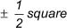
A1ft
Alternative method 2
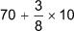
M1
[73, 75]
A1
Additional Guidance
The correct answer is likely to be [73, 75] from a correct graph
[5]
Q15.
(a) 360 − 72 − 90 or 198
oe
100(%) − 20(%) − 25(%) or 55(%)
M1
their 198 ÷ 3 (× 2) or 66 or 132
Correct line drawn implies M1M1
their 55 ÷ 3 (× 2) or 18(.3...) or 36(.6...) or 37
M1
Correct line drawn within 2° and sections labelled correctly
L in the section with [130°, 134°]
M in the section with [64°, 68°]
A1
Additional Guidance
Correct line drawn must be a ruled line for A mark
Angles may be on the diagram
Mark diagram first, if line out of tolerance, check working for method marks
(b) 16 200 ÷ 360 or 45
or 360 ÷ 16 200 or 0.022...
or 16 200 ×
oe
M1
3240
A1
Additional Guidance
Do not ignore further working
16 200 − 3240 = 12 960
M1A0
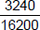 on answer line
M1A0
16 200 ÷ 4 ÷ 90
M1
16 200 ÷ 5
M1
20% of 16 200 without further correct working
M0
[5]
Q16.
Bars should not be of equal width or horizontal scale is incorrect
oe
B1
Vertical axis should be frequency density
or heights of bars incorrect
oe
B1
[2]
Q17.
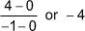
oe
M1
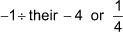
oe
their –4 must be their gradient of OP
M1
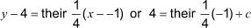
oe
Dep on second M1
oe c = 4.25
M1dep
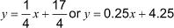
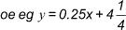
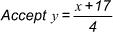
A1
Additional Guidance
An answer of 4y = x + 17, with or without the correct answer seen
M1M1M1A0
For A1, allow a mixture of fractions, decimals and mixed numbers
y – y₁ = m(x – x₁) stated, followed by 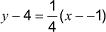 oe
M1M1M1
[4]
Q18.
14x − 3
B1

