Name:_______________
Date:

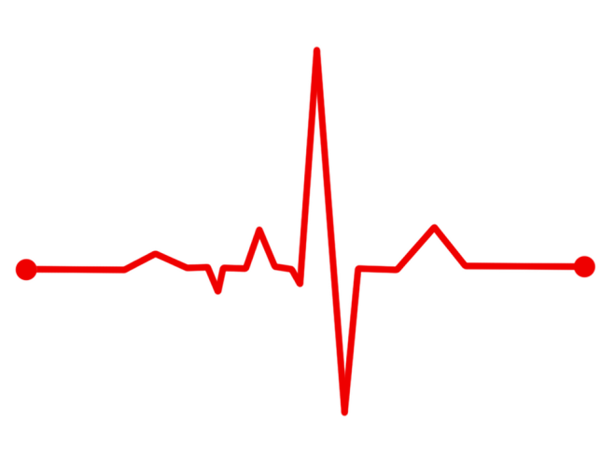
Ten-minute check up

Rules that connect coordinates

Identify the equation of the line connecting x and y from the table of values below
x | -3 | -2 | -1 | 0 | 1 | 2 | 3 | 4
y | -14 | -10 | -6 | -2 | 2 | 6 | 10 | 14

Explain fully how you found your answer. Can you think of more than one method to find this?

Area of shapes
- Find the area of the shaded
region within this square
with side 10cm.
Self-diagnosis

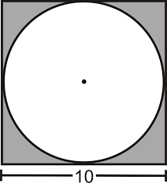

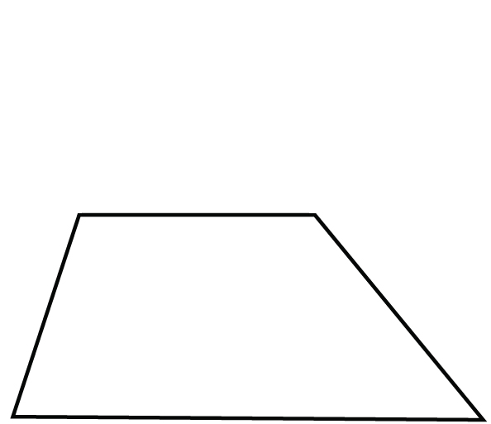
- Would the shaded region from
part (a) fit inside this trapezium?
6.15cm

4cm
2.5cm

11.05cm
Name:_______________
Date:

Ten-minute check up

Rules that connect coordinates

Identify the equation of the line connecting x and y from the table of values below
x | -3 | -2 | -1 | 0 | 1 | 2 | 3 | 4
y | -14 | -10 | -6 | -2 | 2 | 6 | 10 | 14

Explain fully how you found your answer. Can you think of more than one method to find this?
y = 4x – 2
Methods possibly used:
- Finding nth term and rewriting in terms of x, not n
- Identify gradient from any two points, y intercept from point (0,2)
- Sketching and identifying gradient and intercept from graph

Area of shapes
- Find the area of the shaded
region within this square
with sides 10cm.
Self-diagnosis
You know
What to do!

21.46cm²

- Would the shaded region from
part (a) fit inside this trapezium?
6.15cm
2.5cm
21.5cm²
4cm
YES
11.05cm

