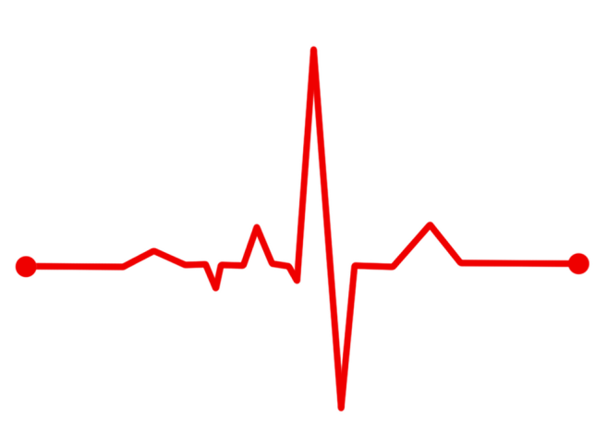
Name:_______________
Date:

Ten-minute check up

Ratio
The ratio of cakes to biscuits is 5:4 and the ratio of biscuits to sandwiches is 3:1. What is the ratio of sandwiches to cakes?

Formulae Can you recall the formulae for…?
Sine rule | Cosine rule for finding a side
Area of a trapezium | Cosine rule for finding an angle
Quadratic functions Sketch the function y = x² – 4x – 5
Drawing a parabola isn’t enough. You need to mark the y intercept, x intercepts (roots) and, if you’re feeling awesome, the turning point! Use all your quadratic skills to help you!
Self-diagnosis

Name:_______________
Date:

Ten-minute check up

Ratio
The ratio of cakes to biscuits is 5:4 and the ratio of biscuits to sandwiches is 3:1. What is the ratio of sandwiches to cakes?
15:12 and 12:4 so 15:12:4 is C:B:S 4:15

Formulae Can you recall the formulae for…?
Sine rule  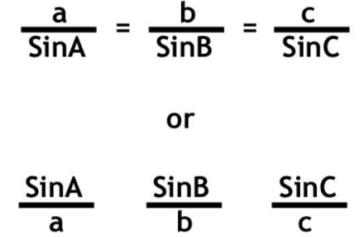 | Cosine rule for finding a side  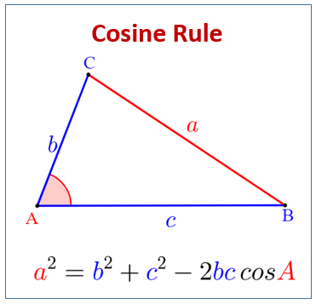
Area of a trapezium  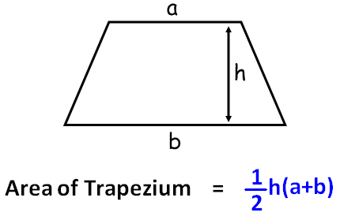 | Cosine rule for finding an angle  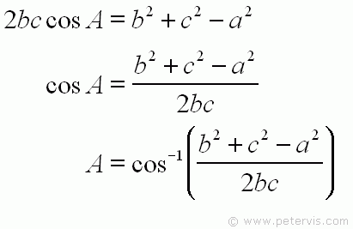
Quadratic functions Sketch the function y = x² – 4x – 5
Roots: x = -1, x = 5
Vertex (turning point): (2, -9)
Self-diagnosis
You know
what to do!

x
(5,0)
(-1,0)
x
x
(0,-5)
x
(2,-9)

