Year 11 Mini Quiz – Week 6 11th October 2019 Maximum Marks = 20
Name:
Section A: Formulae and Facts
Give an example of a decreasing ARITHMETIC sequence
What is the COSINE RULE?
Which formula calculates the sum of the INTERIOR angles of a polygon?
How do you calculate the AREA of a TRAPEZIUM?

Section B: Multiple Choice
What is the nth term of -9, -7, -5, -3… ?

$11-2n$ $2n-11$ $2n+11$ $n-2$
What is the value of $3.1×{10}^{4}+3.1×{10}^{3}$?

$3.41×{10}^{2}$ $3.41×{10}^{4}$ $6.2×{10}^{3}$ $6.2×{10}^{7}$
Solve $10x+3<21$

$$x≥1.8 x=1.8 x<1.8 x>1.8$$
Which calculation increases £500 by 1.05%?

$500×1.105$ $500×1.015$ $500×1.0105$

Section C: Exam Questions
- A car was reduced by 8% in a sale and was bought for £9216

How much was it originally?
(2 marks)

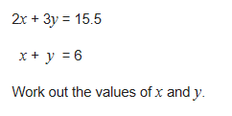
(3 marks)

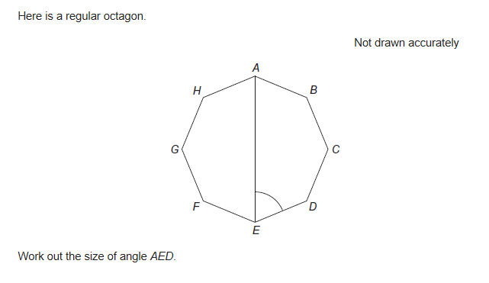

(3 marks)

- Expand $\left(x+7\right)(x-4)$

(1 mark)

- A fisherman catches 50 fish.
The table shows information about the lengths of the fish.

Length, l (inches) | Frequency | Cumulative frequency
5 < l ≤ 10 | 6 | 6
10 < l ≤ 15 | 20 | 26
15 < l ≤ 20 | 13
20 < l ≤ 25 | 8
25 < l ≤ 30 | 3

(a) Complete the table.

(b) Draw a cumulative frequency diagram for the data.

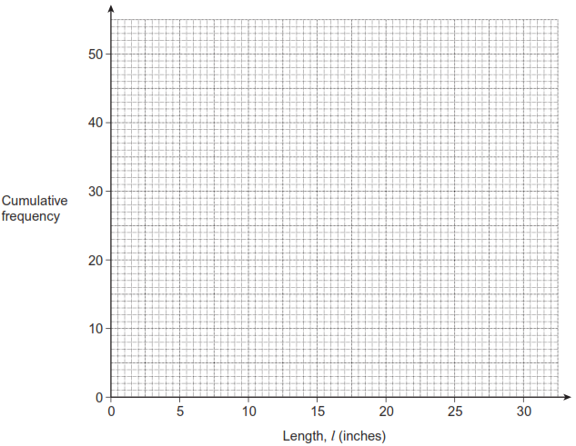
(3 marks)

THE END

