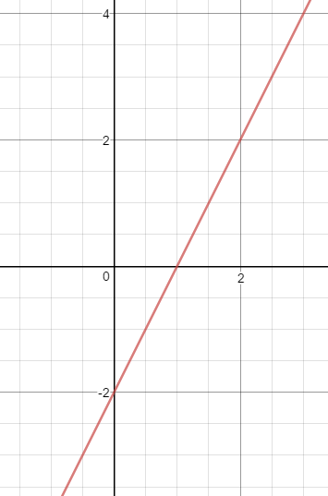 | $$x^{2}+y^{2}=10$$
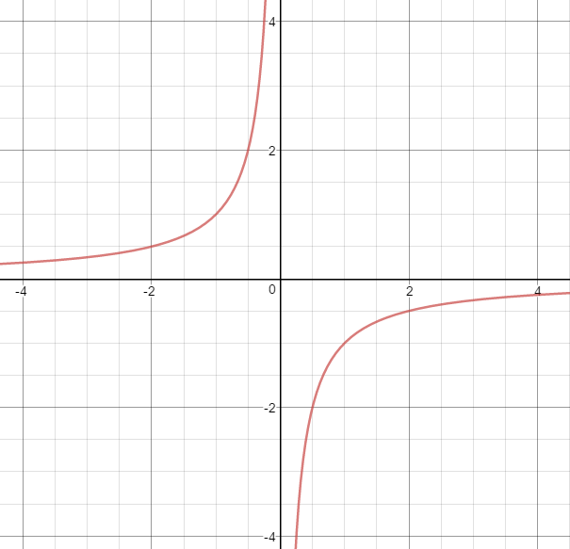 | $$y=2^{x}$$
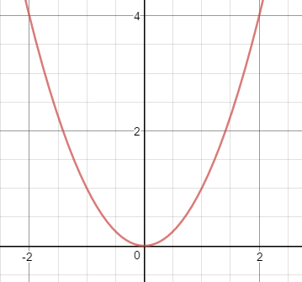 | $$y=2x+2$$
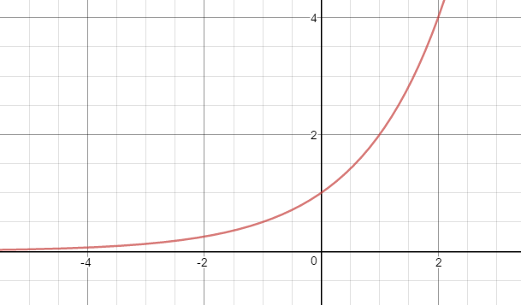 | $$y=2-x^{2}$$
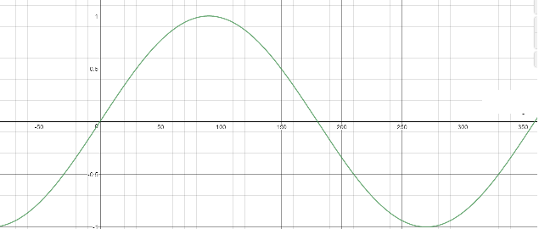 | $$y=\frac{1}{x}$$
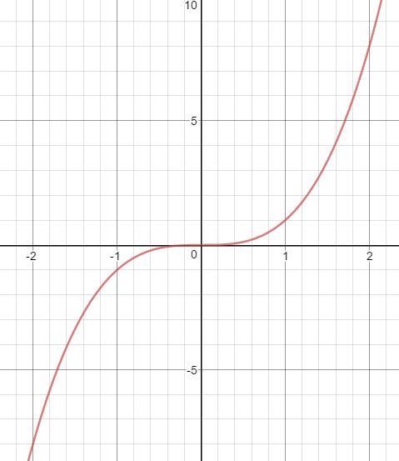 | $$y=-\frac{1}{x}$$
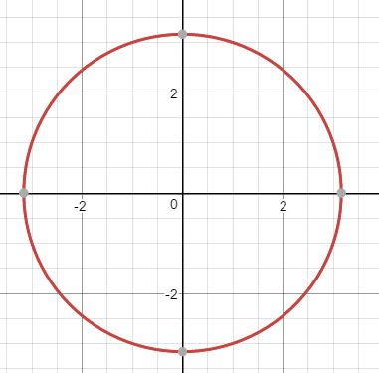 | $$y=2x-2$$
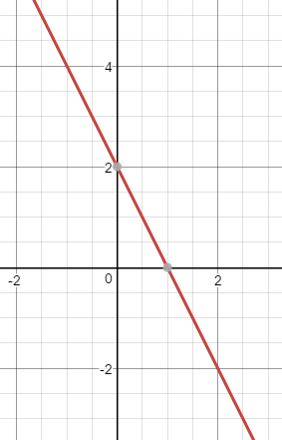 | $$y=2-2x$$
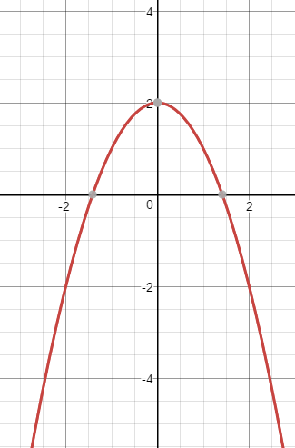 | $$y=\sin{x}$$
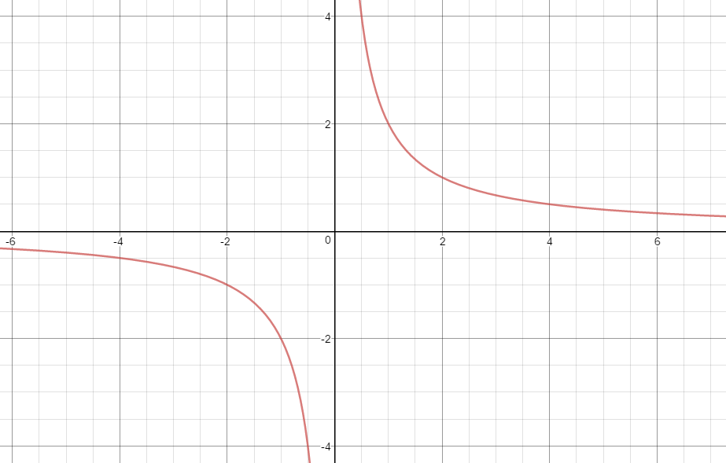 | $$y=2^{-x}$$
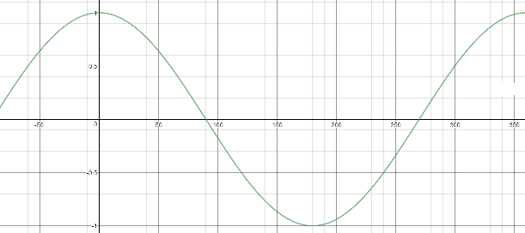 | $$y=-x^{3}$$
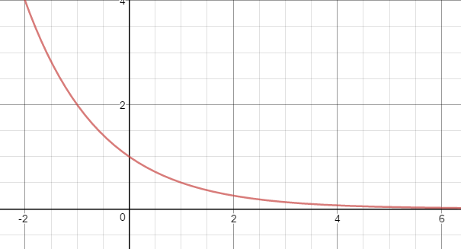 | $$y=\cos{x}$$
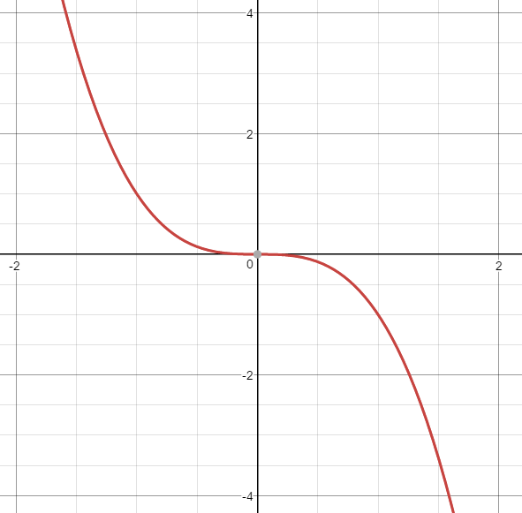 | $$y=x^{2}$$
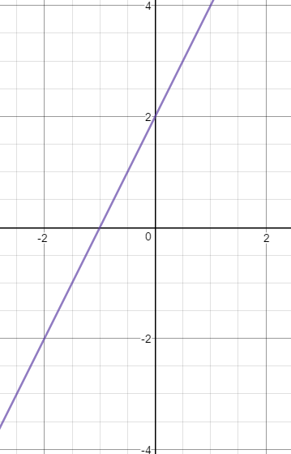 | $$y=x^{3}$$

