Which formula calculates the sum of the interior angles of any polygon? |  | What do the exterior angles of any polygon sum to?
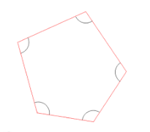 | Q1 | 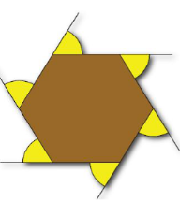 | Q2
What do an interior angle and an exterior angle of a polygon always sum to? |  | What is the formula that calculates the length of an arc?
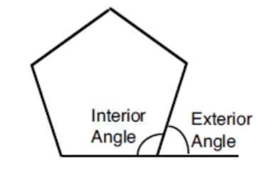 | Q3 | 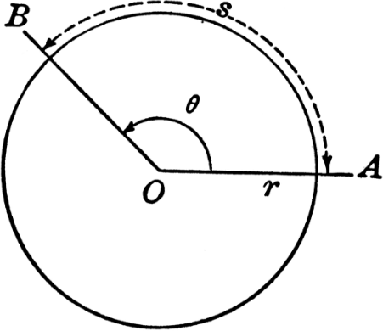 | Q4
360⁰ |  | $$180(n-2)$$
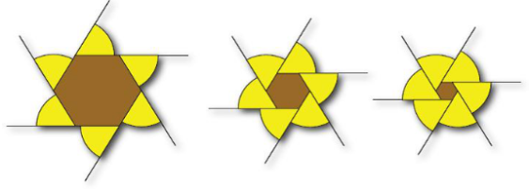 | A2 | 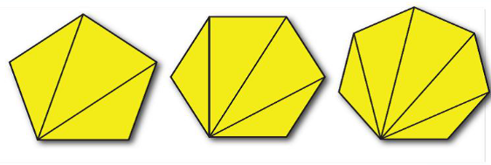 | A1
$$Arc Length =\frac{θ}{360}×2πr$$ |  | 180⁰
 | A4 |  | A3
Which formula calculates the area of a circle? |  | What is the formula that calculates the area of a sector?
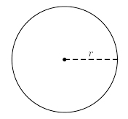 | Q5 | 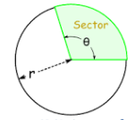 | Q6
Which formula calculates the area of a trapezium? |  | What is the formula that calculates the area of a triangle given its perpendicular height?
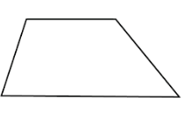 | Q7 | 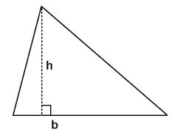 | Q8
$$Sector Area= \frac{θ}{360}×πr^{2}$$ |  | $$Area= πr^{2}$$
 | A6 |  | A5
$$Area of a Triangle= \frac{1}{2}bh$$ |  | $$Area of Trapezium= \frac{1}{2}\left(a+b\right)h$$
 | A8 | 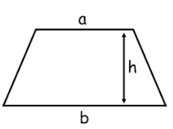 | A7
What do the angles in a triangle always add up to? |  | Can you name these parts of a circle?  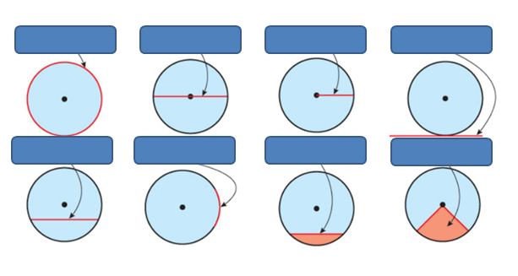
 | Q9 |  | Q10
Which two formulae calculate the circumference of a circle? |  | What is the formula that calculates the density of an object?
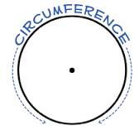 | Q11 |  | Q12
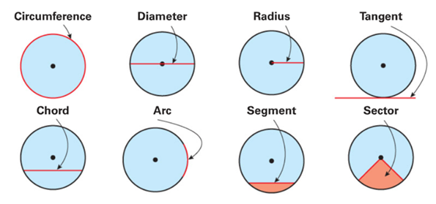 |  | 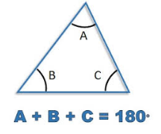
 | A10 | 180⁰ | A9
$$Density= \frac{Mass }{Volume}$$ |  | $$Circumference= πd=2πr$$
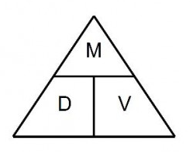 | A12 | 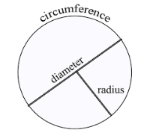 | A11
What is the formula that calculates pressure? |  | What is the formula that calculates the average speed of an object?
 | Q13 | mph | Q14
What do the angles on a straight line always add up to? |  | How do we calculate the AREA of a rectangle?
 | Q15 |  | Q16
$$Speed= \frac{Distance}{Time}$$ |  | $$Pressure= \frac{Force}{Area}$$
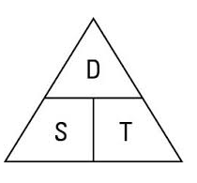 | A14 |  | A13
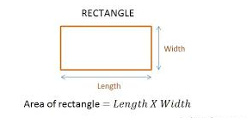 |  | 180⁰
 | A16 |  | A15
How is the MEDIAN calculated? |  | What is the MODE average?
 | Q17 |  | Q18
How do we calculate the RANGE of a set of values? |  | How is PERIMETER calculated?
 | Q19 |  | Q20
The MODE is the value that appears the MOST |  | The values must be in order and then the MIDDLE value is found
 | A18 |  | A17
All of the outside edges of a shape are measured and added together |  | Biggest Value – Smallest Value
 | A20 |  | A19
What is the general equation of a straight line? |  | What makes two shapes CONGRUENT?
 | Q21 |  | Q22
What are the FACTORS? |  | How do you estimate the mean from a frequency table?  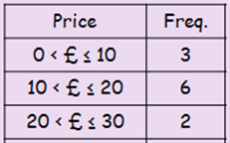
 | Q23 |  | Q24
For two shapes to be congruent they must be the same shape and size |  | $$y=mx+c$$  where m is the gradient and c is the y-intercept
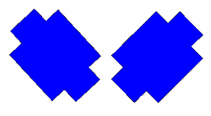 | A22 | 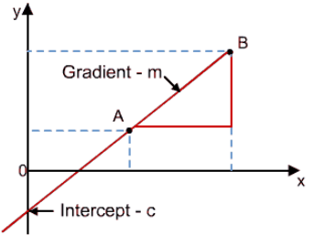 | A21
- Calculate the midpoint of each group  - Multiply each midpoint by its frequency  - Add together the $m×f$ column  - Divide by the total frequency  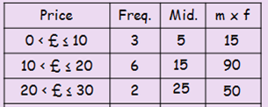 |  | Factors are numbers we can multiply together to get another number: Example: 2 and 3 are factors of 6, because 2 × 3 = 6. A number can have MANY factors!
Mean = $155÷11$ | A24 |  | A23
What are the first 5 PRIME Numbers? |  | Which formula calculates the volume of a pyramid?
 | Q25 | 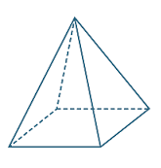 | Q26
What are the first 15 SQUARE numbers? |  | What are the first 5 CUBED numbers?
 | Q27 |  | Q28
$$Volume= \frac{1}{3}×base area ×height$$ |  | 2, 3, 5, 7, 11
 | A26 | Prime Numbers have exactly 2 factors | A25
1, 8, 27, 64, 125 |  | 1, 4, 9, 16, 25, 36, 49, 64, 81, 100, 121, 144, 169, 196, 225
5³ = 5 x 5 x 5 = 125 | A28 | 15² = 15 x 15 = 225 | A27
What does BIDMAS represent? |  | How are cumulative frequency values calculated?
 | Q29 |  | Q30
How many SIGNIFICANT figures do these numbers have?  - 3267  - 3206  - 3260  - 0.032 |  | How many grams in a kilogram?  How many metres in a kilometre?
 | Q31 |  | Q32
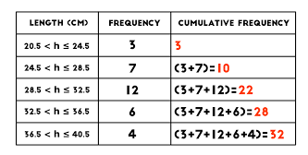 |  | BIDMAS helps us remember the order in which we should work out a calculation.  B – Brackets First  I – Indices Second  D – Division Third  M- Multiplication Forth  A – Addition Fifth  S – Subtraction Sixth
Add the frequencies | A30 |  | A29
1000 |  | - 4  - 4  - 3  - 2  Significant figures are all the nonzero digits of a number and the zeros that are included between them.
 | A32 |  | A31
How many centimetres in a metre? |  | How do we expand  $2x(x-7)$?
 | Q33 |  | Q34
What do parallel lines have in common? |  | How do we expand and simplify  (x + 7)(x + 2)?
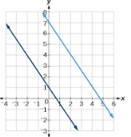 | Q35 |  | Q36
We multiply whatever is outside the bracket by whatever is inside the bracket  A grid can help… |  | $$100$$
  x | x | -7
  2x | 2x² | -14x
The answer is:  2x² – 14x | A34 |  | A33
We multiply all the terms together then add together the like terms.  Again a grid can help… |  | They have the same gradient
  x | x | 2
  x | x² | 2x
  7 | 7x | 14
The answer is:  x²+9x+14 | A36 | $$m_{1}=m_{2}$$ | A35
What is the modal class? |  | Which three formulae does SOH CAH TOA represent?
 | Q37 | 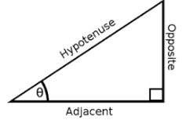 | Q38
What do the 5 lines of a boxplot represent?  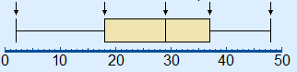 |  | How is interquartile range calculated?
 | Q39 |  | Q40
$$\sin{θ=\frac{opp}{hyp}}$$  $$\cos{θ=\frac{adj}{hyp}}$$  $$tanθ=\frac{opp}{adj}$$ |  | The group with the largest frequency  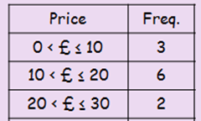  Here the modal class is $10<£≤20$
 | A38 | Mode –  Most Common | A37
Upper Quartile – Lower Quartile |  | 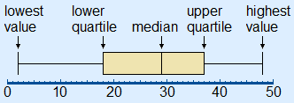
 | A40 |  | A39
What is the formula for the volume of a sphere?  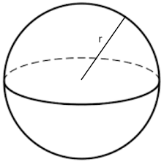 |  | How do you find the volume of a cuboid?
 | Q41 |  | Q42
How do you find the volume of a prism?  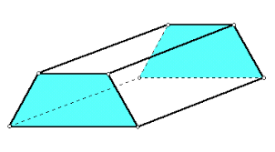 |  | What is the formula for the volume of a cone?  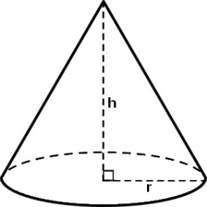
 | Q43 |  | Q44
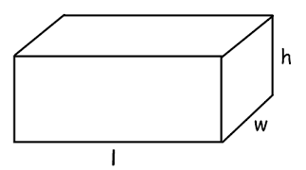 |  | $V=\frac{4}{3}πr^{3}$
Length x Width x Height | A42 |  | A41
$$V=\frac{1}{3}πr^{2}h$$  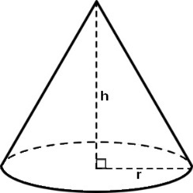 |  | $Volume=Area of cross section ×length$
 | A44 |  | A43
How do we multiply two fractions together?  For example:  $\frac{2}{3}×\frac{1}{7}$ |  | How do we divide by a fraction?  For example:  $$\frac{2}{3}÷\frac{3}{4}$$
 | Q45 |  | Q46
What does $4^{3}×4^{10}$simplify to? |  | What does $4^{3}÷4^{10}$?
Index Laws | Q47 | Index Laws | Q48
Keep the first fraction the same, change the divison sign to a multiplication sign and flip the second fraction upside down.  For example:  $$\frac{2}{3}×\frac{4}{3}=\frac{8}{9}$$ |  | Multiply the numerators and multiply the denominators  $$\frac{2×1}{3×7}=\frac{2}{21}$$
 | A46 |  | A45
$$4^{-7}$$ |  | $$4^{13}$$
When dividing SUBTRACT the powers | A48 | When multiplying ADD the powers | A47
What does ${(4^{3})}^{10}$ simplify to? |  | What are the missing exact trig values?
   | 30° | 45° | 60°
  sin
  cos
  tan
 | Q49 |  | Q50
In a right angled triangle what is tan$θ$?  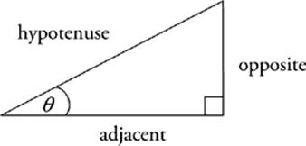 |  | In a right angled triangle what is cos $θ$?
 | Q51 |  | Q52
 |  | $$4^{30}$$
   | 30° | 45° | 60°
  sin | $$\frac{1}{2}$$ | $$\frac{1}{\sqrt{2}}$$ | $$\frac{\sqrt{3}}{2}$$
  cos | $$\frac{\sqrt{3}}{2}$$ | $$\frac{1}{\sqrt{2}}$$ | $$\frac{1}{2}$$
  tan | $$\frac{1}{\sqrt{3}}$$ | 1 | $$\sqrt{3}$$
 | A50 | With brackets MULTIPLY the powers | A49
$$cos θ=\frac{adjacent}{hypotenuse}$$  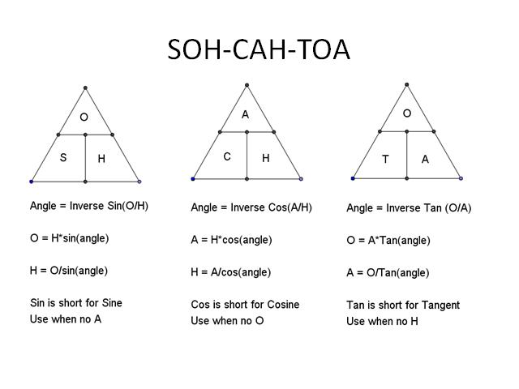 |  | $$tan θ=\frac{opposite}{adjacent}$$
 | A52 |  | A51
In a right angled triangle what is sin$θ$? |  | 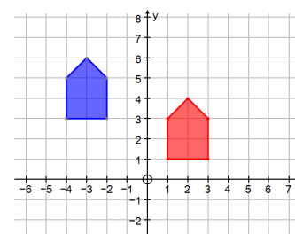  Which two pieces of information are needed to describe this type of transformation?
 | Q53 |  | Q54
Which two pieces of information are needed to describe this type of transformation?  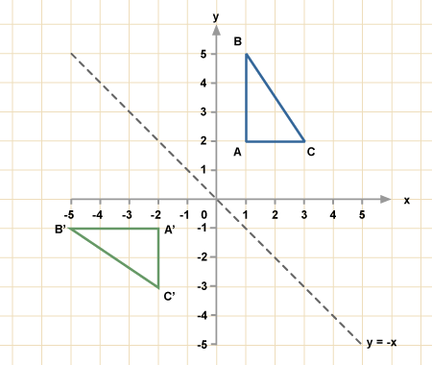 |  | 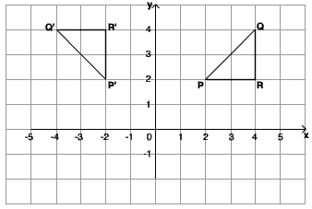  Which three pieces of information are needed to describe this type of transformation?
 | Q55 |  | Q56
The word translation  and a vector |  | $$sin θ=\frac{opposite}{hypotenuse}$$
$$\left(\begin{matrix}x \\ y\end{matrix}\right)$$ | A54 |  | A53
The word rotation  an angle and direction  the centre of rotation |  | The word reflection  and an equation of a line
 | A56 |  | A55
Which three pieces of information are needed to describe this type of transformation?  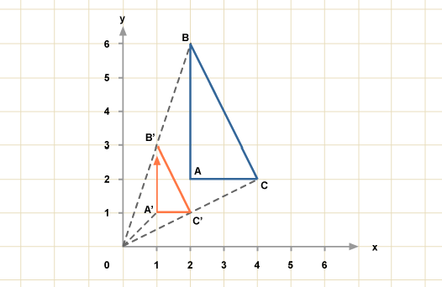 |  | How do we add/subtract fractions with different denominators?  Eg. $\frac{1}{2}+\frac{1}{3}$?
 | Q57 |  | Q58
How do you calculate 10% of a value? |  | How do you calculate 5% of a value?
 | Q59 |  | Q60
Multiply both fractions by a value so that they share the same denominator value than just add the numerators.  Eg. $\frac{1}{2}=\frac{3}{6}$ , $\frac{1}{3}=\frac{2}{6}$  Answer = $\frac{5}{6}$ |  | The word enlargement  A scale factor  the centre of enlargement
 | A58 |  | A57
Find 10% then half the answer  Eg. 5% of £330 = 33$÷$2 = £16.50 |  | Divide by 10  Eg. 10% of £330 = £33
 | A60 |  | A59
In the first step of solving these simultaneous equations, what would you multiply the equations by and why?  $2x+3y=7$  $3x-4y=11$ |  | Two shapes are mathematically similar.  If the scale factor for length is $a$, what are the scale factors for area and volume?  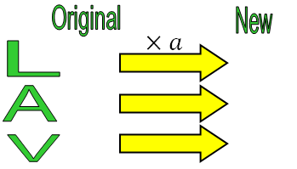
 | Q61 |  | Q62
What type of correlation do each of these graphs show?  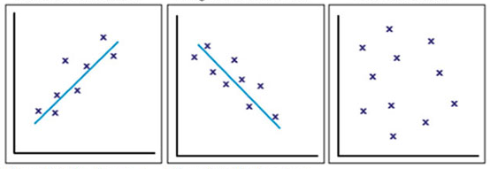 |  | A, B and C shared some money in the ratio  2 : 3 : 6. C got £80 more than A. How much money did B have?  Draw a diagram to represent the problem
 | Q63 |  | Q64
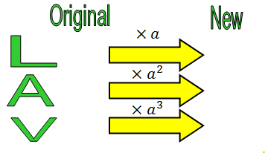 |  | Multiply equation by 3 & equation by 2  Or  Multiply equation by 4 & equation by 3
 | A62 |  | A61
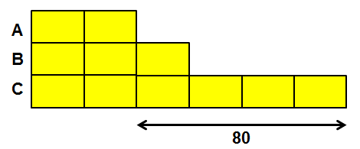  The diagram shows that each box is worth £20, so B has £60 |  | Positive correlation  Negative correlation  No correlation
 |  |  | A63
What is the quadratic formula? |  | What is Pythagoras’ Theorem  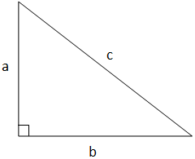
 | Q65 |  | Q66
What are VERTICES?

 | Q67
$$a^{2}+b^{2}=c^{2}$$ |  | $$x=\frac{-b±\sqrt{b^{2}-4ac}}{2a}$$
 | A66 | Helps solve equations like:  $${2x}^{2}+7x+3=0$$ | A65
Corners
A cube has 8 vertices
 |  | 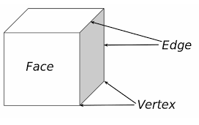 | A67
The prime number decomposition of 60 and 294 is shown in the Venn diagram below. What is the Highest Common Factor? (HCF)  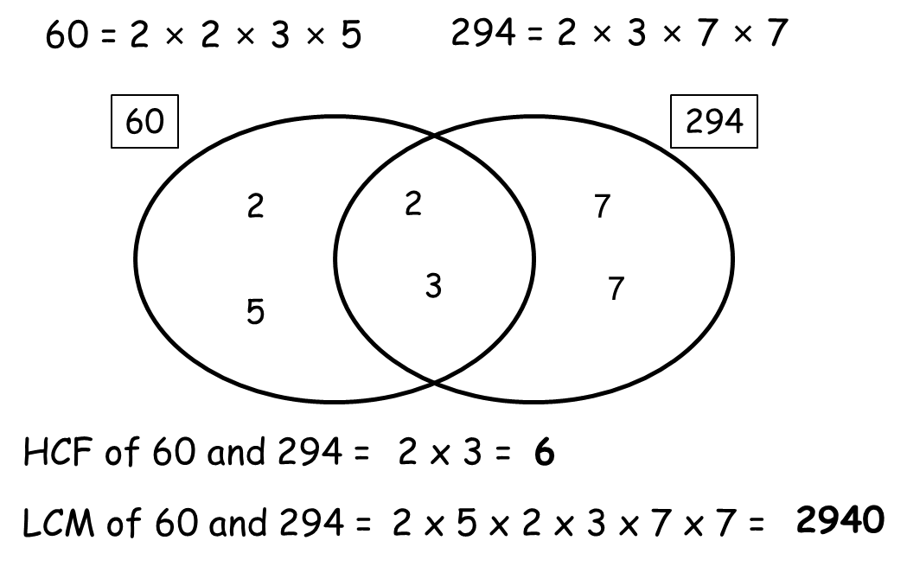 |  | The prime number decomposition of 60 and 294 is shown in the Venn diagram below. What is the Lowest Common Multiple? (LCM)
 | Q68 |  | Q69
How would you find P(B, B) from this tree diagram?  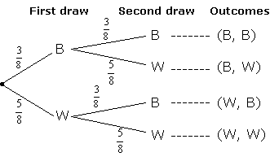 |  | When drawing a pie chart, which calculation would you do to find the angle for hockey?  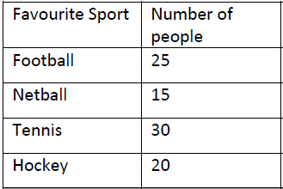
 |  |  | Q71
LCM = 2 $×$ 5 $×$2 $×$ 3$×$ 7 $×$ 7 = 2940  These are all the numbers in the Venn diagram. (The union) |  | HCF = 2 $×$ 3 = 6  These numbers are found in the intersection of the Venn Diagram
 | A69 |  | A68
$$angle= \frac{20}{90}×360$$  Where 90 is the total number of people |  | $$\frac{3}{8}×\frac{3}{8}=\frac{9}{64}$$
 | A71 | Multiply the correct branches together
What is the multiplier for a 32% increase?  What is the multiplier for a 2.5% increase?  $×$? |  | What is the multiplier for a 12% decrease?  What is the multiplier for a 3.8% decrease?  $×$?
 | Q72 |  | Q73
If a bed is reduced by 35% in a sale to £91.00, what calculation would you do to find the original price? |  | A man's weekly wage was ￡336, but now he earns ￡420. How do you calculate the percentage increase?
Reverse Percentages | Q74 |  | Q75
For a 12% decrease, multiply by 0.88  For a 3.8% decrease, multiply by 0.962 |  | For a 32% increase, multiply by 1.32  For a 2.5% increase, multiply by 1.025
 | A73 |  | A72
336 9$91$  $\frac{420}{336}=1.25$, so % increase is 25%  $×$0.65  420 9$91$ |  | The calculation is 91 ÷ 0.65  $× 0.65$  $×$0.65  91 9$91$
 | A75 |  | A74
What is 324000 in STANDARD FORM? |  | What is 0.0032 in STANDARD FORM?
 | Q76 |  | Q77
How do you factorise 4x + 8? |  | How would you factorise  x² + 8x + 7?
 | Q78 | Factorising Quadratics | Q79
3.2 x 10⁻³  Remember when the power is negative we have a small number  (just count the first zeros!) |  | 3.24 x 10⁵  Remember that first number always has to be bigger than 1 but smaller than 10!
 | A77 |  | A76
Think of two number that MULTIPLY to make the c value (7 here) and ADD to make the b value (8 here)  Answer : (x + 1)(x + 7) |  | Work out the HIGHEST COMMON FACTOR of 4 and 8 and then work out what has to go into the bracket so that it would expand to give you 4x + 8  Answer = 4(x + 2)
 | A79 |  | A78
What is the nth term of:  4, 8, 12, 16… |  | What is the nth term of:  5, 9, 13, 17…
 | Q80 |  | Q81
What is the name given to a six sided polygon? |  | What is the name given to a seven sided polygon?
 | Q82 |  | Q83
4n + 1 |  | 4n
The four times table add one | A81 | The four times table | A80
Heptagon |  | Hexagon
 | A83 |  | A82
How do we know that the marked angles are the same here?  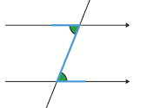 |  | How do we know that these angles are the same?  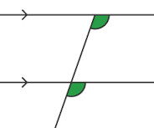
Angles in Parallel Lines | Q84 | Angles in Parallel Lines | Q85
What is the relationship between angle a and angle b?  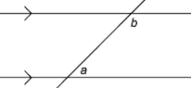 |  | What is a bearing?
Angles in Parallel Lines | Q86 |  | Q87
Corresponding angles are equal |  | Alternate angles are equal
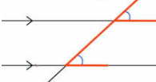F | A85 | 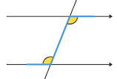Z | A84
An angle measured from North in a clockwise direction and written using three figures. |  | They add up to 180⁰ because they are co-interior angles
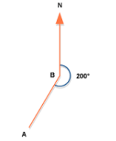 | A87 |  | A86
 | 

