Velocity Time Graphs 1: Find the acceleration and distance travelled for these velocity time graphs

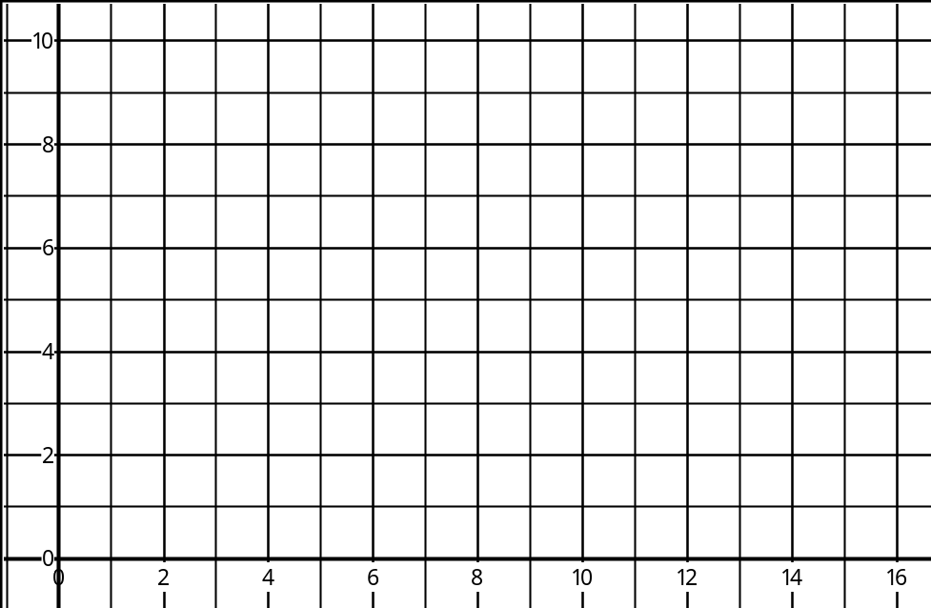  Time sec  Velocity ms⁻¹  Acceleration = ………… ms⁻² Distance = ………… m | Time sec  Velocity ms⁻¹  Acceleration = ………… ms⁻² Distance = ………… m
Time sec  Velocity ms⁻¹  Acceleration = ………… ms⁻² Distance = ………… m | Time sec  Velocity ms⁻¹  Acceleration = ………… ms⁻² Distance = ………… m
Time sec  Velocity ms⁻¹  Acceleration = ………… ms⁻² Distance = ………… m | Time sec  Velocity ms⁻¹  Acceleration = ………… ms⁻² Distance = ………… m
Time sec  Velocity ms⁻¹  Acceleration = ………… ms⁻² Distance = ………… m | Time sec  Velocity ms⁻¹  Acceleration = ………… ms⁻² Distance = ………… m
Time sec  Velocity ms⁻¹  Acceleration = ………… ms⁻² Distance = ………… m | Time sec  Velocity ms⁻¹  Acceleration = ………… ms⁻² Distance = ………… m
Time sec  Velocity ms⁻¹  Acceleration = ………… ms⁻² Distance = ………… m | Time sec  Velocity ms⁻¹  Acceleration = ………… ms⁻² Distance = ………… m

Velocity Time Graphs 2: Find the distance travelled for these velocity time graphs

Time sec  Velocity ms⁻¹  Acceleration = ………… ms⁻² Distance = ………… m | Time sec  Velocity ms⁻¹  Acceleration = ………… ms⁻² Distance = ………… m
Time sec  Velocity ms⁻¹  Acceleration = ………… ms⁻² Distance = ………… m | Time sec  Velocity ms⁻¹  Acceleration = ………… ms⁻² Distance = ………… m
Time sec  Velocity ms⁻¹  Acceleration = ………… ms⁻² Distance = ………… m | Time sec  Velocity ms⁻¹  Acceleration = ………… ms⁻² Distance = ………… m
Time sec  Velocity ms⁻¹  Acceleration = ………… ms⁻² Distance = ………… m | Time sec  Velocity ms⁻¹  Acceleration = ………… ms⁻² Distance = ………… m
Time sec  Velocity ms⁻¹  Acceleration = ………… ms⁻² Distance = ………… m | Time sec  Velocity ms⁻¹  Acceleration = ………… ms⁻² Distance = ………… m
Time sec  Velocity ms⁻¹  Acceleration = ………… ms⁻² Distance = ………… m | Time sec  Velocity ms⁻¹  Acceleration = ………… ms⁻² Distance = ………… m

