Drawing the Sine Graph – Complete the table and plot the coordinates

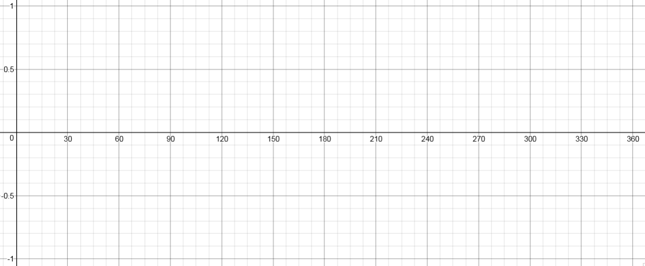

θ | $$0°$$ | $$30°$$ | $$60°$$ | $$90°$$ | $$180°$$ | $$210°$$ | $$240°$$ | $$270°$$ | $$300°$$ | $$330°$$ | $$360°$$
$$\sin{θ}$$

Drawing the Cosine Curve – Complete the table and plot the coordinates

θ | $$0°$$ | $$30°$$ | $$60°$$ | $$90°$$ | $$180°$$ | $$210°$$ | $$240°$$ | $$270°$$ | $$300°$$ | $$330°$$ | $$360°$$
$$\cos{θ}$$

Drawing the Tangent Graph – Complete the table and plot the coordinates

θ | $$0°$$ | $$30°$$ | $$60°$$ | $$90°$$ | $$180°$$ | $$210°$$ | $$240°$$ | $$270°$$ | $$300°$$ | $$330°$$ | $$360°$$
$$\tan{θ}$$

