Ratio and Proportion
Foundation tier exemplification questions:
1 | A recipe for fruit cake uses sultanas and raisins in the ratio 5 : 3  How many grams of sultanas should be used with 150 grams of raisins?
2 | The numbers of coins in two piles are in the ratio 5 : 3  The coins in the first pile are all 2 p coins.  The coins in the second pile are all 5 p coins.  There is 45 p in the second pile.  How much money is in the first pile?

3 |  |  | Cola is sold in two packs.  A pack of 20 cans costs £4.99 and a pack of 12 cans costs £2.75  Which pack is better value for money?  You must show your working.
4 |  |  | There are 6 girls and 27 boys in an after-school computer club.  Write the ratio of girls : boys in its simplest form.
5 |  |  | Write the ratio 15 : 8 in the form n : 1
6 |  |  | The ratio of red balls to blue balls in a bag is 3 : 4  What fraction of the balls are red?
7 |  |  | A coin is biased.  The ratio of the probability of a head to the probability of a tail is 3 : 5  Work out the probability of a tail.
8 |  |  | Before a storm, a pond held 36 000 litres of water.  After the storm, the volume of the pond increased by 12%  How many litres of water does the pond hold after the storm?
9 |  |  | The mean price of four train tickets is £25  All prices are increased by 10%  What is the total cost of the four tickets after the price increase?
10 |  |  | A car increases its speed from 50 mph to 70 mph  Work out the percentage increase.
11 |  |  | Attendance at a football match is 48 400  This is a 10% increase on the attendance at the last game.  What was the attendance at the last game?
12 |  |  | The value of my car has decreased by 15% of the price I paid one year ago.  It is now valued at £17 340  How much did I pay for the car one year ago?
13 |  |  | £5000 is invested at 9.65% compound interest.
 |  | (a) |  | Work out the value of the investment after six years.
 |  | (b) |  | Write down a formula to calculate the value of the investment after n years.

Higher tier exemplification questions:
1 | x : y = 1 : 2  (a) Draw the graph of y as a function of x.  (b) Write down the equation of your graph.

2 |  |  | The mass, m, of a sphere is proportional to the cube of its radius, r.  When r = 5 cm, m = 500 g  Work out the mass of a sphere with r = 10 cm
3 |  |  | For a rectangle of length l and width w,  l = 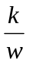  What does the constant k represent?
 | 4  Graph A  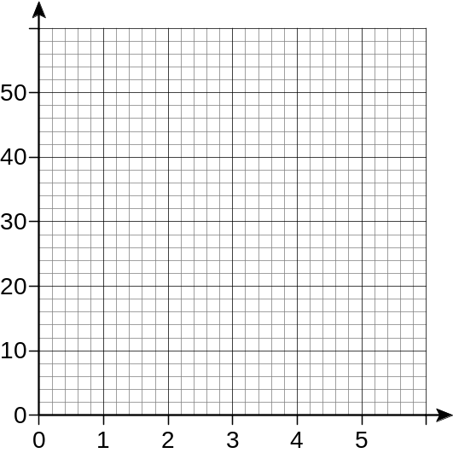  Time  Distance  Graph B  Time  Distance | 7 |  | Match this statement to a graph.  The distance travelled at a steady speed is directly proportional to the time taken.

Graph C

Time
Distance
5 |  |  | The graph shows the height of a firework rocket above the ground plotted against time after take-off.
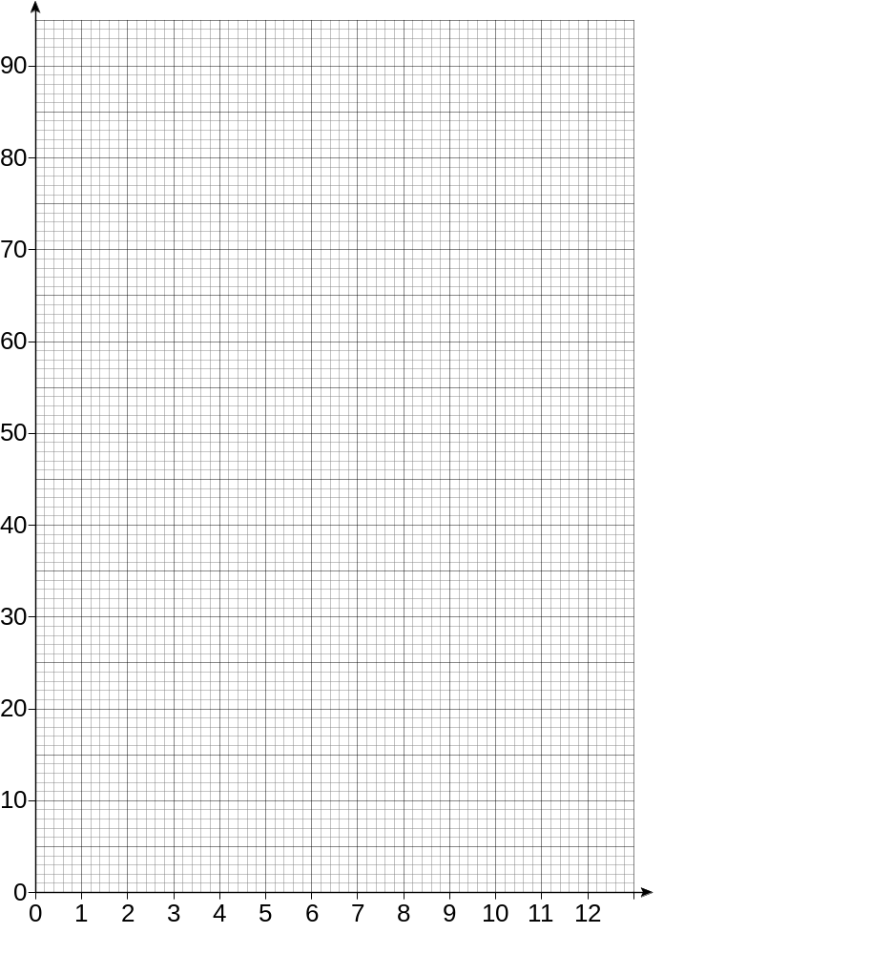
Height
(metres)
Time
(seconds)
 |  |  | (a) |  | Use the graph to find the greatest height reached by the rocket.
 |  |  | (b) |  | How long is the rocket moving upwards?
 |  |  | (c) |  | By drawing a suitable straight-line graph, estimate the speed of the rocket two seconds  after take-off.
 |  |  | (d) |  | When is the rocket rising at its fastest speed?
 | 6
 |  | (a) |  | Write the ratio perimeter A : perimeter B in its simplest form.
 |  | (b) |  | Write the ratio area A : area B in its simplest form.
 | 7 | 4 cm  7 cm  2 cm  B  A  These boxes are similar  2 cm  3 cm  B  4 cm  1 cm  6 cm  A  8 cm  What is the ratio of the volume of box A to box B?

