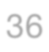Frequency Tree
Y
Y
B
36
B
Y
B
Which team will win?
You will need your results for the 36-game season. You are going to put them on the frequency tree and 2-way table.
- Count how many times each team scored the first goal - these go in the two boxes on the 1st goal tree branches.
- Then count how many times each of these occurred: YY, YB, BY, BB - and put the totals into the boxes on the 2nd goal branches.
- Complete the columns for the final score, the winning team, and the numbers of games for each set of branches.
- Check that the overall total number of games is 36.
- Now put values in the cells in the 2- way table, and check that the grand total is 36.
- Which cells in the 2-way table correspond to the boxes in the tree diagram?
- Are there any values which only occur on one of them?
1st goal

2-way table

Final score

…………..
2nd goal

…………..

…………..

0 - 2

Winning team
…………..

…………..

Draw

…………..

Total

Number of games
…………..

…………..

…………..

…………..

 |  | 2nd goal |  | Total
 |  | Y | B | Total
1st goal | Y
1st goal | B
Total

Frequency Tree
Y
Y
B
36
B
Y
B
1st goal
What do we EXPECT to happen in 36 games?
- Calculate how many times each team would be expected to score the first goal - enter these into the two boxes on the 1st goal tree branches.
- Then calculate how many times we would expect each of these to occur: YY, YB, BY, BB - and enter them into the boxes on the 2nd goal branches.
- Complete the columns for the final score, the winning team, and the numbers of games we would expect for each set of branches.
- Check that the overall total number of games is 36.
- Now put values in the cells in the 2- way table, and check that the grand total is 36.
- Which cells in the 2-way table correspond to the boxes in the tree diagram?
- Are there any values which only occur on one of them?

2-way table

Final score

…………..
2nd goal

…………..

…………..

0 - 2

Winning team

…………..

…………..

Draw

…………..

Total

Number of games

…………..

…………..

…………..

…………..

 |  | 2nd goal |  | Total
 |  | Y | B | Total
1st goal | Y
1st goal | B
Total

Use your tree diagrams and/or 2-way tables to complete the table, comparing what happened in your experiment with what we would expect to happen:

For the 36 games you modelled with dice, how often did: |  |  | Over 36 games, how often would we expect:
 | Number of games | Proportion of 36 |  | Number of games | Proportion of 36
1. The Yellows score the first goal? |  |  | 1. The Yellows score the first goal?
2. The Blues score the first goal? |  |  | 2. The Blues score the first goal?
3. The Yellows win? |  |  | 3. The Yellows win?
4. The Blues win? |  |  | 4. The Blues win?
5. The Yellows score first, then draw? |  |  | 5. The Yellows score first, then draw?
6. The Blues score first, then draw? |  |  | 6. The Blues score first, then draw?
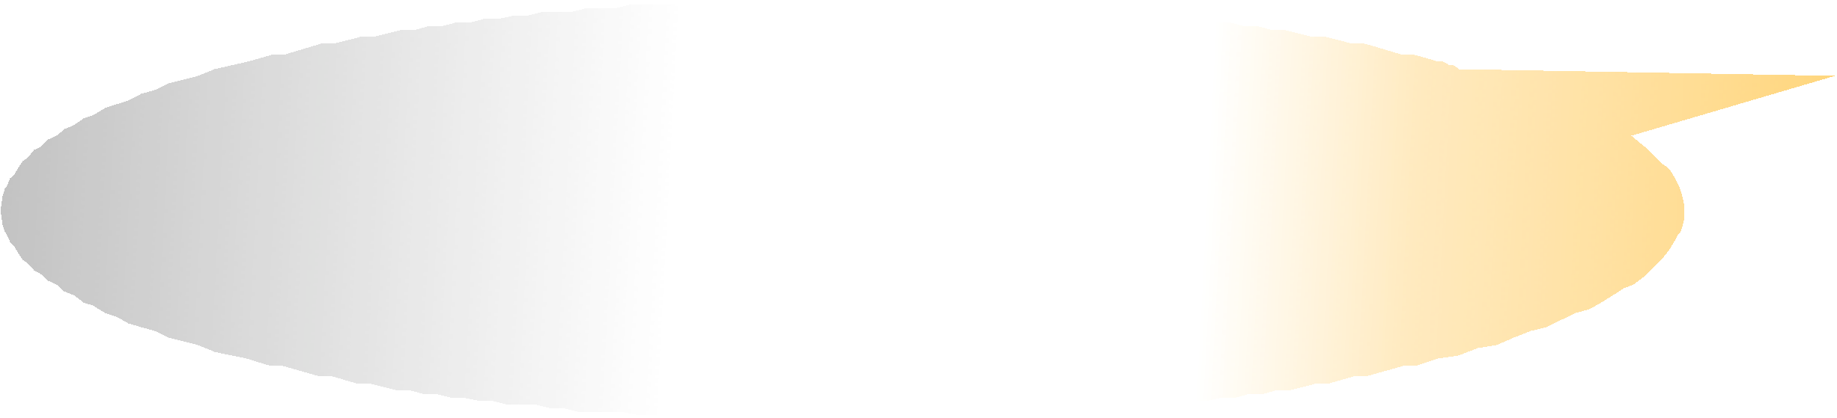

Questions to discuss in your group:
- How well does what actually happened compare with what we would expect?
- Are any of the results (experimental or expected) surprising?

