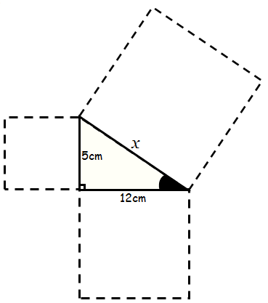
Find the length of $x$
$x$² = ___² + ___²
$x$² = ___+ ___
$x$² = ______
$x$ = ______

Q1.

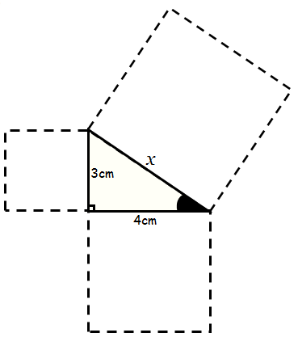
$x$² = ___² + ___²
$x$² = ___+ ___
$x$² = ______
$x$ = ______

Q2.
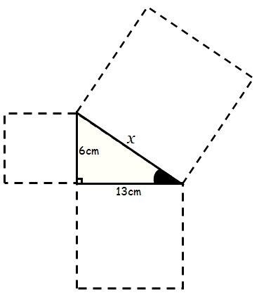
$x$² = ___² + ___²
$x$² = ___+ ___
$x$² = ______
$x$ = ______

Find the length of $x$
Q3.

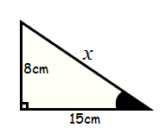
$x$² = ___² + ___²
$x$² = ___+ ___
$x$² = ______
$x$ = ______

Q4.

$x$² = ___² + ___²
$x$² = ___+ ___
$x$² = ______
$x$ = ______

Q5.
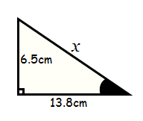

$x$² =
$x$² =
$x$² =
$x$ =

Q6.
