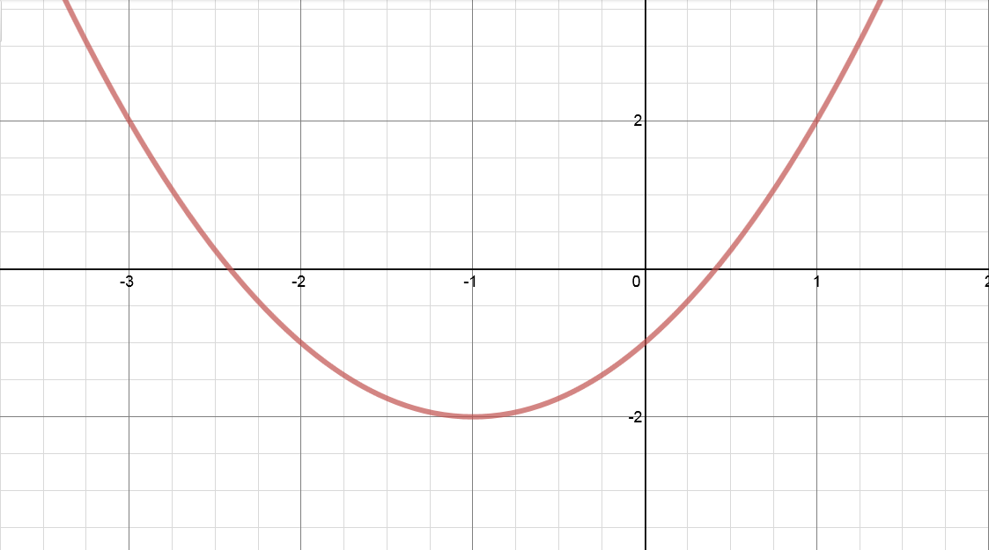
Equation

Why?
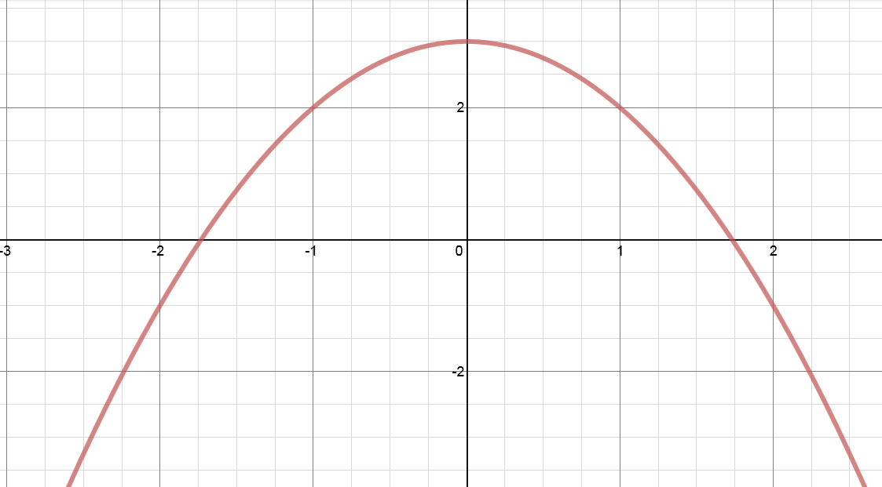
Equation

Why?
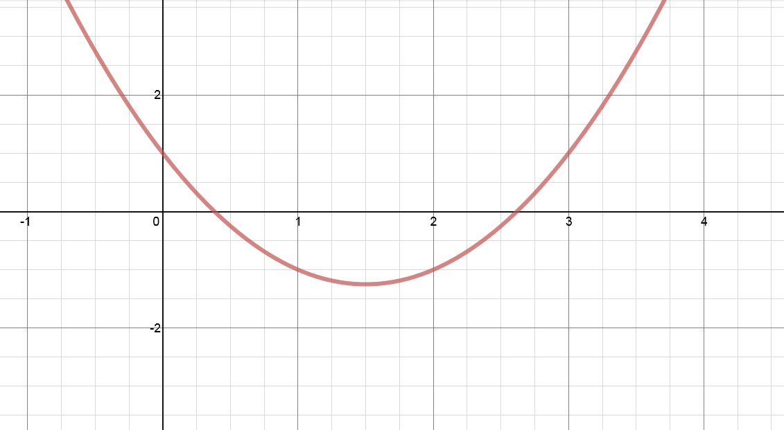
Equation

Why?

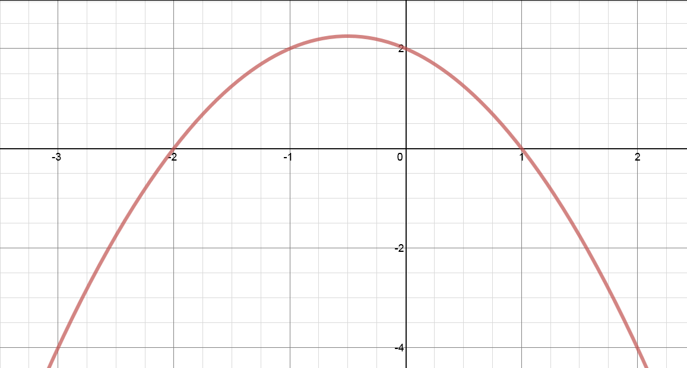
Equation

Why?
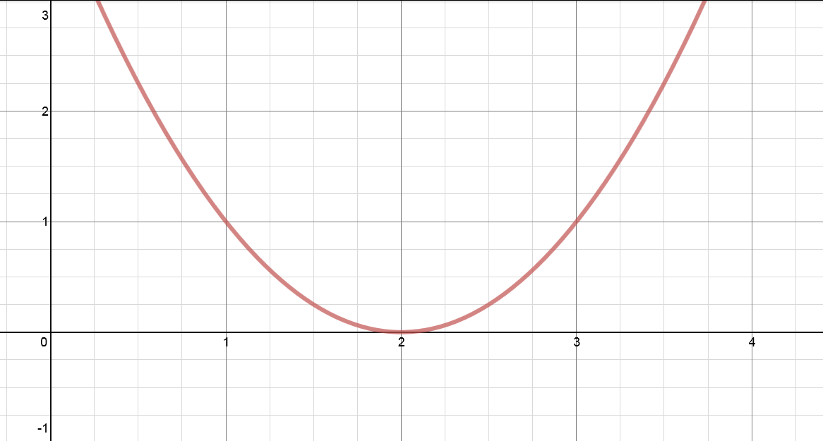
Equation

Why?
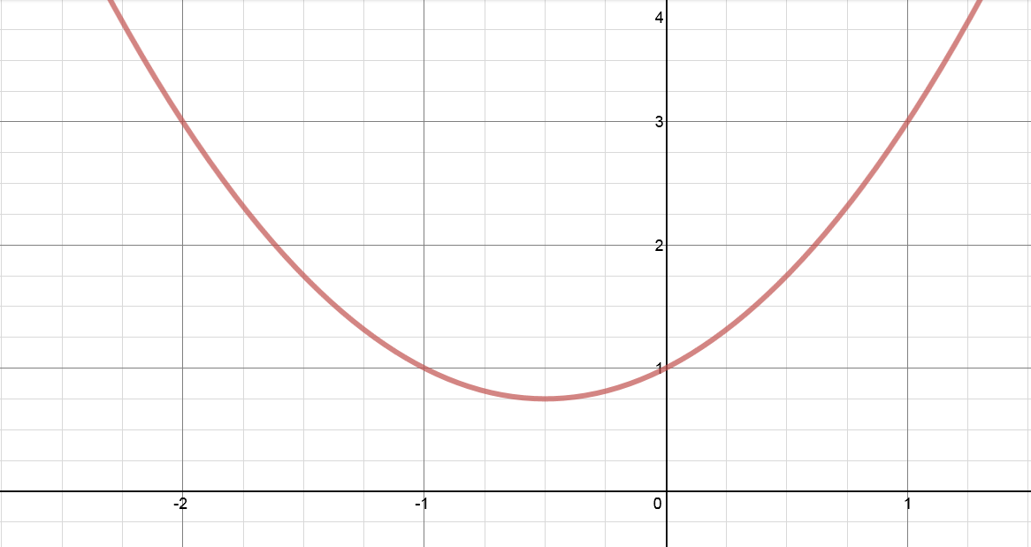
Equation

Why?

y = (x – 2)² | y = x² + x + 1
y = x² – 3x + 1 | y = 2 – x – x²
y = 3 – x² | y = x² + 2x - 1

y = (x – 2)² | y = x² + x + 1
y = x² – 3x + 1 | y = 2 – x – x²
y = 3 – x² | y = x² + 2x - 1

y = (x – 2)² | y = x² + x + 1
y = x² – 3x + 1 | y = 2 – x – x²
y = 3 – x² | y = x² + 2x - 1

