Sample Responses to Discuss
Four students in another class answered The Pentagon Problem using Annabel’s, Carlos’s, Brian’s and Diane’s methods.
Their solutions are shown below. For each piece of work:
- Explain whether the student’s reasoning is correct and complete.
- Correct the solution if necessary.
- Use the method to calculate the measure of angle x.
- Make sure to write down all your reasoning in detail.
- Use the Geometrical Definitions and Properties sheet to help.
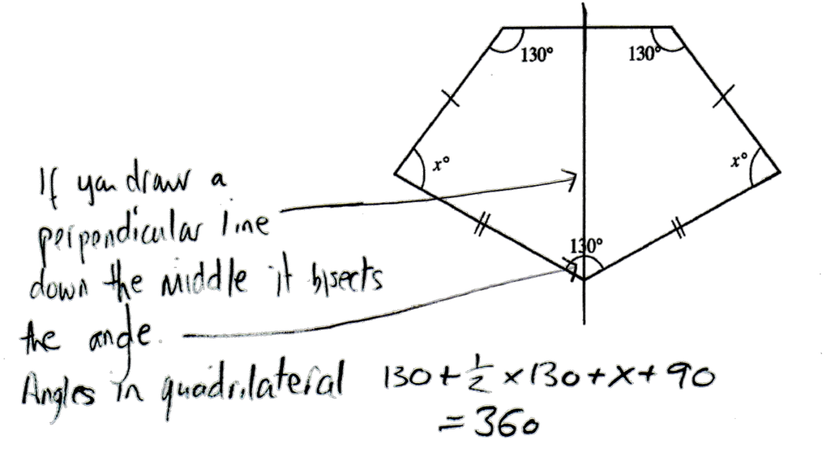
Erasmus

Erasmus used Annabel’s method

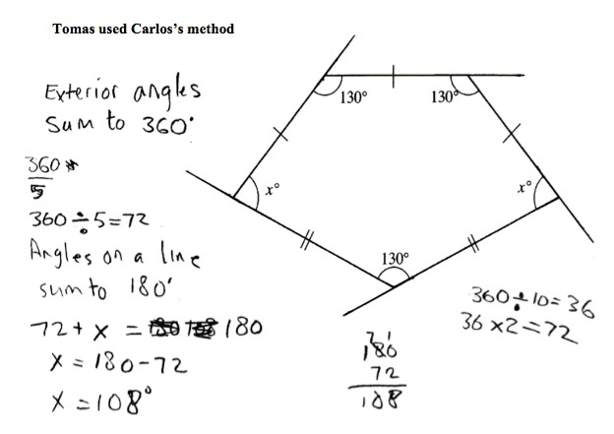
Tomas

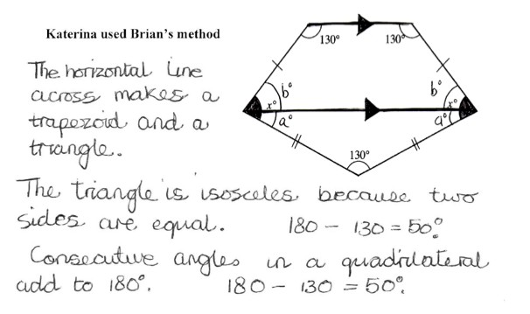
Katerina

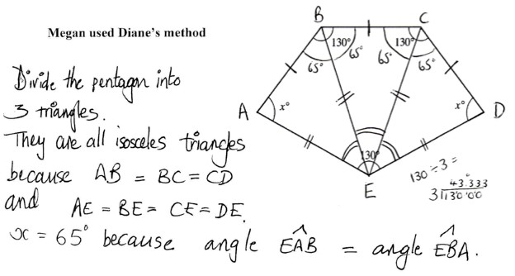
Megan

