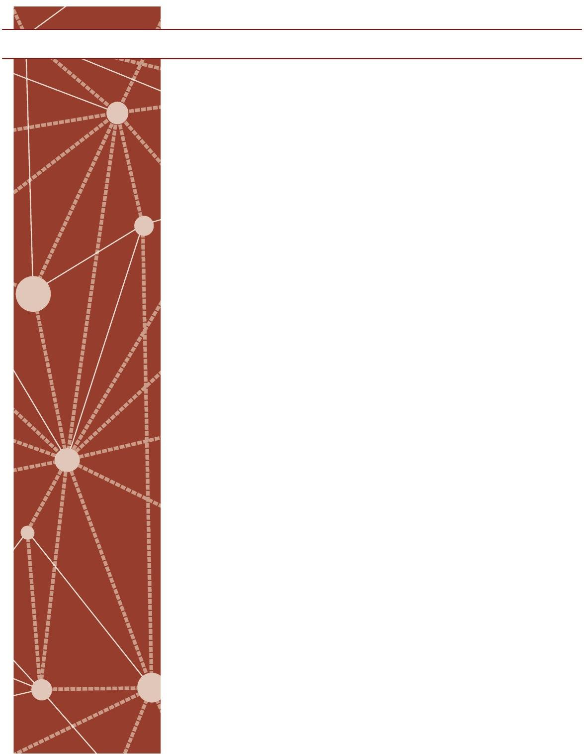
CONCEPT DEVELOPMENT

Mathematics Assessment Project
CLASSROOM CHALLENGES

A Formative Assessment Lesson

Applying Angle Theorems

Mathematics Assessment Resource Service University of Nottingham & UC Berkeley

For more details, visit: http://map.mathshell.org
© 2015 MARS, Shell Center, University of Nottingham
May be reproduced, unmodified, for non-commercial purposes under the Creative Commons license detailed at http://creativecommons.org/licenses/by-nc-nd/3.0/ - all other rights reserved

Applying Angle Theorems

MATHEMATICAL GOALS
This lesson unit is intended to help you assess how well students are able to use geometric properties to solve problems. In particular, it will support you in identifying and helping students who have the following difficulties:
- Solving problems relating to using the measures of the interior angles of polygons.
- Solving problems relating to using the measures of the exterior angles of polygons.

INTRODUCTION
The lesson unit is structured in the following way:
- Before the lesson, students work individually to complete an assessment task designed to reveal their current understanding and difficulties.
- During the lesson, students work in pairs or threes on a collaborative discussion task. They are shown four methods for solving an angle problem and work together to complete the problem using each of the methods in turn. As they do this, they justify their work to each other.
- Working in the same small groups, students analyze sample solutions to the same angle problem produced by students from another class. They identify errors and follow reasoning in the sample solutions.
- There is then a whole-class discussion, in which students explain the reasoning in the sample solutions and compare the methods.
- Finally, students return to their original task and try to improve their own responses.

MATERIALS REQUIRED
- Each student will need two copies of the assessment task Four Pentagons and a copy of the lesson task The Pentagon Problem.
- Each small group of students will need a copy of each of the Sample Responses to Discuss and a copy of the Geometrical Definitions and Properties sheet.

TIME NEEDED
15 minutes before the lesson, a 60-minute lesson, and 10 minutes in a follow-up lesson. All timings are approximate. Exact timings will depend on the needs of the class.

SUGGESTED LESSON OUTLINE
Collaborative problem solving: The Pentagon Problem (20 minutes)
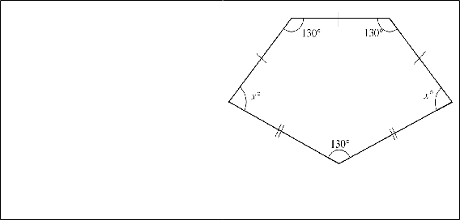
Organize students into small groups of two or three. Give each group a copy of The Pentagon Problem and a copy of the Geometrical Definitions and Properties sheet.
The Pentagon Problem
Mrs. Morgan wrote this problem on the board:

This pentagon has three equal sides at the top and two equal sides at the bottom.

Three of the angles have a measure of 130°.

Figure out the measure of the angles marked x
and explain your reasoning.

Diagram is not accurately drawn.

Four students in Mrs. Morgan’s class came up with different methods for answering this problem.

Use each student’s method to calculate the measure of angle x.
Write all your reasoning in detail.

Use the Geometrical Definitions and Properties sheet to help.
Display Slide P-1 Instructions for The Pentagon Problem (1). Introduce the task and explain what you are asking students to do:
Mrs. Morgan is a teacher in another school. She wrote this problem on the board for her students.
I’m giving you some work written by four of her students. The students all used different methods to solve the problem.
I want you to use each student’s method in turn to solve The Pentagon Problem.
1. Annabel drew a line down the middle of the pentagon.
She calculated the measure of x in one of the quadrilaterals she had made.
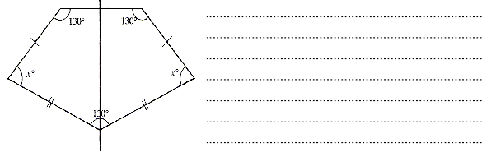
Display Slide P-2 Instructions for The Pentagon Problem (2).
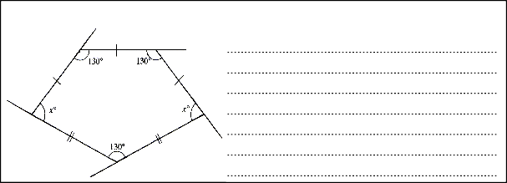
To get started, choose one of the methods and work together to produce a solution. Make sure everyone in your group understands how that method works. Then move on to the next method.
2. Carlos used the exterior angles of the pentagon to figure out the measure of x.
Write all your reasoning in detail and make sure you justify every step.
As students work you have two tasks: to note student difficulties and to support student problem solving.
3. Brian drew a line that divided the pentagon into a trapezoid and a triangle. Angle x has also been cut into two parts so he labeled the parts a and b.

Note student difficulties
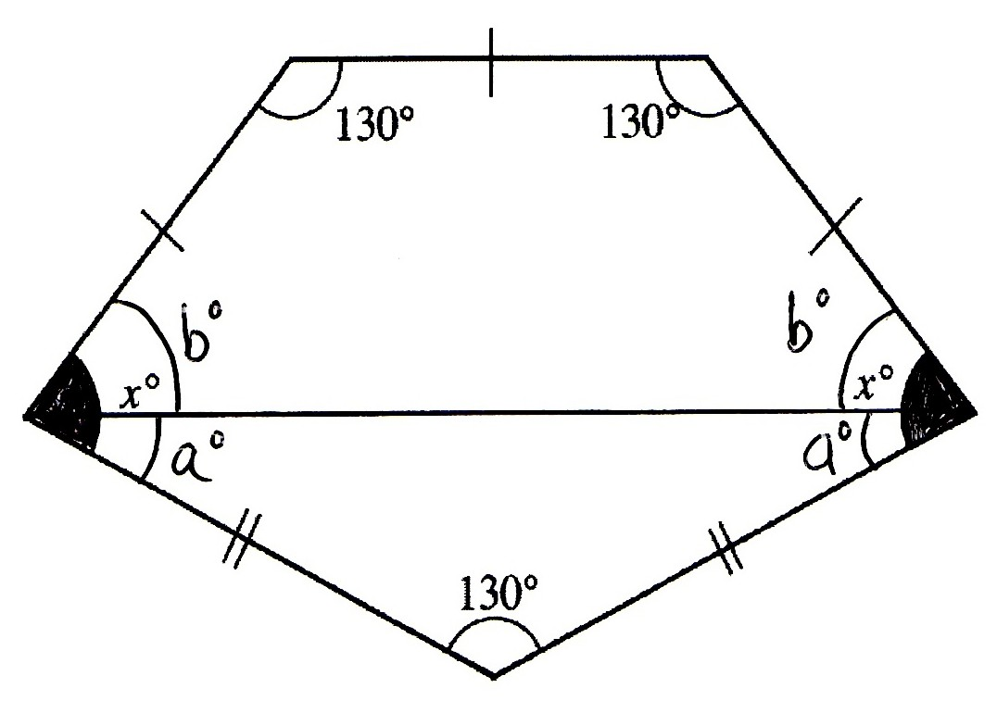
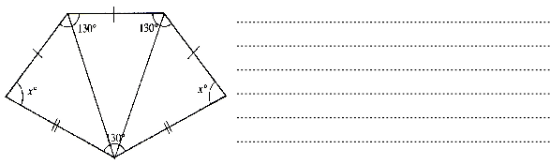
Look for difficulties students have with particular solution methods. Which solution method(s) do they find most difficult to interpret and use? What is it that they find difficult? Notice also the ways they justify and explain to each other. Do they justify assumptions? Do they explain all their calculations with reference to theorems and definitions?
4. Diane divided the pentagon into three triangles to calculate the measure of x.
You can use this information to focus the whole-class discussion at the end of the lesson.

Support student problem solving
Try not to focus on numerical procedures for deriving answers. Instead, ask students to explain their interpretations and use of the different methods. Raise questions about their assumptions and prompt for explanations based in angle theorems to encourage precision in students’ reasoning. Refer them to the Geometrical Definitions and Properties sheet as needed.

Collaborative analysis of Sample Responses to Discuss (25 minutes)
As students complete their solutions, give each group a copy of each of the four Sample Responses to Discuss. You could also display Slide P-3 Instructions for Sample Responses to Discuss.
Four students in another class used Annabel’s, Carlos’s, Brian’s and Diane’s methods to solve the problem like you just did.
Here are copies of the other students’ work. None of this work is perfect! For each student’s solution:
Explain whether the reasoning is correct and complete.
Correct the method when necessary.
Use the method to calculate the measure of the missing angle x, giving detailed reasons for all your answers.
During small group work, note student difficulties and support student problem solving as before. In particular, think about what students are finding most difficult and use this to focus the next activity; a whole-class discussion.

Whole-class discussion: comparing solution methods (15 minutes)
Organize a whole-class discussion comparing the sample solutions methods. Display Slides P-4 to P- 7 showing the Sample Responses to Discuss to help with this discussion.
Using your understanding of your students’ difficulties from the assessment task and their work during the lesson, choose one of the sample responses to discuss. Ask one group to present their analysis of that response. Ask for comments and reactions from other students.
[Celia] What went wrong in Megan’s solution? Why did Brian draw that line?
Can you explain what assumption Katerina made? Was it a correct assumption? [Trevor] Can you explain that in another way?
Then look at another solution method. Finally, compare methods.
Which student’s work provided the most complete reasoning? Which student’s work was most difficult to understand?
The intention is, that students will begin to realize the power of using different methods to solve the same problem and to appreciate the need for, and nature of, adequate reasons for each assertion.

Follow-up lesson: improve individual responses to the assessment task (10 minutes)
Return students’ work on Four Pentagons along with a fresh copy of the assessment task sheet. If you did not write questions on students’ solutions, display them on the board.
Ask students to read through their responses, bearing in mind what they have learned during this lesson.

SOLUTIONS
We give examples of some approaches taken by students in trials. There are other methods that lead to correctly reasoned solutions.

Lesson task: The Pentagon Problem
Each method gives a way of calculating the measure of angle x, 75°. Each method uses different definitions and angle properties in the explanation.

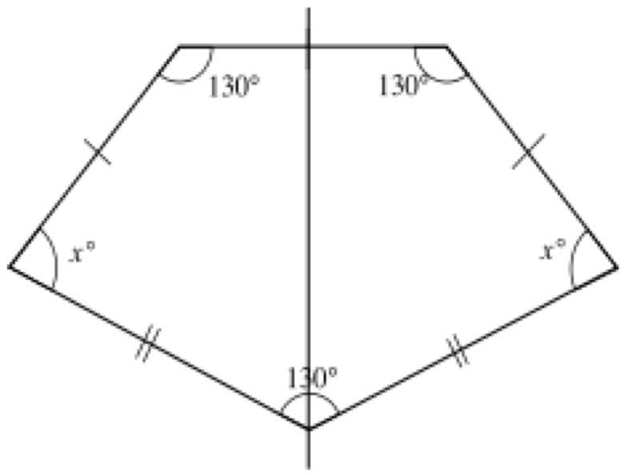
1. Annabel’s method
A
B
c
E
In trials some students did not understand the need to justify the assumption that the line “down the middle of the pentagon” bisects the 130° angle at the base of the pentagon.
F D
The construction line divides AC into segments of
equal length. So AB = BC.
AF = CD is given.
Angle BAF is congruent to angle BCD.
So by SAS, triangles ABF and BCD are congruent. Triangle BFE is congruent to triangle BDE by SSS.
130

So angle FEB = angle BED =
= 65°.

2

To show that the two quadrilaterals ABEF and BCDE are congruent:
The sides are all congruent as BA= BC, AF = CD, FE = DE, and BE is common to both quadrilaterals.
The angle between sides AB and AF is congruent to the angle between sides BC and CD. The angle between sides AF and FE is congruent to the angle between sides CD and DE. So the quadrilaterals are congruent.
The figure is therefore symmetrical. So angle ABE = angle CBE = 90°.
Since the sum of the angles in a quadrilateral is 360°, x = 360° – (90° + 130° + 65°) = 75°.

Carlos’s method
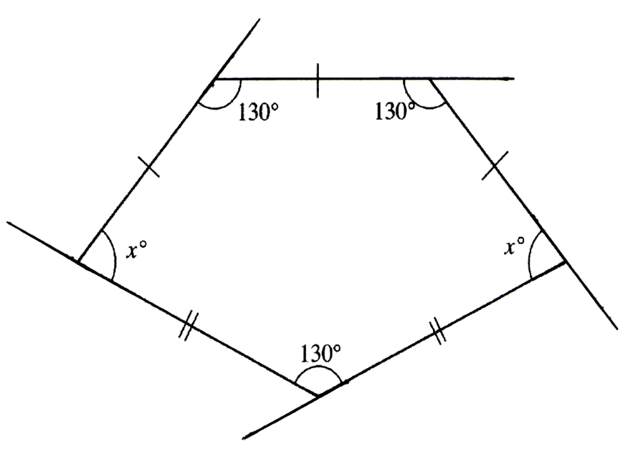
In trials, some students made the false assumption that all the exterior angles are congruent.
The sum of an interior and an exterior angle is 180°.
Three of the angles of the pentagon are known; all three are 130°.
The exterior angle for each of these interior angles is 180° – 130° = 50°.
The sum of the exterior angles of a polygon is 360°.
360° – 3 × 50° = 360° – 150° = 210°.
This is the sum of the two missing exterior angles.
The two missing interior angles are congruent.
x = 180° – 1 × 210° = 180° – 105° = 75°.
2

Brian’s method
The pentagon is divided into a quadrilateral and a triangle.
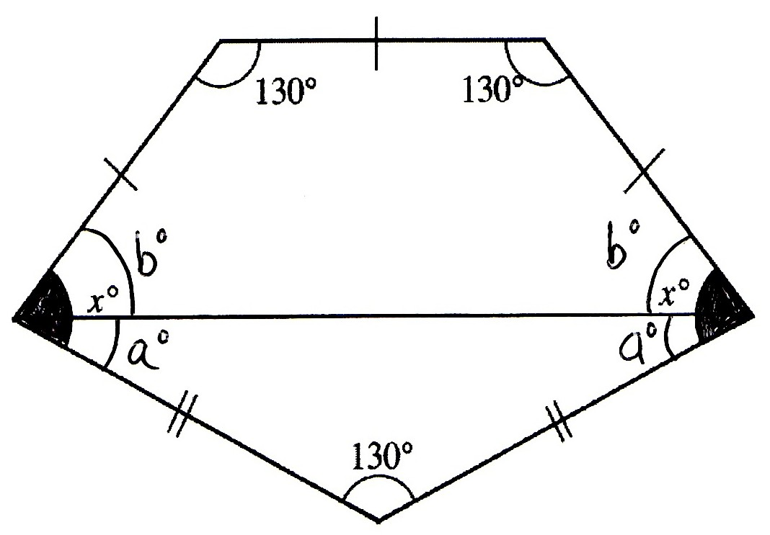
In trials, some students did not understand the need to justify the claim that the quadrilateral is a trapezoid and others did not understand the need to show that both triangle and trapezoid are isosceles.
The triangle is isosceles because it has two congruent sides so the angles marked a are congruent. The angles marked b = x − a are also congruent to each other.
The quadrilateral is an isosceles trapezoid because the two slant sides are congruent and meet the horizontal side at congruent angles.

It follows that the base is parallel to the top and angles marked b are also congruent. The angles in a triangle sum to 180°.
2a = 180° – 130° = 50°.
a = 25°.
The angles in a quadrilateral sum to 360°. 2b = 360° – 2 × 130° = 100°.
b = 50°.
Alternatively, since the top and base of the trapezoid are parallel, the angles b and 130° are supplementary and b = 180° – 130° = 50°.

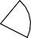
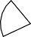
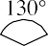
Diane’s method
xo
xo
Some students in trials, perhaps relying on the appearance of the diagram, assumed the three triangles were all isosceles.
Diane shows the pentagon divided into three triangles. The sum of the angles in any triangle is 180°. The sum of the angles in the pentagon is thus 180° × 3 = 540°.
The three known angles are all 130°. The two unknown angles are congruent. 2x = 540° – 3 × 130° = 150°
x = 75°.
The outer triangles are not isosceles.

Analysis of Sample Responses to Discuss

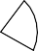
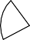
Erasmus used Annabel’s method
xo
xo
Erasmus does not justify the claim that the perpendicular bisector of the horizontal side divides the 130° into two equal parts. He could do this by showing that the pentagon is symmetrical so that the bisector of the vertical side passes through the opposite vertex.
He also needs to explain that the perpendicular bisector then divides the pentagon into two congruent quadrilaterals. Then he can apply the property that the sum of the angles in a quadrilateral sum to 360°.
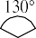

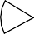

His calculation method is correct but he did not finish his working out. Erasmus’s use of Annabel’s method gives the correct measure of x = 75°. Tomas used Carlos’s method
xo
xo
Tomas makes a false assumption that all the exterior
angles are congruent.
He did not notice that the pentagon is not regular. The exterior angles are all congruent only when the polygon is regular.
Tomas should calculate the size of the exterior angles for each of the known 130° interior angles first.
The angles on a line sum to 180°, so there are three exterior angles of 50°.
360° – 3 × 50° = 360° − 150° = 210°.
So, the two missing exterior angles are congruent and sum to 210°. Each is 210° ÷ 2 = 105°. Then, since the angles on a line sum to 180°, x + 105° = 180°. So x = 75°.

Katerina used Brian’s method
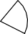
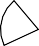
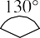
Katerina is correct that a trapezoid and triangle are formed by the horizontal line, but she does not fully explain her reasoning. It is not clear that the quadrilateral is a trapezoid, or that the trapezoid is isosceles.
XO
XO
b°
a°
b°
a°
She needs to show the base of the quadrilateral is parallel to the top to show that the quadrilateral is a trapezoid.
The horizontal side has at each end the same angle. The slant sides are the same length so the line joining the ends of those slant sides is parallel to the top (trapezoid).
The trapezoid is isosceles because the slant sides are equal in length and joined to the top by congruent angles (symmetry) so both base angles can be labeled b.
She is correct that the triangle is isosceles because it has two congruent sides, so the two unknown angles in the triangle are congruent and can both be labeled a.
Katerina made a numerical error in stating a = 50°. The angles in a triangle sum to 180°.
2a = 180° – 130° = 50°
She had forgotten to divide by two. Katerina’s next piece of reasoning is faulty.
It is not true that the consecutive angles in every quadrilateral sum to 180°. For example, it is not true that any two consecutive angles in a trapezoid always sum to 180°.
In a trapezoid, the angles formed by a transversal crossing the parallel sides forms a pair of supplementary angles.
Supplementary angles sum to 180°. So b = 180° – 130° = 50°
Katerina also needs to finish her solution by finding
x = a + b = 25° + 50° = 75°.

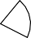

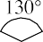
Megan used Diane’s method
65°
65
65°
65°
x0
x0
Diane divided the pentagon into three triangles to calculate the measure of x. There is not enough detail to specify a method.
Megan uses faulty reasoning with Diane’s trisection. She makes a false assumption that the triangles are all isosceles.
Megan would need to give reasons to support the assertion
that the triangles are isosceles and there are none beyond surface appearance, since they are not!

Diane’s trisection method can lead to a correct solution. The sum of the angles in a triangle is 180°. So the total angle sum of the pentagon is 3 × 180° = 540°.
This could be provided using the formula for the sum of the angles in a polygon with n sides, 180° (n − 2).
The interior angles sum is 540° and there are three known angles of 130°.
In Q4, it is not expected that students will show that Megan’s assumption is false. However, we supply a solution in case you want to work on this with students.
So 2x = 540° – 3 × 130° and x = 75°.
Assuming that the triangles are isosceles leads to a contradiction, showing that the assumption is false. (Proof by contradiction.)
Megan assumes the three triangles formed are all isosceles triangles with two congruent base angles of 65°. Suppose she is correct.
Each has base line of equal length, the base angles of equal measure, two sides of equal length, the apex angles must also be congruent to each other and the triangles are thus congruent.
Each apex angle would be 130° ÷ 3 = 43 1 °.
3
Since the triangles are isosceles and the angles in a triangle sum to 180°, the two base angles are (180° − 43 1 ) ÷ 2 = 68 1 °.
3 3

x cannot be both 68 1 ° and 65°. The assumption leads to a contradiction and must be false.
3

Mathematics Assessment Project
Classroom Challenges

These materials were designed and developed by the
Shell Center Team at the Center for Research in Mathematical Education University of Nottingham, England:
Malcolm Swan,
Nichola Clarke, Clare Dawson, Sheila Evans, Colin Foster, and Marie Joubert
with
Hugh Burkhardt, Rita Crust, Andy Noyes, and Daniel Pead

We are grateful to the many teachers and students, in the UK and the US,
who took part in the classroom trials that played a critical role in developing these materials
The classroom observation teams in the US were led by
David Foster, Mary Bouck, and Diane Schaefer

This project was conceived and directed for
The Mathematics Assessment Resource Service (MARS) by
Alan Schoenfeld at the University of California, Berkeley, and
Hugh Burkhardt, Daniel Pead, and Malcolm Swan at the University of Nottingham

Thanks also to Mat Crosier, Anne Floyde, Michael Galan, Judith Mills, Nick Orchard, and Alvaro Villanueva who contributed to the design and production of these materials

This development would not have been possible without the support of
Bill & Melinda Gates Foundation
We are particularly grateful to
Carina Wong, Melissa Chabran, and Jamie McKee

The full collection of Mathematics Assessment Project materials is available from
http://map.mathshell.org

© 2015 MARS, Shell Center, University of Nottingham
This material may be reproduced and distributed, without modification, for non-commercial purposes, under the Creative Commons License detailed at http://creativecommons.org/licenses/by-nc-nd/3.0/ All other rights reserved.
Please contact map.info@mathshell.org if this license does not meet your needs.

