Geometrical Definitions and Properties

Isosceles Triangle  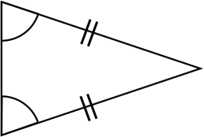  An isosceles triangle has at least two congruent angles and at least two congruent sides. | Trapezium  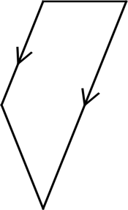  A trapezium is a quadrilateral with at least one pair of parallel sides.  (In some countries this is called a trapezoid) | Regular Polygon  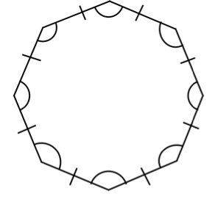  All interior angles of a regular polygon are congruent. Sides are all congruent.
Isosceles Trapezium  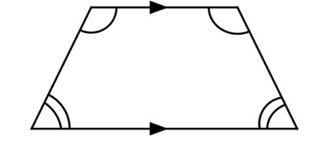  An isosceles trapezium has two pairs of congruent angles. The slant sides are congruent. | Angles on a Straight Line  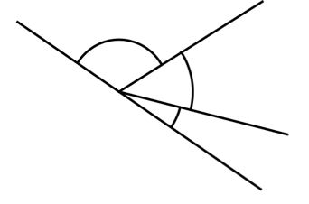  Angles forming a straight line sum to 180°. | Corresponding Angles  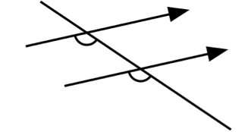  Corresponding angles formed by a transversal crossing a pair of parallel lines are congruent.
(Co-)Interior Angles  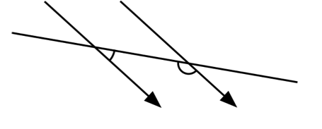  (Co-)Interior angles formed by parallel lines crossed by a transversal sum to 180°. | Vertically Opposite Angles  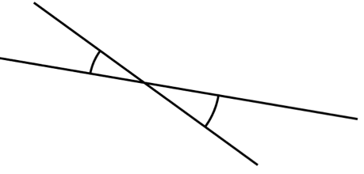  Vertically opposite angles are congruent. | Angles Around a Point  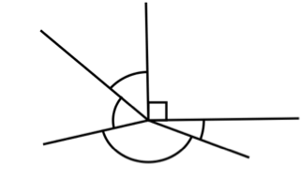  Angles around a point sum to 360°.
Alternate Angles  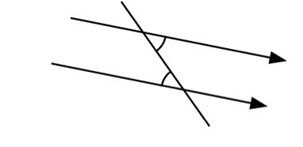  Alternateangles formed when parallel lines crossed by a transversal are congruent. | Exterior Angles of a Polygon  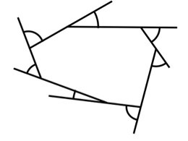  The sum of the exterior angles of a polygon is 360°. | Interior Angles of a Polygon  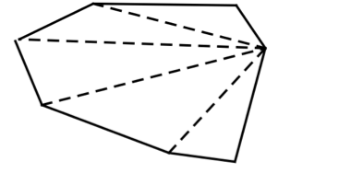  The sum of the interior angles of an  n sided polygon is 180 (n-2)°.

