BEFORE THE LESSON
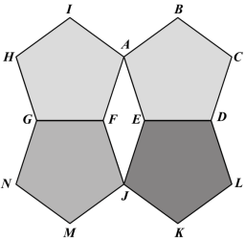
Assessment task: Four Pentagons (15 minutes) Have the students do this task in class or for homework a day or more before the formative assessment lesson. This will give you an
Four Pentagons
This diagram is made up of four regular pentagons that are all the same size.

- Find the measure of angle AEJ.
Show your calculations and explain your reasons.

- Find the measure of angle EJF.
Explain your reasons and show how you figured it out.

- Find the measure of angle KJM. Explain how you figured it out.
opportunity to assess the work and to find out the kinds of difficulties students have with it. You should then be able to target your help more effectively in the subsequent lesson.
Give out the assessment task Four Pentagons. Introduce the task briefly and help students to understand the problem and its context.

Ask students to attempt the task on their own, without discussion.
Don't worry if you cannot understand everything, because there will be a lesson on this material [tomorrow] that will help.
By the end of the next lesson, you should expect
to be more confident when answering questions like these.
It is important that, as far as possible, students are allowed to answer the questions without assistance.
Students who sit together often produce similar answers and then when they come to compare their work, they have little to discuss. For this reason, we suggest that when students do the task individually, you ask them to move to different seats. Then at the beginning of the formative assessment lesson, allow them to return to their usual seats. Experience has shown that this produces more profitable discussions.

Assessing students’ responses
Collect students’ responses to the task and read through their papers. Make some notes on what their work reveals about their current levels of understanding and their different problem solving approaches. The purpose of this is to forewarn you of issues that will arise during the lesson itself, so that you may prepare carefully.
We suggest that you do not score students’ work. The research shows that this will be counterproductive, as it will encourage students to compare scores and distract their attention from what they can do to improve their mathematics. Instead, help students to make further progress by summarizing their difficulties as a series of questions. Some suggestions for these are given in the Common issues table on the next page. These have been drawn from common difficulties observed in trials of this lesson unit.
We suggest you make a list of your own questions, based on your students’ work. We recommend you either:
- write one or two questions on each student’s work, or
- give each student a printed version of your list of questions and highlight the appropriate questions for individual students.

If you do not have time to do this, you could select a few questions that will be of help to the majority of students and write these on the board when you return the work to the students in the follow-up lesson.

Common issues: Suggested questions and prompts:

Has difficulty getting started  The student writes little in response to any of the questions. | - Write what you know about this diagram.  - How might that information be useful?  - What else can you calculate?
Makes arithmetic errors  For example: The student writes, “Angle EJF = 180° − 144° = 46°.” | - How can you be sure your solution is correct?
Uses an incorrect formula  For example: The student does not identify the correct formula to use to find the interior angle of a pentagon (Q1). | - Find the correct formula for the interior angle of a regular pentagon.  - What does n stand for in this formula?
Produces a partially correct solution  For example: The student does not follow through the method s/he has written down.  Or: The student calculates 540° but does not find interior angle.  Or: The student calculates 108° or 216° but does not find angle AEJ. | - You have given an answer of [216°]. Which angle is this on the diagram?  - What do you need to do to complete your solution?
Uses unjustified assumptions  For example: The student argues that supplementary angles sum to 180°, without first establishing that the figure is a rhombus. | - The angles in a parallelogram are supplementary, but how do you know that this is a parallelogram?
Provides poor reasoning  For example: The student calculates using a theorem but does not state what the theorem is. | - How do you know that this is the correct calculation to perform?  - Would someone reading your solution understand why your solution is correct?
Produces a full solution  The student provides a full and well-reasoned solution and has justified all assumptions. | - Can you find another way of solving each part of the Four Pentagons problem?

Assessment task solutions: Four Pentagons

- The measure of angle AEJ is 144°.
Explanation 1:
The sum of the measures of the interior angles of an n-gon is 180°(n − 2). For a pentagon this is 180° × 3 = 540°.
The pentagons are regular so all their interior angles are congruent. Each interior angle of a regular pentagon is 540° ÷ 5 = 108°.
The sum of the angles forming a straight line is 180°.
Each exterior angle of a regular pentagon is 180° − 108° = 72°.
Angle AEJ is twice the exterior angle of the pentagon = 2 × 72° = 144°.
Explanation 2:
Angle AEF is an exterior angle of a regular pentagon, as is angle FEJ. The sum of the exterior angles of a polygon is 360°.
There are five congruent exterior angles in a regular pentagon, each of measure 360° ÷ 5 = 72°. So AEJ = AEF + FEJ = 72° + 72° = 144°.

- The measure of angle EJF is 36°.
Explanation 1:
Since consecutive angles of a parallelogram are supplementary, angle EJF = 180° − 144° = 36°.
Explanation 2:
The sum of the interior angles of the quadrilateral AFJE is 360°.
Since the four pentagons are regular and congruent, sides AF, AE, EJ, JF are equal in length. So AEJF is a rhombus.
Opposite angles in a rhombus are congruent. From part 1, angle AEJ = 144° = AFJ.
The sum of the angles in a quadrilateral is 360°. 360° − 2 × 144° = 72°.
FJE = FAE = 1 × 72° = 36°.
2

- The measure of angle KJM is 108°.
Explanation:
The sum of the measures of the four angles around the point J is 360°.
The measure of each of the interior angles in a regular pentagon is 108° and angle EJF is 36° from Question 2.
Angle KJM = 360° − (36° + 2 × 108°) = 108°.

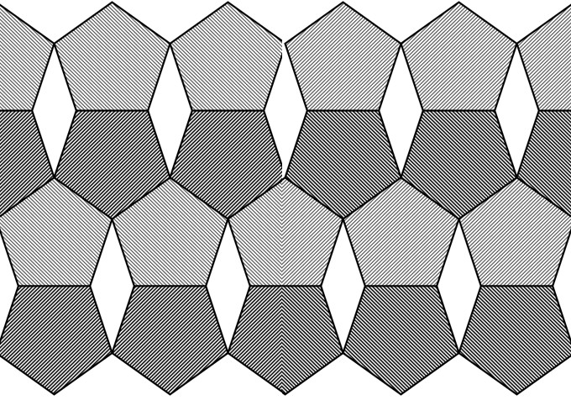
From this diagram, we can see that regular pentagons and rhombuses together form a semi-regular tessellation that can be used, for example, as a floor or wall tiling:

