Annabel drew a line down the middle of the pentagon.
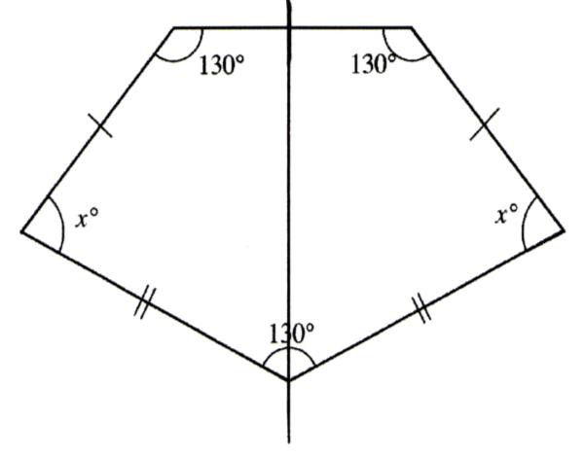
She calculated the measure of x in one of the quadrilaterals she had made.

  - Carlos used the exterior angles of the pentagon to figure out the measure of x.
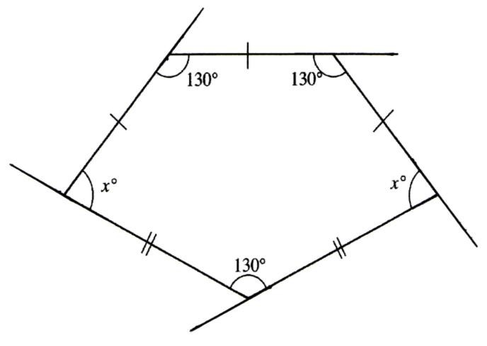

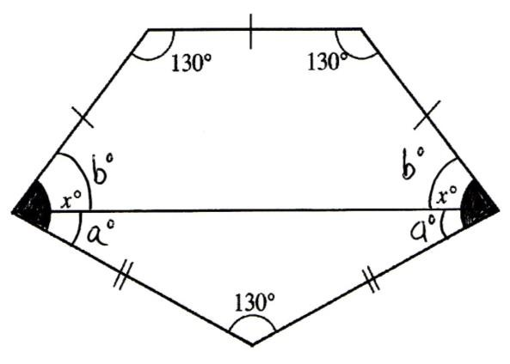
  - Brian drew a line that divided the pentagon into a trapezoid and a triangle. Angle x has also been cut into two parts so he labeled the parts a and b.

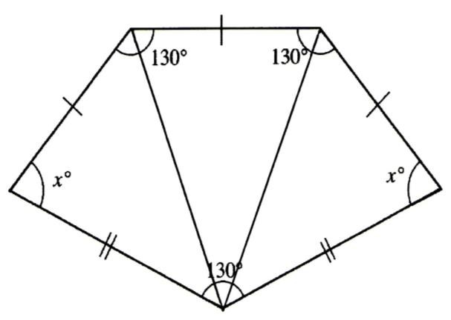
  - Diane divided the pentagon into three triangles to calculate the measure of x.

