Using Des-face
Click on link on Bluecoatmaths.
You will need to register before your lesson, or you can sign in using Google if you have a Google account. Kids don’t need an account.
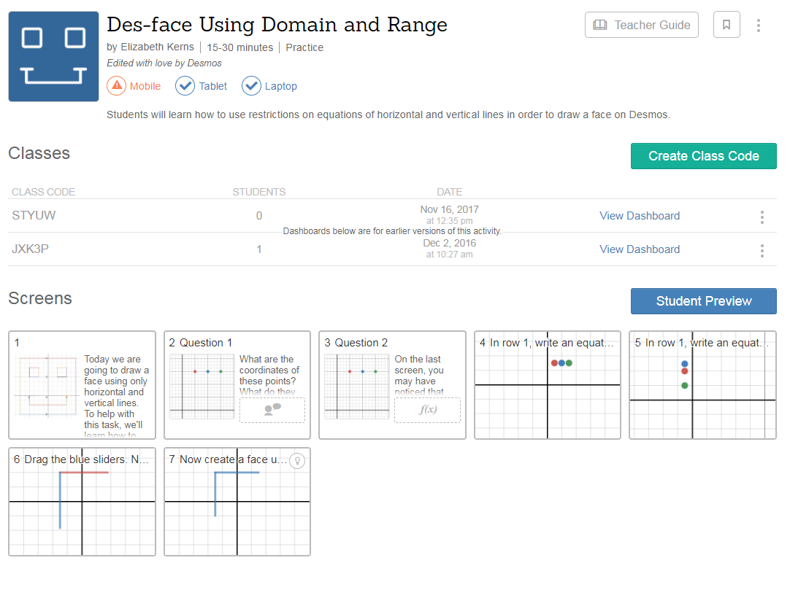
Click the Green Create Class Code Button
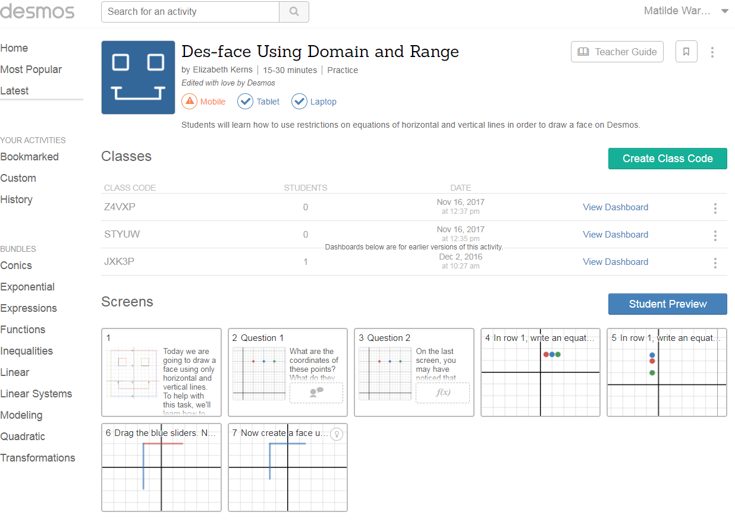
Click the class code you have just created (all your old class codes will be there – the most recent one is at the top.
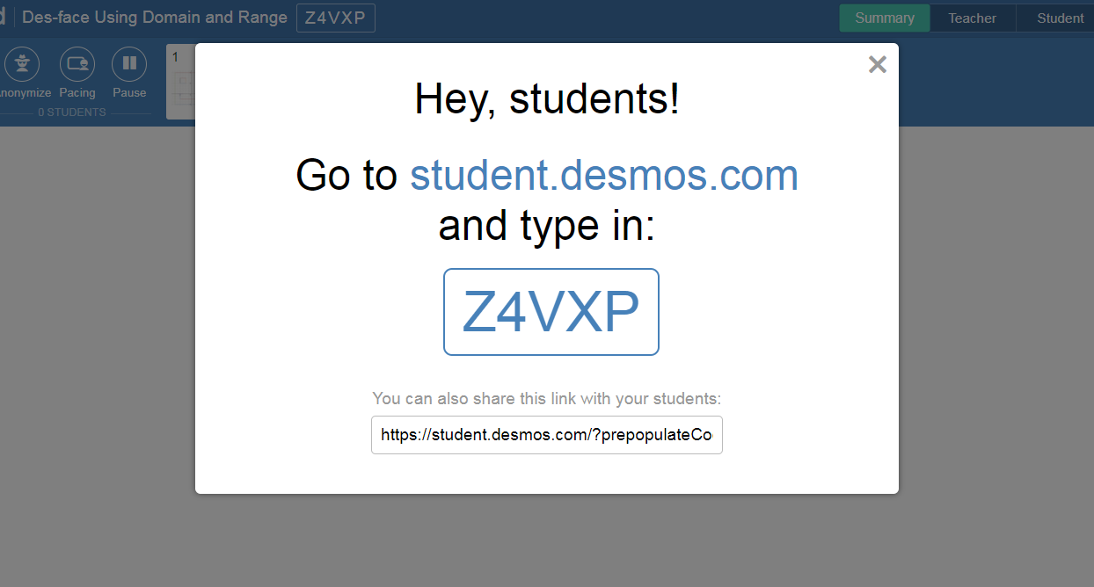
Tell the kids to do this. Make sure they use capitals.

Kids will see this
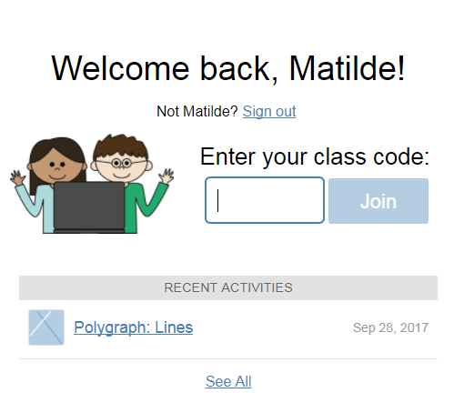
They can write their names on the next screen
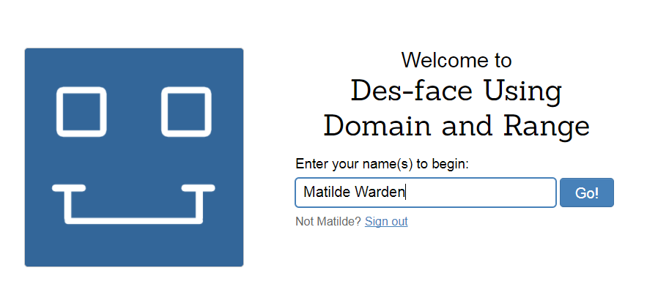

Instructions are clearly given on the screen
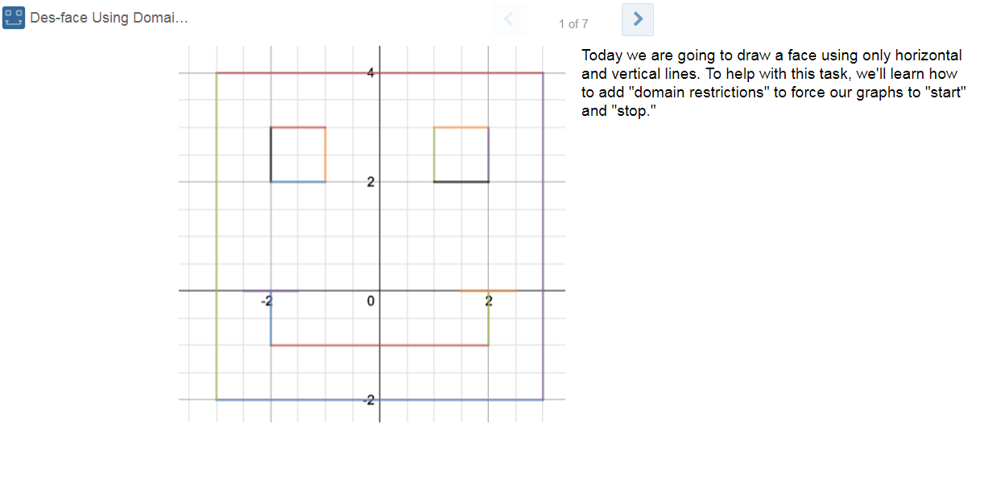
Clear the message on your screen and you will see your dashboard that shows you where all the students are up to.
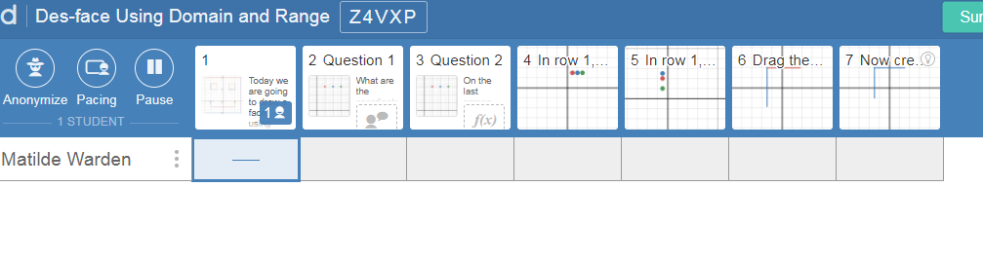The kids can see what others are writing
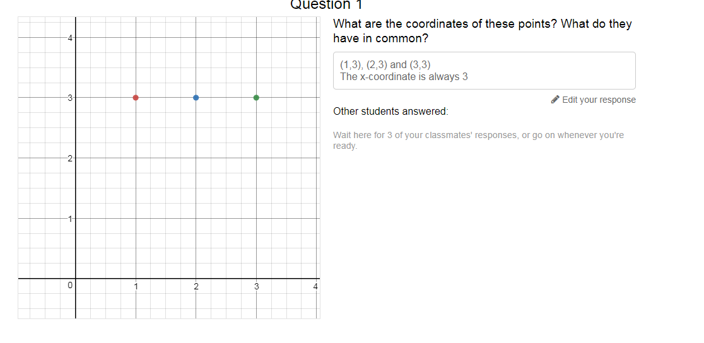

And so can you if you click on the lesson
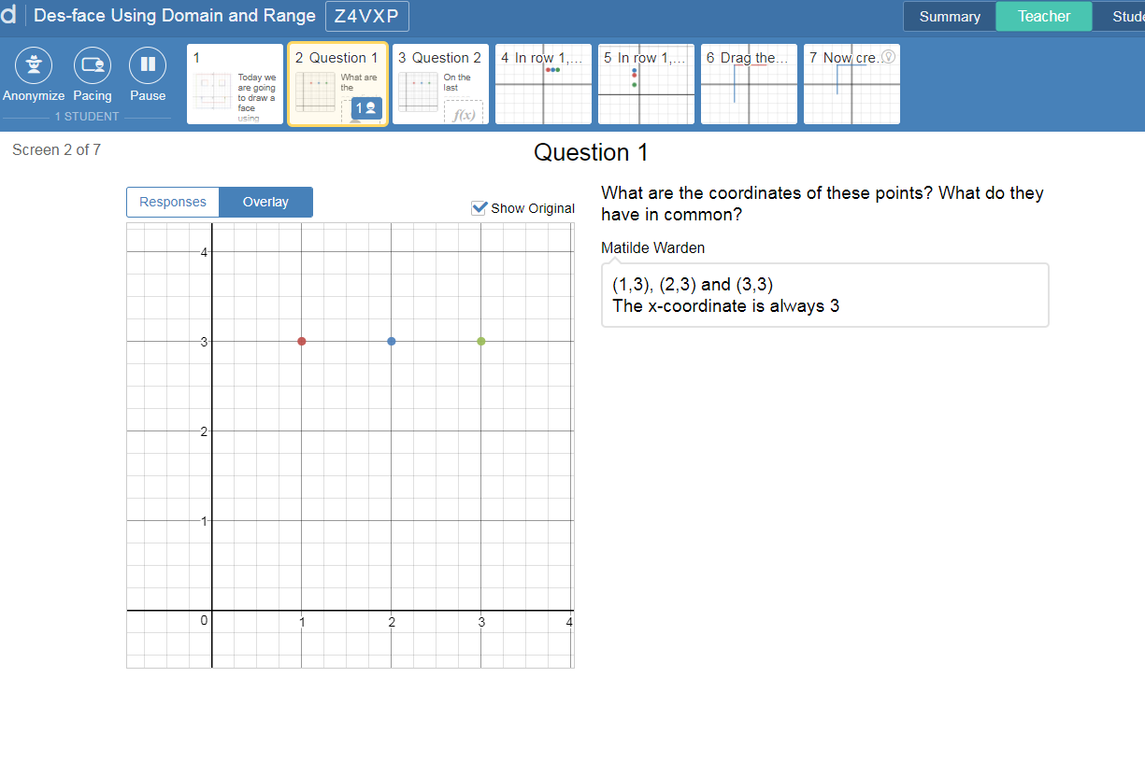
You can randomly choose student responses for the class to discuss and improve.

