Defining Lines by Points, Slopes and Equations

MATHEMATICAL GOALS
This lesson unit is intended to help you assess how well students are able to:
- Find the slopes and equations of linear graphs defined by pairs of coordinates.
- Calculate the slope and y-intercept of a straight line.
- Use the slope and y-intercept of a straight line to derive its equation. Students may use the properties of similar triangles to achieve these goals.

INTRODUCTION
- Before the lesson, students work individually on an assessment task designed to reveal their current understanding. You then review their responses and create questions for students to consider when improving their work.
- After a whole-class introduction, students work in small groups on a collaborative discussion task, matching cards that describe the same line. Throughout their work, students justify and explain their thinking and reasoning.
- Students review their work by comparing their matches with those of their peers.
- In a whole-class discussion, students discuss what they have learned.
- In a follow-up lesson, students revisit their initial work on the assessment task and work alone on a similar task to the introductory task.

MATERIALS REQUIRED
- Each student will need a mini-whiteboard, pen, and wipe, and a copy of the assessment tasks
Lines, Slopes and Equations and Lines, Slopes and Equations (revisited).
- Each small group of students will need a cut-up copy of the Card Set: Lines, a pencil, a marker, a large sheet of poster paper and a glue stick.

TIME NEEDED
15 minutes before the lesson, an 90-minute lesson (or split into two shorter ones), and 15 minutes in a follow-up lesson (or for homework). These timings are not exact. Exact timings will depend on the needs of your students.

SUGGESTED LESSON OUTLINE
Whole-class introduction (20 minutes)
The aim of the introduction is for students to recognise that they cannot rely on appearances to determine whether or not points lie on a straight line. Instead they must use a mathematical strategy.

Give each student a mini-whiteboard, pen, and wipe. Display Slide1 of the Powerpoint
Are the lines the same?
Do these two cards describe the same straight line? How can you tell?
Line A passes through
(0, 2) and (6, 10)
Line B passes through
(6, 10) and (10, 16)
Students may suggest plotting points to check, but this is not enough as looks can be deceptive. Display Slide 2, which shows a diagram drawn to scale:
Let’s plot them!
If we plot the points they look like they might be the same straight line .
y
(10, 16)
But looks can be deceptive.
(6, 10)
How can we be sure?
(0, 2)
x
The points certainly look as though they are on a straight line, but are they exactly on a straight line?
How can we tell whether they lie on a straight line without drawing? Spend a few minutes discussing your ideas.
Think about what calculations you could do.
Use your mini-whiteboard for any calculations you think might help.
Some students may suggest looking at whether or not the two line segments have the same slope, or whether they have the same equation.
Note that the resource uses the word ‘slope’. You may want to explain that another word is gradient.
Slide 3 shows some possible construction lines:
Let’s plot them!
Here are some construction lines that might help you decide.
y
(10, 16)
(6, 10)
(0, 2)
x
Can these two right-angled triangles help you decide?
What are the lengths of the sides of the triangles? [Lower: 6 horizontally and 8 vertically. Upper: 4 horizontally and 6 vertically.]
How could you use this information to see if the points lie on a straight line?
[Optional interlude] Some students view an enlargement as an additive transformation rather than a multiplicative one and so may assume the points lie on a straight line because the measures of the sides of the lower triangle are two units more than the corresponding measures of the sides of the upper triangle (4 + 2 = 6; 6 + 2 = 8). If this issue arises, one approach is to consider the two constructed triangles as members of a sequence of right-angled triangles whose sides all differ by constant amounts, as shown on Slide 4:
Are these triangles similar?

Are the angles marked “a” all equal?
7
8
5
6
4
a
a
a
a
a
2 3 4 5 6
The two triangles in question are shaded. You may like to ask students to consider adding additional triangles to this sequence:
If I add a new triangle to the left of the sequence, what will it look like? (… and another?) What will the 100th triangle in the sequence look like?
Will the angles marked “a” all be equal? Why/Why not?

Continue the discussion of slide P-3 by directing students’ attention to the slope of the lines (from previous lesson)
What is the slope of the hypotenuse of the lower triangle? [(10 - 2) ÷ (6 - 0) = 8 ÷ 6 = 1⅓] What is the slope of the hypotenuse of the upper triangle? [(16 - 10) ÷ (10 - 6) = 6 ÷ 4 = 1½] These are close but are not equal.
If we drew a straight line from (0, 2) to (10, 16) what would its gradient be? [14 ÷ 10 = 1⅖] This lies between the other two slopes.
What does this tell us about lines A and B? [They are not the same straight line. If the points were all in a straight line these slopes would all be equal.]
You may like to probe further to seek equations.
What is the equation of the hypotenuse in the lower triangle? [y = 4x/3 + 2] What about the hypotenuse of the upper triangle? [y = 3x/2 + something]
Will the hypotenuse of the upper triangle go through the origin? How can we find out?

Summarise the purpose of the introduction and introduce the collaborative activity:
In today’s lesson you will not be able to rely on appearances. You will be given a collection of cards and your task will be to find pairs of cards that describe the same line.

Collaborative small group work (30 minutes)
Ask students to work in groups of two or three. Give each group a cut-up copy of Card Set: Lines, a glue stick, a pencil, a marker and a large sheet of poster paper.
Display Slide 5 and explain how students are to work together:
Working Together

- Look for pairs of cards that describe the same line.

- Some of the cards have information missing. You will need to work out the missing information once you have matched the card.

- Before writing anything down, describe your reasoning to your partner. Your partner must challenge your explanation if they disagree, or describe it in their own words if they agree.
- Once agreed, glue the pair of cards onto the poster and write your reasoning in pencil next to it.

Work together until all the cards are placed.
The purpose of this structured work is to encourage students to engage with their partner’s explanations and take responsibility for each other’s understanding. Students should use their mini- whiteboards for calculations and to explain their thinking to each other. While students are working, you have two tasks: to notice their approaches to the task and to support student reasoning.

Notice different student approaches to the task
Listen to and watch students carefully. Notice how students make a start on the task, where they get stuck, and how they overcome any difficulties.
Do students begin by first sketching a diagram? Do they attempt to calculate slopes and equations? Do they assume that because slopes are equal then the lines are the same? Are students checking their work? If so, what method are they using?
Note also any common mistakes. For example, do students use the orientation of the triangle correctly when calculating the slope? Do they make any incorrect assumptions? You may want to use the questions in the Common issues table to help address any misconceptions that arise.

Support student problem solving
Help students to work constructively together, referring them to Slide P-5. Check that one student listens to another by asking the listener to repeat the speaker’s reasoning in different words. Check that students are recording their discussions as rough notes on their mini-whiteboards.
Try not to do the reasoning for them. Instead, ask strategic questions to suggest ways of moving forward.
What do you know? What additional information can you add?
In what ways does this help you to determine whether or not the two lines are the same?
What do you need to find out?
What math do you know that connects to that?
What’s the same about these two triangles? What is different?

In what ways is this line similar to one that you have already matched? How does this help?
Is it possible to match the cards without working out the equation first?
Support students in developing written explanations. Suggest that they draft explanations on their mini-whiteboards and then refine these explanations for their poster.
If students are struggling, suggest that they start with the lines where the y intercept is already known (Lines A, D, E and F).
If students succeed with the task, ask them to deduce the shape created by the six lines from the cards (without plotting accurately). Where do the lines intersect? Which are parallel? [The six lines describe a parallelogram with its two diagonals.]

Extending the lesson over two days
If you are taking two days to complete the unit then you may want to end the first lesson here. At the start of the second day, briefly remind students of their previous work before moving on to students sharing their work.

Sharing work (10 minutes)
As students finish their posters, ask them to critique each other’s work by asking each pair to turn and discuss with another pair.

Poster review (10 minutes)
After students have had a chance to share their work and discuss their matches and reasoning with their peers, give them a few minutes to review their posters.
Now that you have discussed your work with someone else, you need to consider as a pair whether to make any changes to your own work.
When you are confident with your decisions, go over your work in pen (or make amends in pen if you have changed your mind).

Whole-class discussion (15 minutes)
Organise a whole-class discussion about what has been learned and explore the different methods used when matching the lines.
For two lines to be the same, what did you need to show?
[That they have the same slope and a point in common; or that they have the same equation.]
You may want to first select a pair of lines that most groups matched correctly as this may encourage good explanations.
Can you explain your method to us clearly? Can anyone improve this explanation?
Does anyone have a different explanation? Which explanation do you prefer? Why?
To help students explain their work, there are slides in the Powerpoint showing the correct matched pairs from the lesson task. Try to include a discussion of lines that have both positive and negative gradients. After one group has justified their choice for a particular match, ask other students to contribute ideas of alternative approaches and their views on which reasoning was easier to follow. You might like to ask if and how students have calculated the slope and/or equation of the line(s).
For example:
Consider Lines B and K:
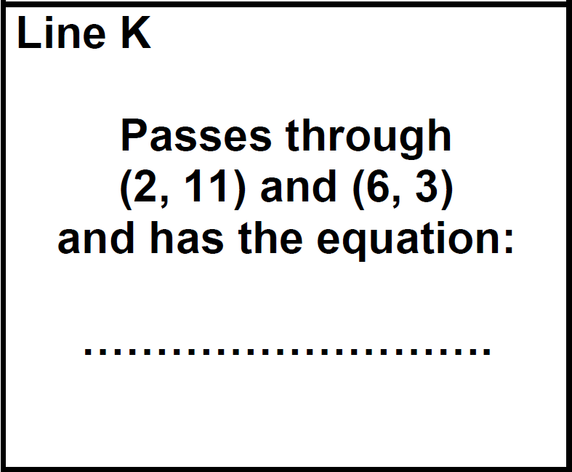
Line B

(3, 9)

(4, 7)

What is the slope (gradient) of line B? [-2] How did you decide this? What is the slope (gradient) of line K? [-2] Again, how did you decide?
Does this mean that the lines are the same? [No, they may just be parallel.] How did you find out whether or not they are the same line?
Different methods are possible. One method might involve finding the equations of both lines and showing that they are equal. An alternative method would be to consider one point from Line B (e.g. (3,9)) and one point from line K (e.g. (6,3) and show that the gradient between them is also -2.

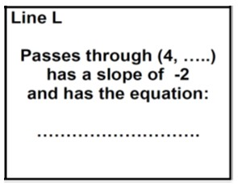
Cards F and L are matched by default. There is insufficient information on card L to define a line. This reverses the task; given that they do match, what information must we have on card L?
Line F

Passes through (0, 3) and (1, 1)
To conclude, ask students what they learned by looking at other students’ work and whether or not this helped them with cards they had found difficult to match or were unsure about:
Which lines did you find the most difficult to match? Why do you think this was? Did seeing the work of another group help? If so, can you give an example?
In what ways did having another group critique your poster help? Can you give an example?
During the discussion, draw out any issues you noticed as students worked on the activity, making specific reference to the misconceptions you noticed. You may want to use the questions in the Common issues table to support your discussion.

Follow-up lesson: reviewing the assessment task (15 minutes)
Give each student a copy of the review task, Lines, Slopes and Equations

SOLUTIONS

Lesson task
The cards are matched below:

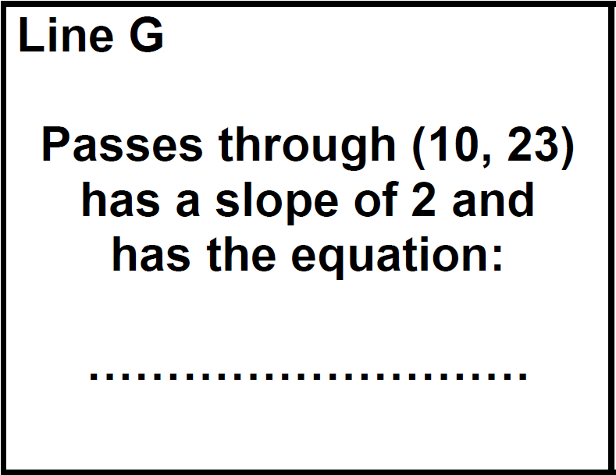
If a graph were drawn, then the lines would appear as follows:

E I A G
Line A

(3, 9)

(0, 3)

y
These two cards both have the equation y = 2x + 3
y = 4x-3 y = 2x+3
C H
y = 2x-1

D J
Line B

(3, 9)

(4, 7)

These two cards both have the equation y = -2x + 15

(3,9)

(4,7)
y = x+3

B K

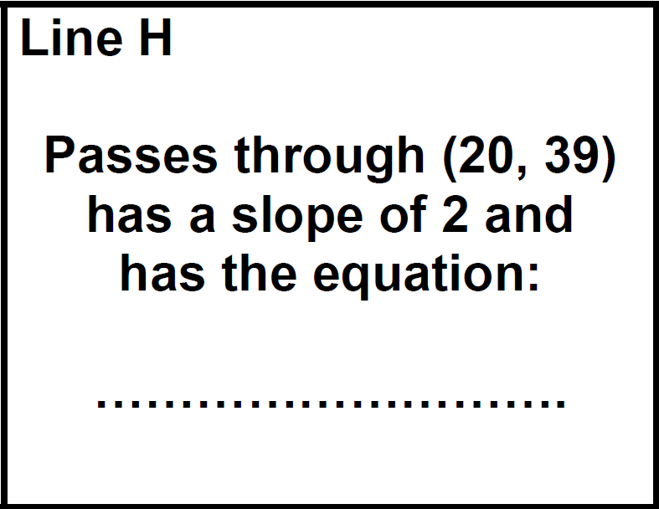
(0 3) y = -2x+15
Line C

Passes through (1, 1) and (4, 7)

These two cards both have the equation y = 2x -1

(1,1)

x

y = -2x+3

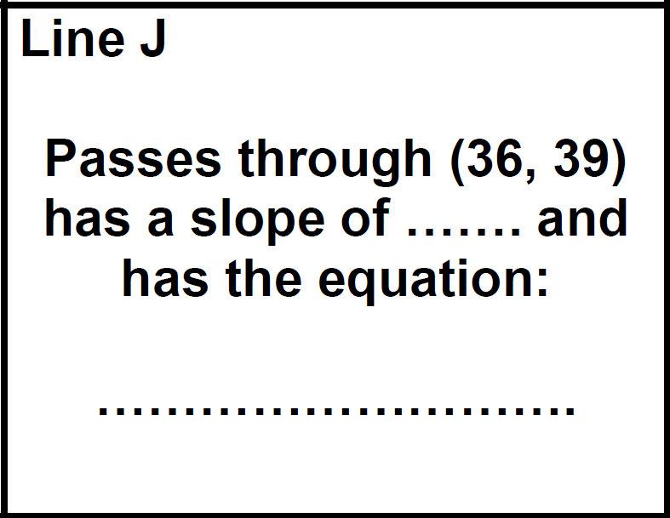
F L
Line D

Passes through (0, 3) and (4, 7)

These two cards both have the equation y = x + 3

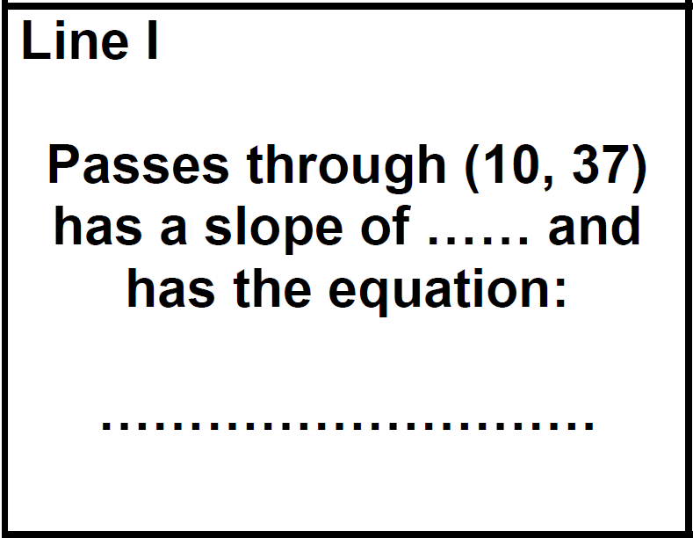
Line E

Passes through (0, -3) and (3, 9)

These two cards both have the equation y = 4x – 3

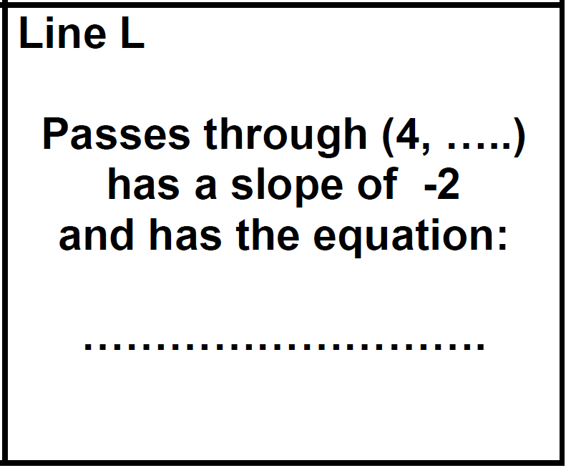
Line F

Passes through (0, 3) and (1, 1)
Line L must pass through (4, -5) for the lines to be the same. These two cards both have the equation y = -2x + 3

Thus they form a parallelogram along with its diagonals.

Assessment Task: Lines, Slopes and Equations

The slopes of the lines are: Line A: 3
Line B: 2
Line C: 2
Line D: 1.5
- Line A is steepest.
- Lines B and C are parallel
- The point (10, 30) lies on Line A.
- The point (11, 21) lies on Line B.
- The equation of line C is y = 2x - 3.

