Creating a Measure of Slope

MATHEMATICAL GOALS
This lesson unit is intended to assess students’ understanding of the four quadrants of the coordinate plane, while at the same time introducing them to a mathematical understanding of slope. The task helps students to link their intuitive understandings of steepness to a more precise, calculated measure of slope.

INTRODUCTION
This lesson unit is structured in the following way:
- Before the lesson, students work individually on an assessment task, Steepness, which is designed to reveal their current understanding with regard to slope. You then review their work and create questions for students to answer in order to improve their solutions.
- In the lesson, students work in small groups on a collaborative task in which they put line segments into order of slope. They then examine some sample student work and critique the measures of slope used there.
- Then students try to construct a better measure of slope.
- In a follow-up lesson, students receive your comments on the assessment task and use these to attempt the similar task, approaching it with insights that they have gained from the lesson.

MATERIALS REQUIRED
- Each student will need a copy of the task sheets Steepness and Steepness (revisited) and a Grid Paper sheet.
- Each small group of students will need copies of the cut-up Card Set, the four Sample Responses to Discuss, and some squared paper.
- Have protractors, tracing paper, and squared paper or graph paper available on request.
- There is a projector resource to support whole-class discussions.

TIME NEEDED
15 minutes before the lesson, a 100-minute lesson (or two 55-minute lessons), and 15 minutes in a follow-up lesson. Timings given are approximate and will depend on the needs of your class.

BEFORE THE LESSON
Assessment task: Steepness (15 minutes) Have students complete this task, in class or for homework, a few days before the formative assessment lesson. This will give you an
Steepness

1. Five line segments A, B, C, D, and E are shown below:
a. Put them in order of steepness. (Write letters in the boxes.)
b. Explain your method below.

2. Five line segments A, B, C, D, and E are drawn between the following pairs of coordinates.
a. Put the line segments in order of how steep they are.
b. Explain your method. (Use squared paper to illustrate, if you wish.)
A
E
C
D
B
opportunity to assess the work and to find out the kinds of difficulties students have with it. You should then be able to target your help more effectively in the subsequent lesson.
Least Steep = !!!! | !!!!! | !!!!!!. | !!!!!!. | Most Steep = !!!!

Give each student a copy of Steepness and a Grid Paper sheet. Have protractors available for students to use on request.
A | Between (–3, 1) and (0, 3)
B | Between (–1, 1) and (–2, –1)
C | Between (1, 3) and (–1, 0)
D | Between (1, –1) and (3, 1)
E | Between (1, 0) and (–2, –3)

Introduce the task briefly:
Think about walking or cycling up a slope. When is it easier or more difficult?
What can you say about the slope?
Least steep = !!!! | !!!!! | !!!!!!. | !!!!!!. | Most steep = !!!!

Can you describe what we mean by the words ‘steepness’ and ‘slope’?
Be as precise as you can.
Try to probe for explanations of how you can tell whether something is more or less steep. Students may talk about the effort involved in climbing/cycling/driving up a particularly steep hill, for instance.
On the sheet, you are asked to put the line segments A to E in order of steepness. Please try and explain how you do this.
Then try the same thing with line segments defined by the coordinates of their ends. There is some Grid Paper, which you may use if you wish to help you with this.
You may need to remind students about coordinate pair notation, however it is important that, as far as possible, students answer the questions on the sheet without assistance. If students are struggling to get started, ask questions that help them understand what they are being asked to do, but do not do the problem for them. The first few questions on the Common issues table were found to be helpful in trials of this lesson.
Students should not worry too much if they cannot understand nor do everything, because there will be a lesson related to this which should help them. Explain to students that by the end of the next lesson they should expect to answer questions such as these confidently; this is their goal.

Assessing students’ responses
Collect students’ responses to the task. Make some notes on what their work reveals about their current levels of understanding and their different problem-solving approaches.
We suggest that you do not score students’ work. Research suggests that this will be counter- productive, as it will encourage students to compare their scores and will distract their attention from what they can do to improve their mathematics. Instead, help students to make further progress by summarizing their difficulties as a series of questions. Some suggestions for these are given in the Common issues table on page T-4. These have been drawn from common difficulties observed in trials of this unit.

We suggest you make a list of your own questions, based on your students’ work. We recommend you either:
- write one or two questions on each student’s work, or
- give each student a printed version of your list of questions and highlight the questions for each individual student.
If you do not have time to do this, you could select a few questions that will be of help to the majority of students and write these on the board when you return the work to the students in the follow-up lesson.

Common issues Suggested questions and prompts

Struggles to get started | - Think about going up these slopes on a bicycle. Which would be the steepest to climb?
Confuses length with slope  For example: The student thinks line segment D is steepest (Q1). | - Do you think that longer slopes are always steeper?
Uses the difference between the vertical heights to measure slope  For example: Student gives order as B or C (least steep) then D or A, then E (steepest) because they rise by 3, 4, 5 units respectively (Q1). | - Do you think that slopes that climb higher are always steeper?  - Which is steeper, a slope that goes up 100 feet over ten miles, or a slope that goes up 50 feet over one mile?
Inaccurately measures the angle of the slope | - Carefully place your protractor on the grid. Think about what you need to line-up.  - Would it help to make the lines longer? Would this change their steepness?
Uses “rise – run” to measure slope  For example: The student thinks that E is the steepest because rise – run = 5 – 2 = 3, which is the greatest value (Q1). | - Do you think that the difference between the vertical and horizontal distance is a good way of measuring steepness?  - What would happen then if you just increased the length of the line?
Has technical difficulties with axes (Q2)  For example: The student plots some/all coordinates the wrong way round e.g. plots (0, 3) on the x-axis.  Or: The student mislabels axes, omitting zero on one or both axes, or placing the negative numbers in the wrong direction.  Or: The student plots negative coordinates as positive coordinates, e.g. plots (–3, 1) at (3, 1). | - What is the difference between (0, 3) and (3, 0)?  - Where should zero go on this axis?  - Where would you plot (3, 1)?
Is able to calculate the slope as a fraction but cannot order the fractions (Q2)  For example: The student cannot decide whether a 5/2 slope is bigger or smaller than a 3/1 slope. | - Can you simplify the fractions 5/2 and 3/1?  - Can you change your fractions to decimals with a calculator? Does this help you to order them?
Obtains correct order visually without performing any calculations (Q2) | - Can you find a way of doing this without drawing, by just using the numbers?
Obtains incorrect order without drawing the line segments (Q2) | - Can you draw some of the line segments to check your answers?
Obtains correct order using coordinate values (Q2) | - Can you make a formula to describe what you are doing?  - What do you think might happen in three dimensions with coordinates like (1, 2, 3)?

SUGGESTED LESSON OUTLINE
Introduction (5 minutes)
Remind students of the Steepness task they did in the previous lesson or for homework.
Resist using the introduction to sort out all the issues that have arisen from this task as this denies students the opportunity to confront and address misconceptions for themselves during the collaborative activity.

Collaborative small-group work (25 minutes)
Ask students to work in groups of two or three and give each group a cut-up copy of the Card Set and some squared paper. Have protractors and tracing paper available for students to use on request.
Display the instructions on Slide P-1 and explain to students what they are being asked to do:
Collaborative Task

- Work in small groups.
- You have eight line segments: four of them are drawn and four are defined by the coordinates of the end-points.
- Put all eight of them in order across the table from the least steep to the steepest.
- Talk about it in your group and try to agree on the order of steepness.
Students might sometimes find it helpful to trace line segments onto tracing paper so that they can place cards on top of each other, to assist their comparisons.
While students are working you have two tasks: to notice their approaches to the task and to support student problem solving.

Make a note of student approaches to the task
Notice how students tackle the problem. With cards E-H, do students draw each one, or do they notice beforehand, for example, that F is going to be horizontal? Do they make any use of the horizontal and vertical distances between the end-points? Do they figure out a value for the slope? You can use this information to focus a whole-class discussion later.

Support student problem solving
It is important that you do not tell students a conventional definition of slope, since the purpose of the task is for them to construct a measure for themselves. Instead, ask questions to help students clarify their thinking.

Whole-class discussion (15 minutes)
Invite students to share their thinking:
Can anyone explain how you ordered the cards? How did you decide which was the least steep card?
If the students seem to be having difficulty with the idea of slope, encourage them with more questions.
Look at this card (C). Would you describe the slope of the line segment as steep? Could you say how steep it is?

Is the slope of the line segment on card C greater or smaller than the slope of the line segment in card A?
Focus on cards E to H. Depending on what has already come up in the discussion, ask the students questions such as:
How did you order these line segments?
Could you tell if any of the line segments are horizontal? How? Would it be possible to order E-H without drawing them?
Ask the students to volunteer explanations of slope. If some students offer a conventional definition of slope, you could acknowledge it but avoid dwelling on it. There is still plenty for such students to do in understanding why a definition is effective and in critiquing alternatives.

Extending the lesson over two days
If you are taking two days to complete the unit then you may want to end the first lesson here. At the start of the second day, briefly remind students of their previous work before moving on to the collaborative analysis of sample responses.

Collaborative analysis of Sample Responses to Discuss (20 minutes)
Give a copy of each of the four Sample Responses to Discuss to each small group of students. Explain that the students who produced these responses were asked to compare the steepness of two different lines segments, line A between (4, 5) and (5, 7) and line B between (4, 3) and (6, 6).
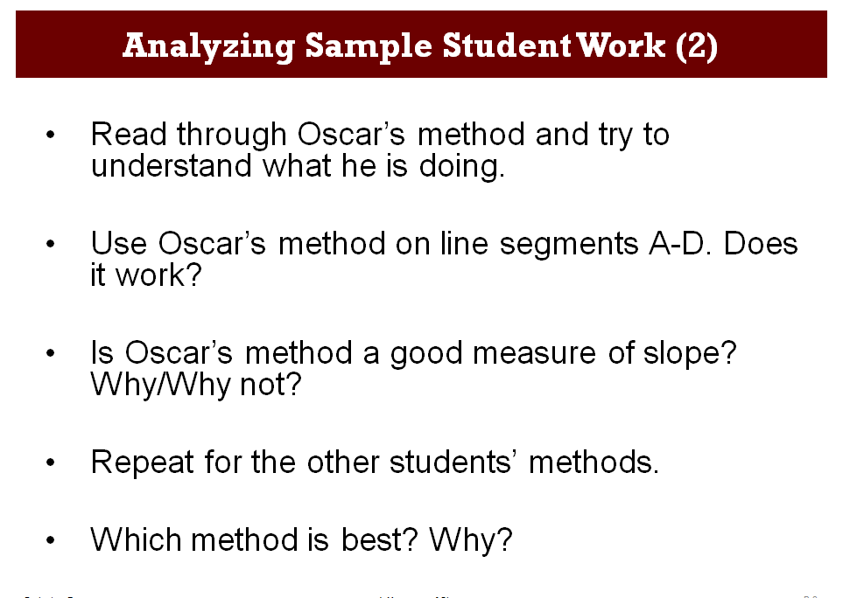
Ask students to read the responses carefully to try and understand what the students have done. If they are unfamiliar with the idea of critiquing other students’ work, you could go through one example (e.g. Oscar’s) with them. Use Slides P-2 and P-3 to explain what students need to do:
Analyzing Sample Student Work (1)

- You have some work produced by students from another class on comparing the slopes of two line segments.

- These students were asked to compare the slopes of the line segments:
  - A between (4,5) and (5,7)
  - B between (4,3) and (6,6)

You might choose to omit one or more samples of work if something very similar has just been offered by a student and discussed in the whole-class discussion. The purpose of the sample student

work is to suggest alternative possibilities that students have not considered and confront common misconceptions.
The four approaches rely on different ways of measuring slope. Give students time to understand the methods that the students are using:
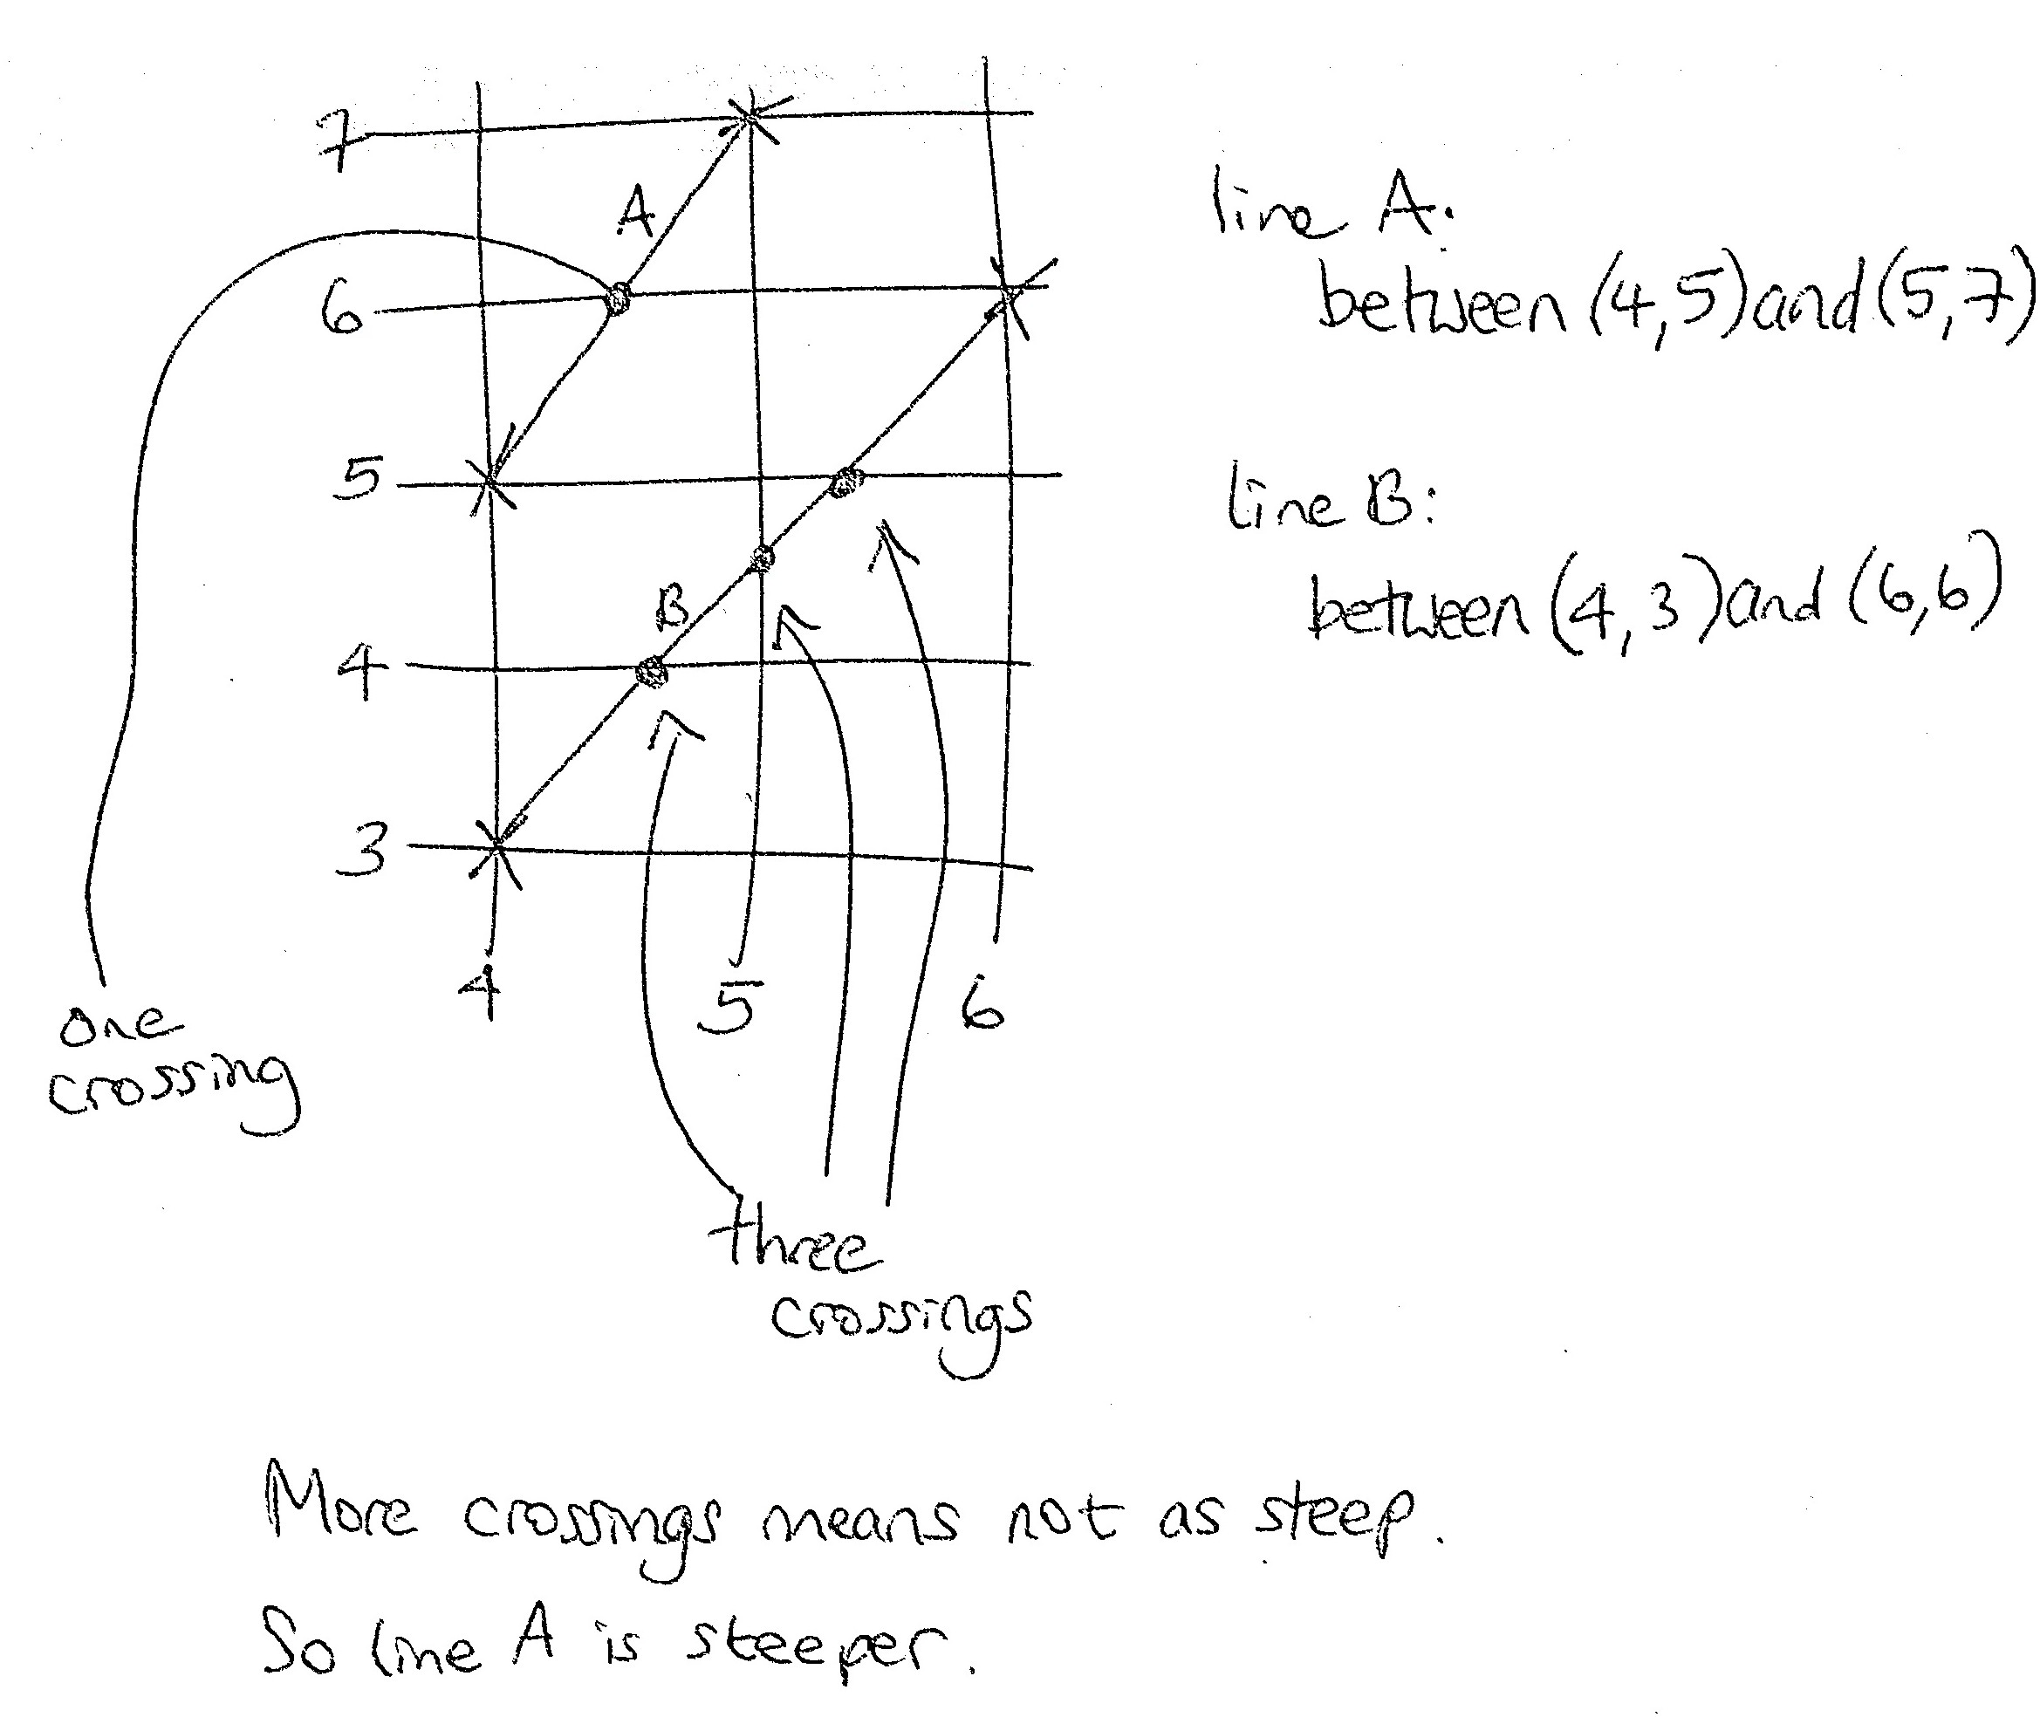
Oscar counts the number of times the slopes cross the grid lines. However, this total will depend on the length of the line segment and not just on its slope. He does not explain why he takes more crossings to mean that the line segment is less steep. He reaches the correct conclusion for these two line segments, but if he considered a line segment between (3, 3) and (5, 7), for example, this would have the same slope as line segment A but would be twice as long. It would contain three crossing points instead of one, making it appear to have the same steepness as line segment B. This is clearly incorrect.
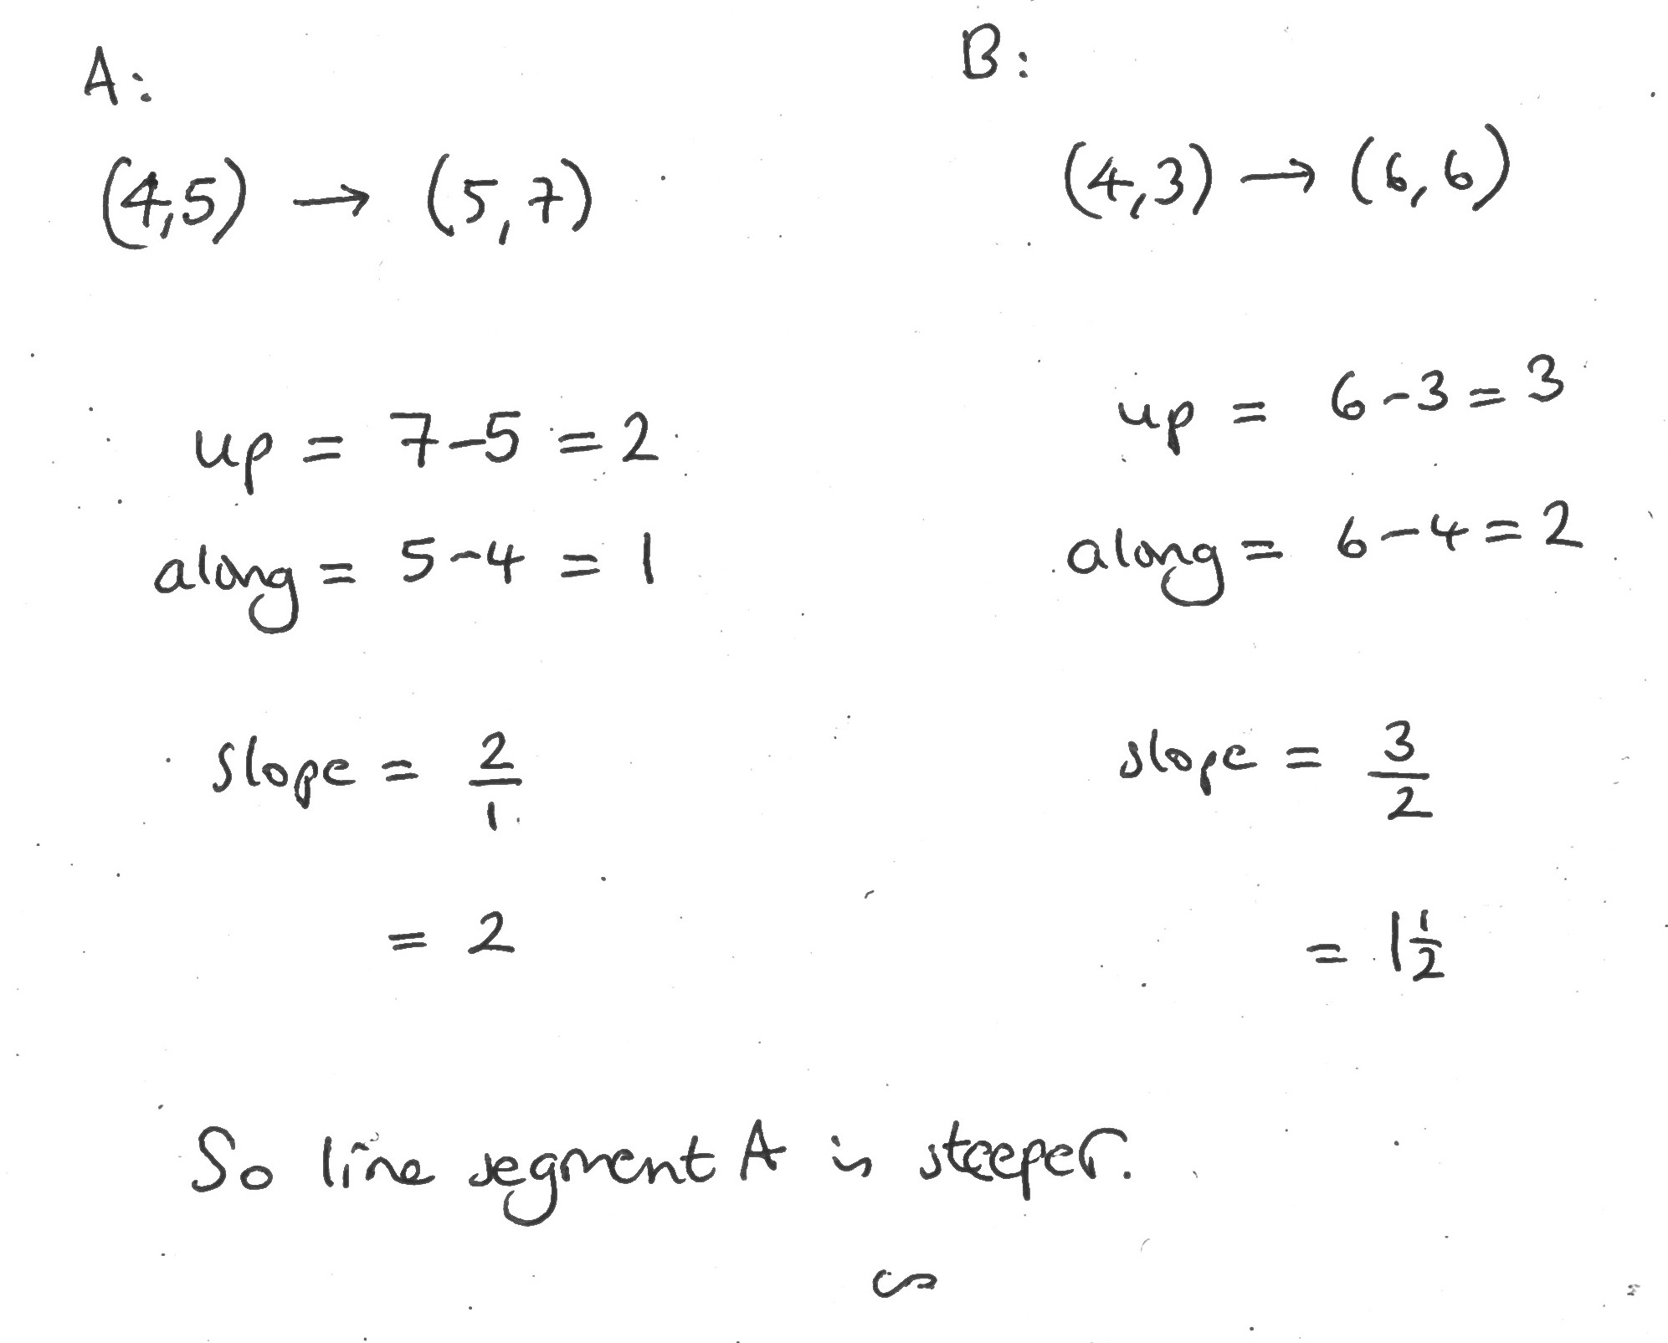

Can you add another line that supports/contradicts Oscar’s thinking?

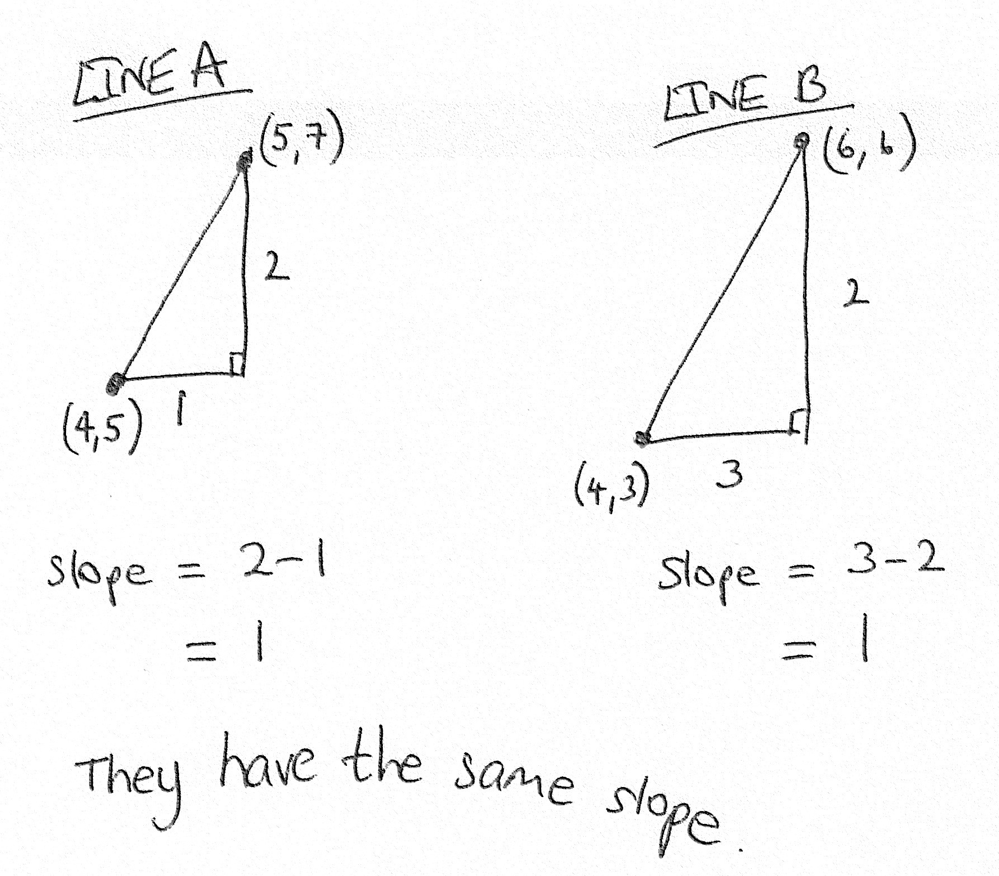
Stefan has found the correct horizontal and vertical displacements for the line segments. However, subtracting the displacements does not give a good measure of slope. Despite his misleading sketch, line B is actually less steep than line A. Unless a line segment has a slope of 1, adding the same amount to the vertical and horizontal displacements will produce a line segment with a different slope. This means that the difference between the vertical and horizontal displacements does not capture what we mean by ‘slope’. Another way to think about this is dimensionally: Stefan’s measure of slope, since it is the difference between two lengths, has the dimension of ‘length’, so it will generally be greater for a scaled up (similar) version of the same triangle.
Heidi uses a correct measure of slope, by dividing the vertical displacement by the horizontal displacement. This gives a greater value for steeper line segments and parallel line segments will give the same answer. Although it is not clear what she would do for ‘downhill’ slopes, this makes a very effective measure of slope.

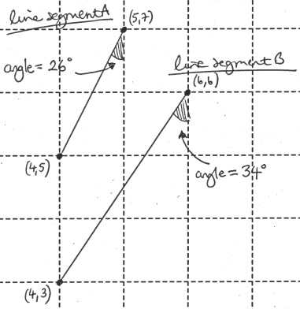
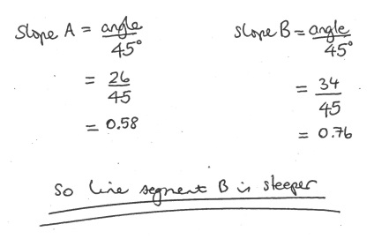
Becky has used a protractor to find the measures of the angles between the line segments and the vertical. Her method of dividing the measure of the angle by 45 degrees would give the correct slope for a line of slope 1, but because she has chosen to use the angle with a vertical, rather than with the horizontal, she will get smaller answers for steeper line segments (at least for ‘uphill’ ones).
Her method could be adapted into a good measure of slope, by finding the measure of the acute angle between the line segment and a horizontal line and dividing by 45 degrees. At least for lines of positive slope, this would provide a workable measure of slope. However, for angles greater than 90 degrees it will not work (e.g. a slope of 9 would be the same as a slope of 1.)

Collaborative work: devising a measure of slope (15 minutes)
Now it is the students’ turn to devise a measure of slope:
Now it’s your turn to come up with a way of measuring slope. There is more than one possible way to do it.
You might be able to adapt some of the ideas from the sample student work. Which method fits best with your own intuition?
If students are stuck, try to avoid giving them suggestions. Instead, ask questions to probe their thinking:
What ideas have you come up with?
Why have you chosen that particular way of measuring slope? Which line segments have you tried it on? What happened?
Do the coordinates help?
If students really want a suggestion of how to proceed, you could choose a line segment and say:
Can you draw some more line segments with the same slope as that one? Make several. See if you can work out what is the same about the coordinates of the end-points.
If they know a good definition, don’t let them off the hook. Instead, probe for mathematical reasons why that definition is superior:
Why does that definition work when some of those in the sample student work don’t? What is different about it?

Whole-class discussion (20 minutes)
Now hold a whole-class discussion in which students discuss their methods. You could begin by returning to the sample student work. Projector resource Slides P4 – P7 show these.
Does Oscar’s/Stefan’s/Becky’s/Heidi’s method work? Did it put the line segments in the right order?
If it doesn’t work, why doesn’t it work?

It is worth spending time trying to explore what is wrong with these methods and why they do not capture the essence of what we mean by ‘slope’.
Then move to students’ own measures:
What measure of slope have you come up with? Why did you choose it?
When does it work? Does it always work? Why do you think your measure is better?

Follow-up lesson (15 minutes)
Remind the students of their previous work on slope. Then give a copy of Steepness (revisited) to each student. This is similar to the assessment task Steepness.
See if you can use what you have learnt during the lesson to answer these questions. Try it on your own and see how you get on.
This task could be given for homework.

SOLUTIONS
Assessment task: Steepness
- The correct order from least steep to most steep is:
D (slope of 2/3); B (slope of 1); A (slope of 2); E (slope of 5/2); C (slope of 3).
- The correct order for the line segments from least steep to most steep is: A (slope of 2/3); D and E (slope of 1); C (slope of 3/2); B (slope of 2).
The simplest method to find the slope between (a, b) and (c, d) is to calculate the ratio: (vertical displacement / horizontal displacement) = (d-b) / (c-a).

Collaborative small-group work
The correct order, from shallowest to steepest, is F < A = E < B = H < C = G < D. The diagram below shows the ordering:
D
G

(2,1)
H

(1,1)
E
y
(-2,1)
(1,1)
x
y
(2,1)

x
(-1,-2)
y
x
(-1,-2)
y
x
(1,-2)
C

A

B

F

Assessment task: Steepness (revisited)
- The correct order from least steep to most steep is:
A (slope of 2/3); E (slope of 1); D (slope of 2); C (slope of 5/2); B (slope of 3).
- The correct order for the line segments is:
D (slope of 0); B (slope of 1/3); C (slope of 1); A (slope of 3/2); E (slope of 2)
.

