
School Reports
Tyrese has worked well and deserves that marvellous exam result. Well done!
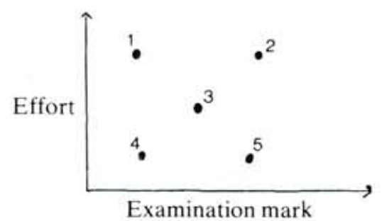



Questions:

- Label 4 points with the correct names.
- Make up a school report for the remaining number
- Which pair put in the same amount of effort?
- Which pair scored similar marks in the examination?
- Write your own school report and plot it on the graph.

Natalia has worked reasonably well this term and has achieved a satisfactory exam result.
Alex has been extremely lazy all term and this has resulted in an extremely poor exam performance
Claire is a very able pupil, as her exam mark clearly shows, but her concentration and behaviour in class are very poor. With more effort, she could do very well in this subject

Activity:

Write five reports for your own scatter graph for a display.
The poster should show:
- The five reports
- A fully labelled scatter graph

In an experiment, 192 fathers and sons were measured.
(The sons were measured when they were at full adult height.)
IS HEIGHT HEREDITARY?
What can you say about points A and B?

Can you answer the question in the title from the graph?

What conclusions can you get from the graph?
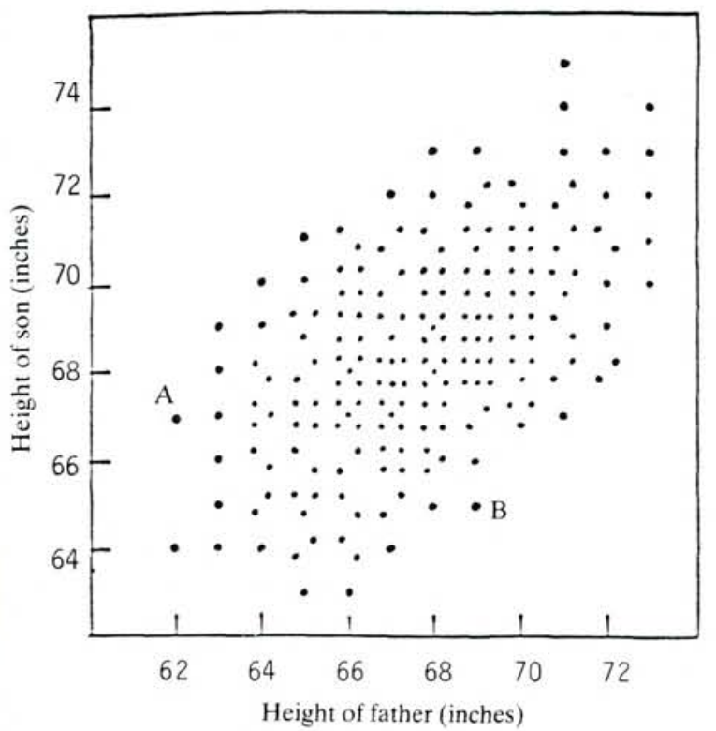
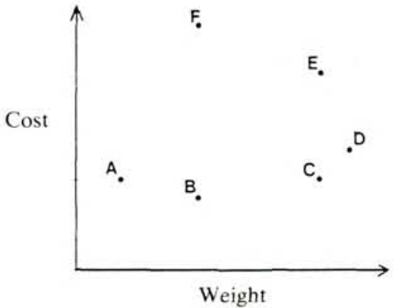
BAGS OF SUGAR


Each point on this graph represents a bag of sugar.

- Which bag is heaviest?
- Which bag is cheapest?
- Which bags are the same weight?
- Which bags are the same price?
- Which of F or C would give better value for money?
How can you tell?
- Which of B or C would give better value for money?
How can you tell?
- Which two bags would give the same value for money?
How can you tell?
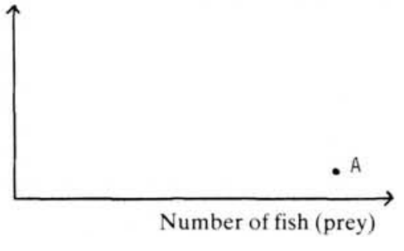
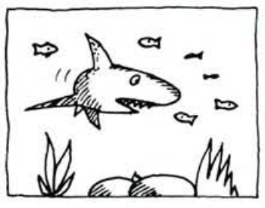
- Due to the absence of many sharks, there are lots of fish.
- Sensing a large supply of fish for food, sharks enter the area.
- The sharks eat many of the fish, until…
- … the fish population is too small to support all the sharks. Many sharks decide to leave.
- With few sharks around, the fish population increases once again.
- The area now contains enough food to support more sharks, so they return…
- … and begin to each the fish… until…
Here is a simplified description of what can happen when two species interact. The sharks are the predators and the fish are the prey. The situation in statement A has been represented on the graph by a point.

How does this point move as time goes by?
Point A has been plotted for you. Now plot points A-G.
SHARKS AND FISH

