- The scatter graph shows some information about 8 cars.
For each car it shows the engine size, in litres, and the distance, in kilometres, the car travels on one litre of petrol.
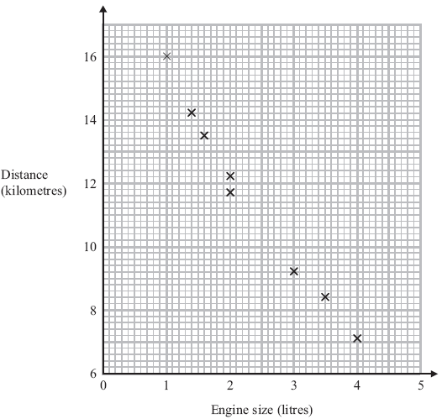
  - What type of correlation does the scatter graph show?

..............................................................................................

A different car of the same type has an engine size of 2.5 litres.

  - Estimate the distance travelled on one litre of petrol by this car.

.............................................. kilometres

- The scatter graph shows information about the height and the arm length of each of 8 students in Year 11.
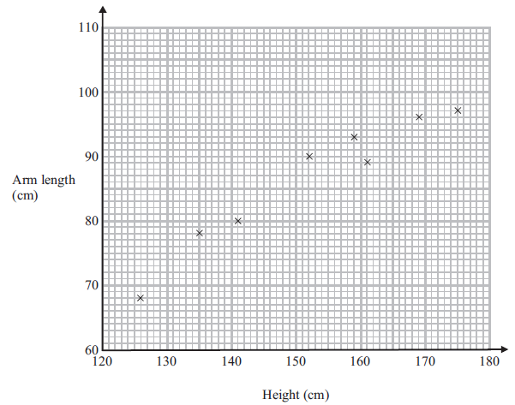

  - What type of correlation does this scatter graph show?

..............................................................

A different student in Year 11 has a height of 148 cm.

  - Estimate the arm length of this student.

..............................................................cm

- The scatter graph shows information about 10 apartments in a city.

The graph shows the distance from the city centre and the monthly rent of each apartment.
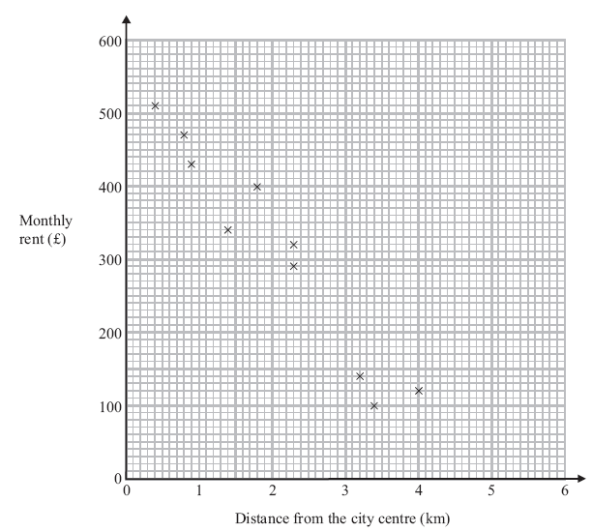
The table shows the distance from the city centre and the monthly rent for two other apartments.

Distance from the city centre (km) | 2 | 3.1
Monthly rent (£) | 250 | 190

  - On the scatter graph, plot the information from the table.

  - Describe the relationship between the distance from the city centre and the monthly rent.

.....................................................................................................................................................

.....................................................................................................................................................

An apartment is 2.8 km from the city centre.

  - Find an estimate for the monthly rent for this apartment.

£ ......................................................

- The scatter graph shows information about the height and the weight for nine students.

100

90

80

70

60
Weight
in kg 50
40

30

20

10

0
110 120 130 140 150 160 170
Height in cm
The table shows the height and the weight for three more students.

Height in cm | 135 | 155 | 170
Weight in kg | 70 | 75 | 85

  - On the scatter graph, plot the information from the table.

  - What type of correlation does this scatter graph show?

.....................................

  - The weight of another student is 80 kg.

Estimate the height of this student.

.....................................cm

- Some students took a mathematics test and a science test.
The scatter graph shows information about the test marks of eight students.
60

50
Mark in
science

test
40

30

20

10

0
0 10 20 30 40 50 60
Mark in mathematics test

The table shows the test marks of four more students.

Mark in mathematics test | 14 | 25 | 50 | 58
Mark in science test | 21 | 23 | 38 | 51

  - On the scatter graph, plot the information from the table.
  - Describe the correlation between the marks in the mathematics test and the marks in the science test.

…………………………………………………..

Josef was absent for the mathematics test but his mark in the science test was 45

  - Estimate Josef’s mark in the mathematics test.

…………………………..

6. The scatter graph shows the average body length and average foot length of different species of rodents.
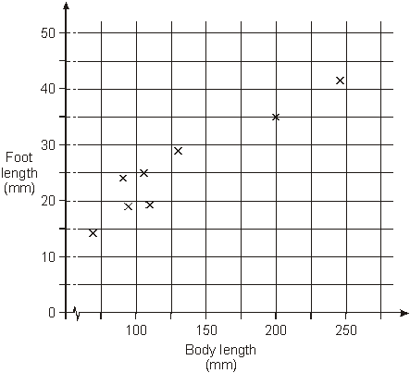
(a) What does the scatter graph tell you about the type of correlation between the body length and foot length for these rodents?

(b) Draw a line of best fit on the scatter graph.

(c) If body length increased by 50 mm, by approximately how many millimetres would you expect foot length to increase?
Ring the correct value below.
2 7 15 50 275

(d) An animal has a body length of 228 mm, and foot length of 22 mm.
Is this animal likely to be one of these species of rodents?
Tick () Yes or No.
 Yes No
Explain your answer.

7. The goldcrest is Britain’s smallest species of bird.
On winter days, a goldcrest must eat enough food to keep it warm at night. During the day, the mass of the bird increases.
The scatter diagram shows the mass of goldcrests at different times during winter days. It also shows the line of best fit.
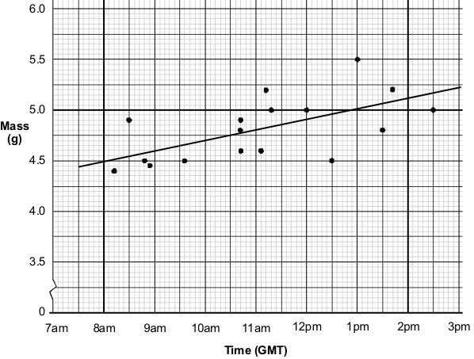
(a) Estimate the mass of a goldcrest at 11 : 30 am.
............................ g

(b) Estimate how many grams, on average, the mass of a goldcrest increases during one hour.
............................ g

(c) Which goldcrest represented on the scatter diagram is least likely to survive the night if it is cold?
Show your answer by circling the correct point on the scatter diagram, then explain why you chose that point.

