Penalty Shoot-Out

The bar chart represents the outcome of a penalty shoot-out competition. Each person in the competition was allowed six shots at the goal.

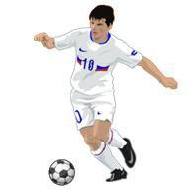
The graph shows, for example, that four people only scored one goal with their six shots.

  - How many people were involved in the shoot-out? Show how you obtain your answer.

  - Complete the table with values for the Mean, Median, Mode, and Range of scores. Explain how you calculate each answer.

Mean score | ----------
Median score | ----------
Mode score | ----------
Range of scores | ----------

- There is another penalty shoot-out.
Use the table of results to draw a possible bar chart of the scores:

Mean score | 3
Median score | 3.5
Mode score | 4
Range of scores | 4

Show all your work.

