Year 7 Summer 2 Lesson 7: Understanding mean, median and mode.
Objective | Calculate the mean, median, mode, and range from a frequency chart.  Use a frequency chart to describe a possible data set, given information on the mean, median, mode, and range.
Aim | This lesson is one of the classroom challenges from the Mathematics Assessment Project and is structured in the following way:  • Before the lesson (at the end of last lesson), students work individually on an assessment task designed to reveal their current understanding and difficulties. You then review their responses and create questions for students to consider when improving their work.  • After a whole-class introduction, students work in pairs on a collaborative task, matching bar charts with statistical tables.  • To end the lesson there is a whole-class discussion.  • To follow up, students again work alone on a task similar to the initial assessment task.  It will probably take two lesons.
Resources | Penalty shoot out pre-task  Powerpoint  Card sort  Poster paper  Boy band follow up task

Key words: Mean, median, mode, range, frequency, frequency diagram.
Settler: Numeracy Ninjas (max 10 mins)

Pre task: (In previous lesson)
Have students complete this task, in class or for homework, a few days before the formative assessment lesson. This will give you an opportunity to assess the work and to find out the kinds of difficulties students have with it. You should then be able to target your help more effectively in the lesson that follows.
Give each student a copy of the assessment task: Penalty Shoot-Out.
It is important that, as far as possible, students are allowed to answer the questions without your assistance.
Students should not worry too much if they cannot understand or do everything, because in the next lesson they will work on a similar task, which should help them. Explain to students that by the end of the next lesson, they should be able to answer questions such as these confidently. This is their goal.

Assessing student work before the next lesson:
Help students to progress by summarizing their difficulties as a series of questions. Some suggestions for these are given in the common issues table on the next page. These have been drawn from common difficulties observed in trials of this unit.

Common issues Suggested questions and prompts
Misinterprets the axes on the bar chart  For example: The student states that there were six people involved in the shoot-out (Q1a).  Or: The student does not understand the term ‘Frequency’. | - Complete this sentence: “This bar shows that  ...” (indicate one of the bars).  - What does the term ‘Frequency’ mean?  - How many people scored three goals? How many people scored four goals?
Uses incorrect values to calculate the mean  For example: The student finds the total of the frequencies rather than the total number of goals.  Or: The student divides by six rather than the total frequency.  Or: The student adds the scores (1+2+3+4+5+6) and divides this total by six. | - How many goals were scored?  - Six goals were scored five times. So what is the total number of goals? Compare this to your total, what do you notice?  - Imagine writing the scores out as a list. From this list, how would you work out the mean?
Confuses the position of the median with the value for the median  For example: The student adds one to the total frequency and divides by two to give a median of 8.5 (Q1b).  Or: The student just halves the frequency (Q1b).  Or: The student assumes the median is 3.5, half way between 1 and 6.  Or: The student writes two values for the median, 3 and 4. | - The median is the middle score when all the scores are in order. Is this what you have found?  - Try writing the scores in order:  1, 1, 1, 1, 2, 2, 3, …Which is the middle score? How could you do this directly from the frequency graph without writing a list?
Presents the range as two figures, the highest and the lowest scores | - What calculation is needed to obtain the range?
Calculates the range in frequencies rather than the range of goals scored | - What was the highest number of goals scored?  - What was the lowest number of goals scored?
Reads off the frequency of the tallest bar as the mode, rather than the score  For example: The student gives the mode as 5 (Q1b). | - Which score was the most popular? How can you tell?
Draws a bar chart that satisfies none or some of the criteria given in the table  For example: The student draws a bar chart with a mode of 4 but the other values in the table are not satisfied (Q2). | - Check that your bar chart works for all the values in the table. What is the mean/median/mode/range?  - Can you use the bar chart to draw a frequency table?
Completes the task  The student needs an extension task. | - Can you produce a different bar chart (to Q2) that describes the same data measures? What is the same and what is different?

Activity 2:
Display the first slide of the Powerpoint. Ask students to rate an imaginiary computer game where 1 = poor and 6 = great. They should show their scores on their whiteboards.
The results of the survey will be used on the next slide to produce a bar chart from which they will find the averages and range.
Ask students how you should collect the data from the class. Some students will suggest a tally. If no one suggests a frequency table, introduce this and check that they understand the word frequency.
Go to slide 2 and fill in the frequency table.
Questions for progression | - How can we record these results efficiently?  - What does the word ‘frequency’ mean?

Activity 3:

Ask a volunteer to come and fill in the bar chart from the frequency table.
Ask the students to discuss in their pairs how they would find the median, mode and range from the bar chart.

Students may struggle to find the median directly from the bar chart and may prefer to write the data points in order and cross out until the ‘middle’ number is reached. If this is the case, spend some time exploring different strategies for finding the ‘median’ directly from the bar chart. Depending on the data collected.

Hold a discussion on how to find the mean – rlate back to previous lessons on evening out and calculating the mean.

Questions for progression | - How do we find the mean/median/mode/range?

Activity 4:

Show slides 3 and 4 with the instructions for the activity.

Students work in their pairs to match the bar charts and statistics tables. Once they are happy with their matches they should stick down on a poster.
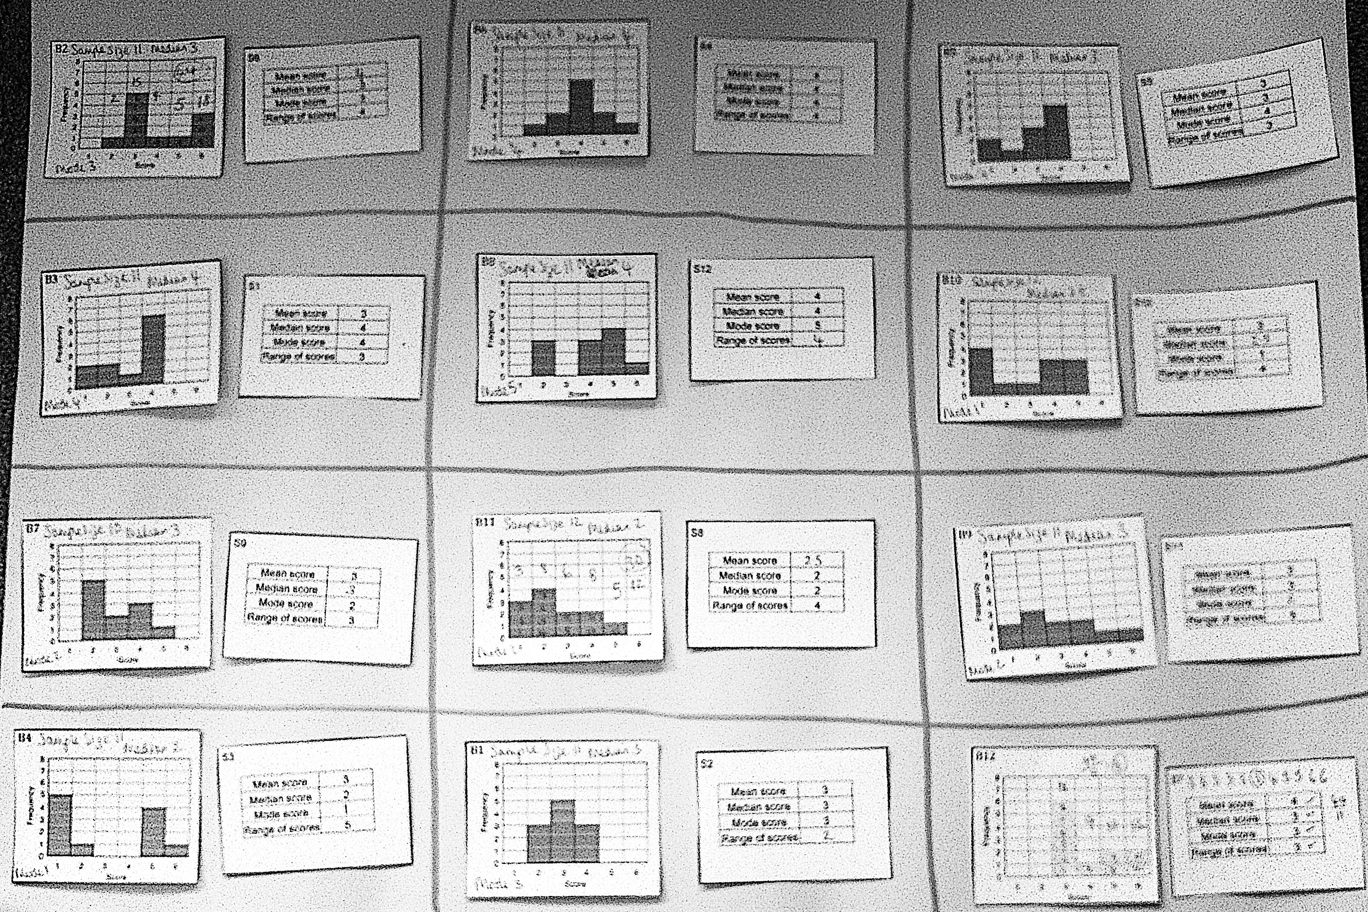

At the end of a set time, bring the class back together to discuss and compare their posters.

Questions for progression | - Which two bar chart cards show a sample size of 12? How do you know?  - Can we tell how big the sample size is from the statistics table? Why / Why not? Is there more than one way of completing the blank bar chart?  - What is the sample size for the bar chart you have drawn?  - Can you draw a bar chart with a different sample size that still satisfies the values in the statistics table?  - What have you done so far?  - Can you explain your reasons for your chosen strategy?  - Has anyone else used a different strategy?  - Do you need to calculate all four statistics in turn for each bar chart? If not, why not? Which statistic is easiest to find? How might you use this to complete the task?  - What similarities or differences could you look for in the cards? How could you use what you notice?  - Which cards were the easiest to match? Why was this? Which cards were difficult to match? Why was this?  - When matching the cards, did you always start with the bar chart/statistics table? Why was this? Did anyone use a different strategy?

Follow up task: Boy bands
Give each student a copy of the assessment task Boy Bands and their original scripts from the assessment task Penalty Shoot-Out. If you have not added questions to individual pieces of work, then write your list of questions on the board. Students select from this list only those questions they think are appropriate to their own work.
Read through your papers from Penalty Shoot-Out and the questions [on the board/written on your script.] Answer these questions and revise your response.
Now look at the new task sheet, Boy Bands. Can you use what you have learned to answer these questions?

Acknowledgements:
This lesson is taken and adapted from the Mathematics Assessment Project 'Representing Variability with Mean, Median, Mode, and Range'

