Correlation
For each of the sentences below:
- Discuss what the graph will look like with your partner.
- Copy the sentence.
- Draw the appropriate, labelled graph from those below.
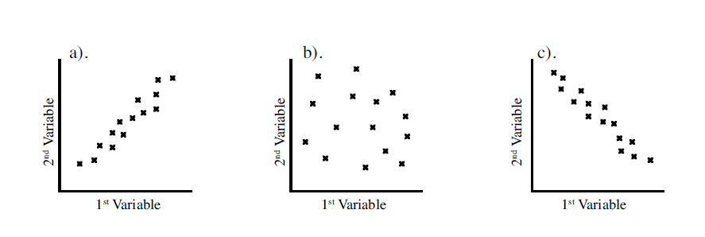
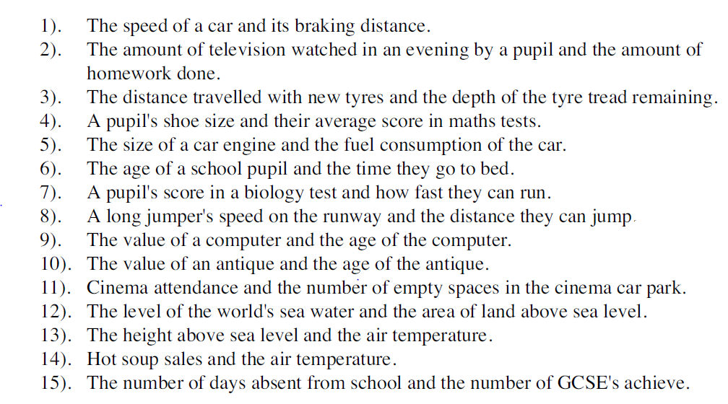
- Write down the type of correlation
- Write down a sentence.

