Boy Bands

The bar chart represents the scores from a quiz.
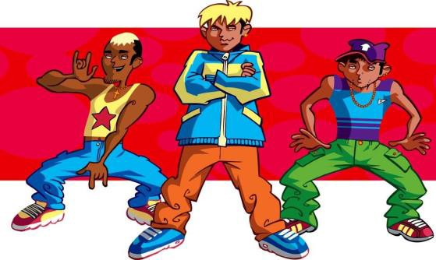
Children were asked to name six boy bands in 30 seconds. Each score represents the number of correctly named bands.

  - How many children were involved in the quiz? Show how you obtain your answer.

  - Complete the table with values for the Mean, Median, Mode, and Range of scores. Explain how you calculate each answer.

Mean score | ----------
Median score | ----------
Mode score | ----------
Range of scores | ----------

- The results of another quiz question is shown in the table below. Draw a possible bar chart of the scores:

Mean score | 4
Median score | 3.5
Mode score | 3
Range of scores | 4

Show all your work.

