Year 7 Summer 2 Lesson 6: Average of 5 numbers
Objective | To find the mean, median, mode and range of a set of numbers
Aim | This lesson uses an excel sheet to generate the numbers. It is important that the content is enabled (yellow bar across the top of the screen when you open it).  Instructions for use:  - Enable content when you open the file  - Click the star on the left hand side to generate new numbers  - Click the star on the right to order the numbers.  - All squares can be switched ‘on’ and ‘off’ by clicking on the boxes  - To reveal the range, click on the word ‘range’  - All numbers in the cells are integers between 1 and 10 inclusive
Resources | Average of 5 numbers question generator  Average and Range Spiders - alutwyche on TES

Key words: Mean, median, mode, representative value, outlier.
Settler: Numeracy Ninjas (max 10 mins)

Activity 1:
Students answer questions on their whiteboards. Start off with the 5 numbers displayed so they just have to find the mean, median and mode.

Eg)
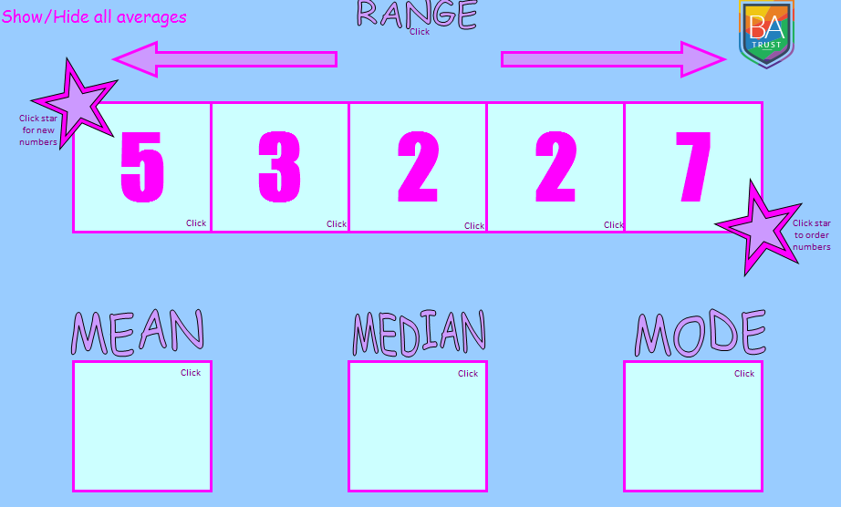

Questions for progression | - Why is your median wrong?  - Can you remember how we divide by 5 mentally?

Activity 2:
Make the questions gradually more difficult by hiding one of the numbers (click it) and showing one of the averages.
Eg)
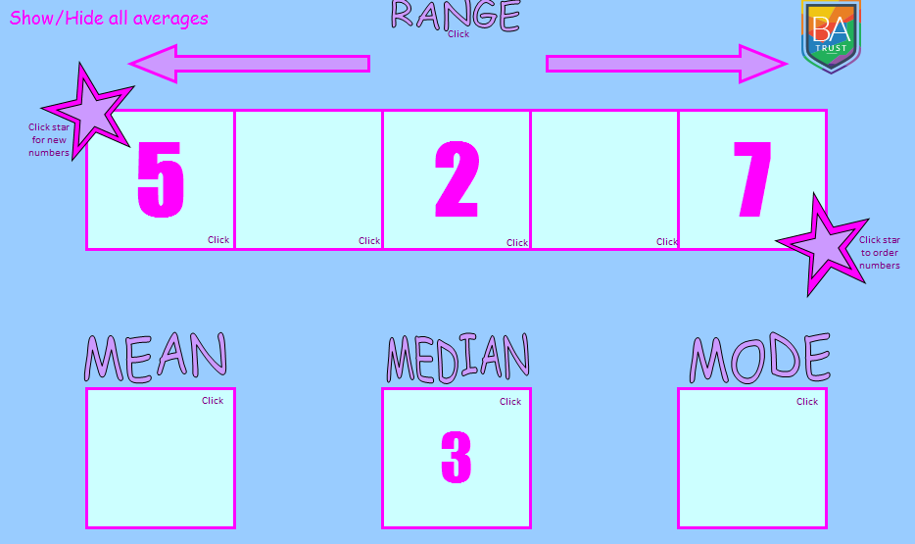
Build it up, slowly to eventually have no numbers showing, with all averages showing.
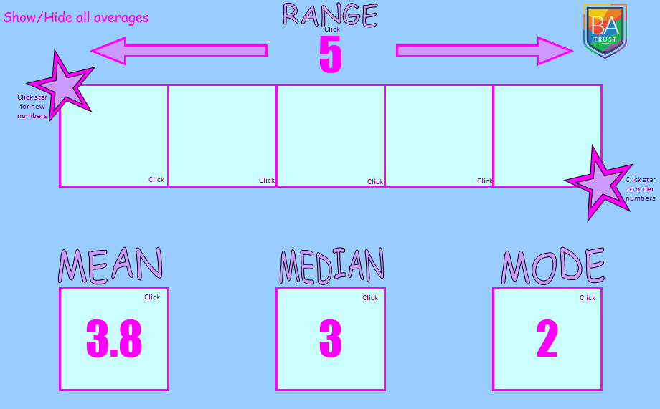
Judge how fast to go by checking students' understanding on whiteboards. Don't move ahead regardless.

Questions for progression | - Is the answer unique?  - How many different answers can you find?  - What do all of the solutions have in common?  - If the missing cells are called a and b, what can you tell me about a and b?  - Show me 5 numbers that have a mean of 10.  - And another, and another.  - What if one of the numbers is 9? And another, and another...  - Show me 5 numbers with a mean of 1 with no number repeated.  - And another and another..

Activity 3:
Averages and range spiders.
Print off sheets from the attached Powerpoint for students to work through.

Questions for progression | - Is the answer unique?  - How many different answers can you find?  - What do all of the solutions have in common?

Acknowledgements:
Excel generator - M Warden
Average and Range Spiders - alutwyche on TES

