UNDERWATER
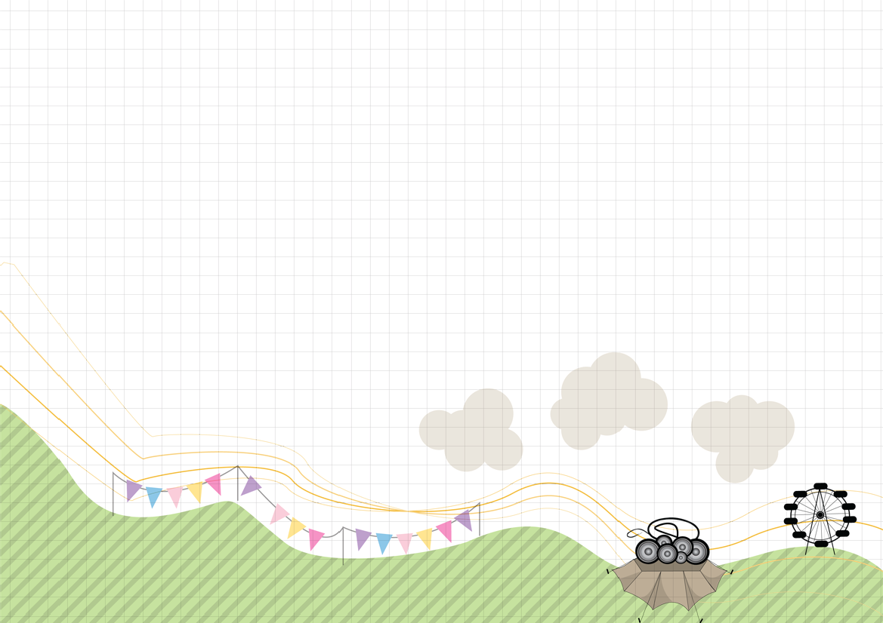
Torrential rain has hit Torbury Festival and the site is flooded! When the equipment arrives, you will have just one hour left to avoid the festival becoming a washout!
This is a plan of the entrance area, a small part of the festival site. On the plan, 1 centimetre represents 10 metres. On the next page, there are details of four ways of removing water.
Can you remove the water from the four flooded areas in time for the festival to open? Which method of removing water will you use in which area? You must decide!
