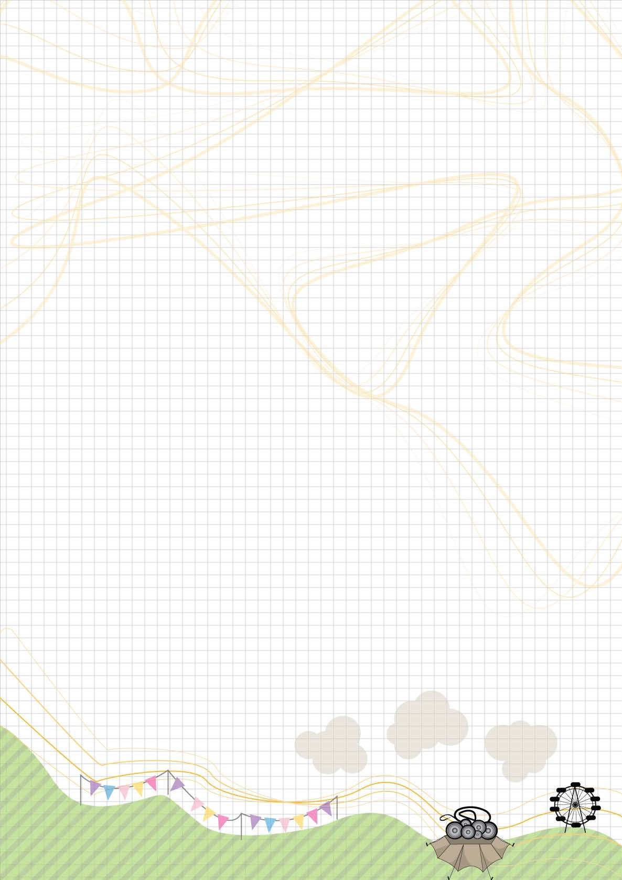
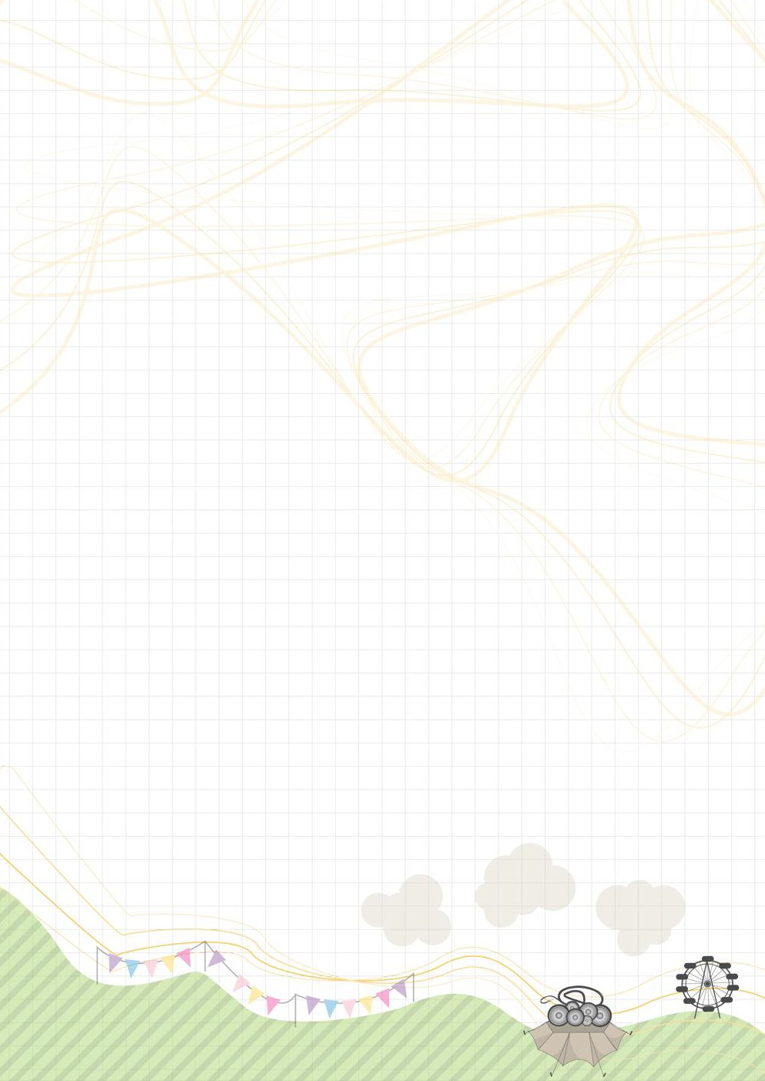
Lesson 2: Challenge Questions

Merchandise Mayhem

Extra problems

1 At 2:00 pm on the third day, Del sees he is running out of T-shirts. He wants his assistants to make 1350 more T-shirts by 7:00 pm.
They will obviously get tired with so much sewing to do.
So Del says that in each hour they can make 60 fewer T-shirts than the hour before.
- How many T-shirts must Del's assistants make in each hour up to 7:00 pm?
- If they went on making 60 fewer T-shirts in each hour after 7:00 pm, what is the maximum number of T-shirts they could make and by what time?

2 A small T-shirt can be made from a rectangle of jersey fabric 1 metre long and half a metre wide.
You have a piece of jersey fabric 1 metre wide and 2 metres long.
In how many different ways can you cut out the rectangles to make T-shirts?
What if your piece of fabric is 1 metre wide and 2.5 metres long?
3 metres long?
3.5 metres long?
Record your answers in the table below.
See if you can find a rule for calculating the number of different ways to do this with longer pieces of fabric.

 | Length of fabric 1 metre wide | 0.5 m | 1 m | 1.5 m | 2 m | 2.5 m | 3 m | 3.5 m
Number of ways to cut out rectangles

