Questions
Q1.
The diagram represents a solid made from seven centimetre cubes.

On the centimetre grid below, draw a plan of the solid.
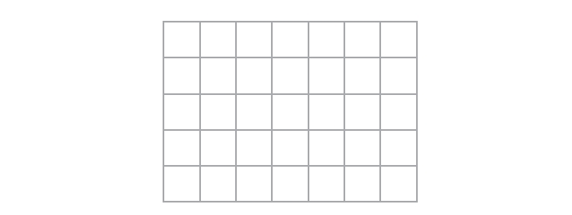

Q2.
Amy has some toy bricks.
Each brick is a cube of side 1 cm.
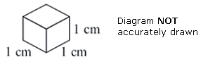
Amy uses some of the bricks to make this solid shape.
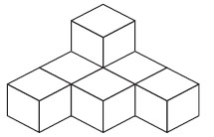
Amy adds some more of the bricks to this solid shape to make a cube of side 3 cm.
(a) How many bricks does Amy add?

. . . . . . . . . . . . . . . . . . . . . .
Naveed uses some of the bricks to make this solid shape.
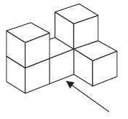
(b) On the grid below, draw the view of the solid shape from the direction shown by the arrow.
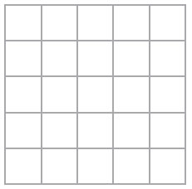

Q3.
The side elevation and the front elevation of a cuboid are drawn on the centimetre grid.
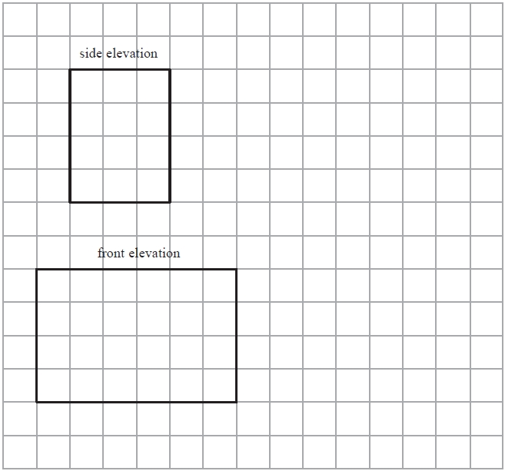
On the grid, draw an accurate plan of the cuboid.

Q4.
Here is a solid prism.
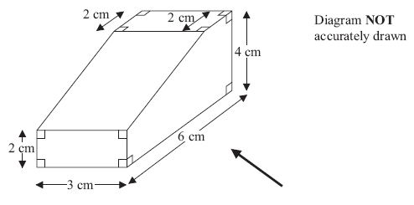
On the grid, draw an accurate side elevation of the solid prism from the direction of the arrow.
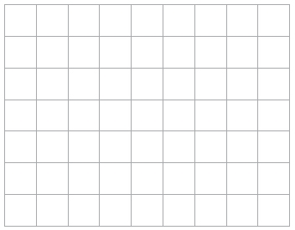

Q5.
The diagram shows a solid prism.
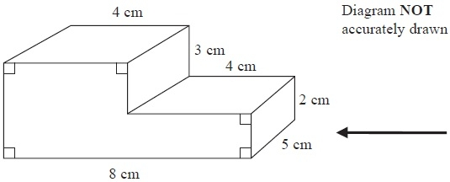
On the centimetre square grid, draw the side elevation of the solid prism from the direction shown by the arrow.
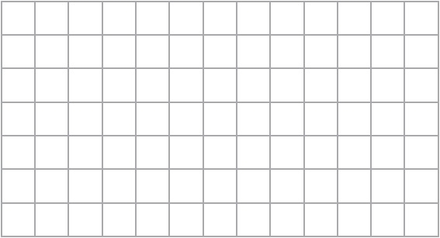

Q5.
The plan, front elevation and side elevation of a solid prism are drawn on a centimetre grid.
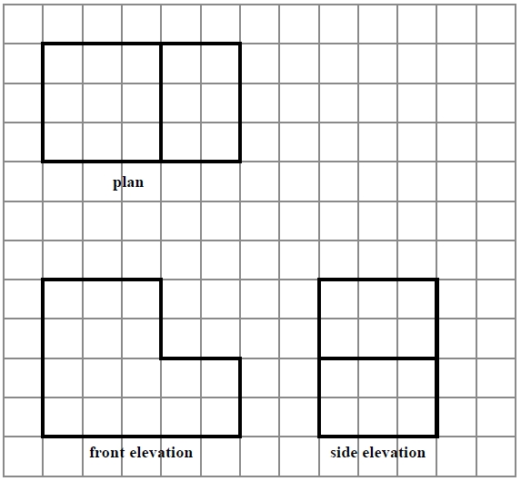
In the space below, draw a sketch of the solid prism.
Write the dimensions of the prism on your sketch.

