Write a maths sentence for the diagram below and find the value of a.

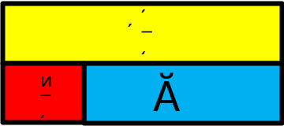

What is the perimeter of this rectangle?

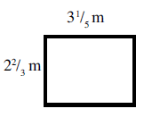

Dad bakes a cake. He eats $\frac{1}{4}$ of it straight away. Mum then eats $\frac{1}{3}$ of it when she gets home. The kids get the rest. What fraction do the kids eat?
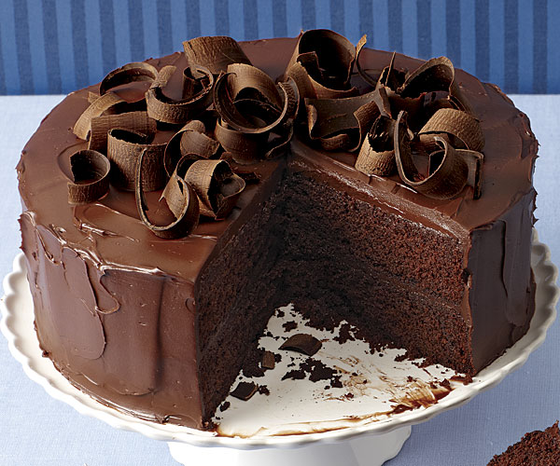
What is the missing length in this rectangle?
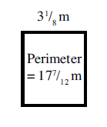
An urn contains $8\frac{1}{4}$ litres of tea before the tea break. After the break it contains $5\frac{3}{8}$ litres of tea. How much tea has been used from the urn?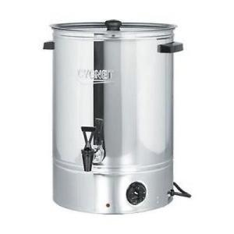
Beth got her pocket money yesterday. She spent $\frac{3}{4}$ of it straight away. She spent $\frac{1}{5}$ of it today. What fraction of her pocket money does she have left?
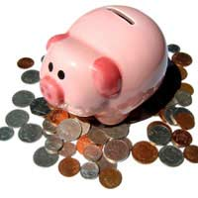
A plank of wood is $6\frac{1}{3}$ m long. $2\frac{5}{8}$ m is sawn off. What length of the plank is left?
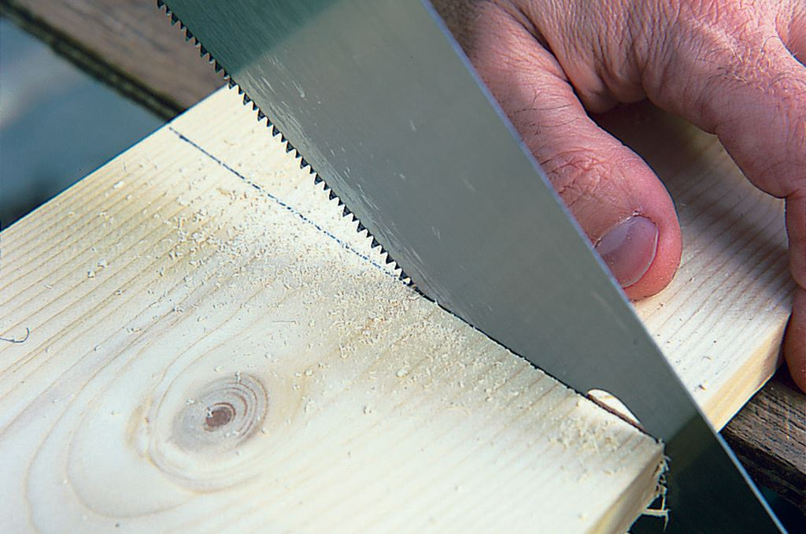
Two parcels weigh $2\frac{3}{5}$ kg and $4\frac{9}{10}$ kg. What is their combined weight?
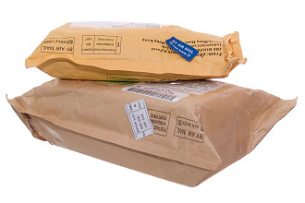
A bottle of lemonade holds 2 litres. A jug is filled to the top with lemonade from the bottle. The jug holds $1\frac{1}{3}$ litres. How much lemonade is left in the bottle?
