Find the Pairs

Each of these shapes is identical to another one.

Draw each shape on isometric paper next to its 'partner'

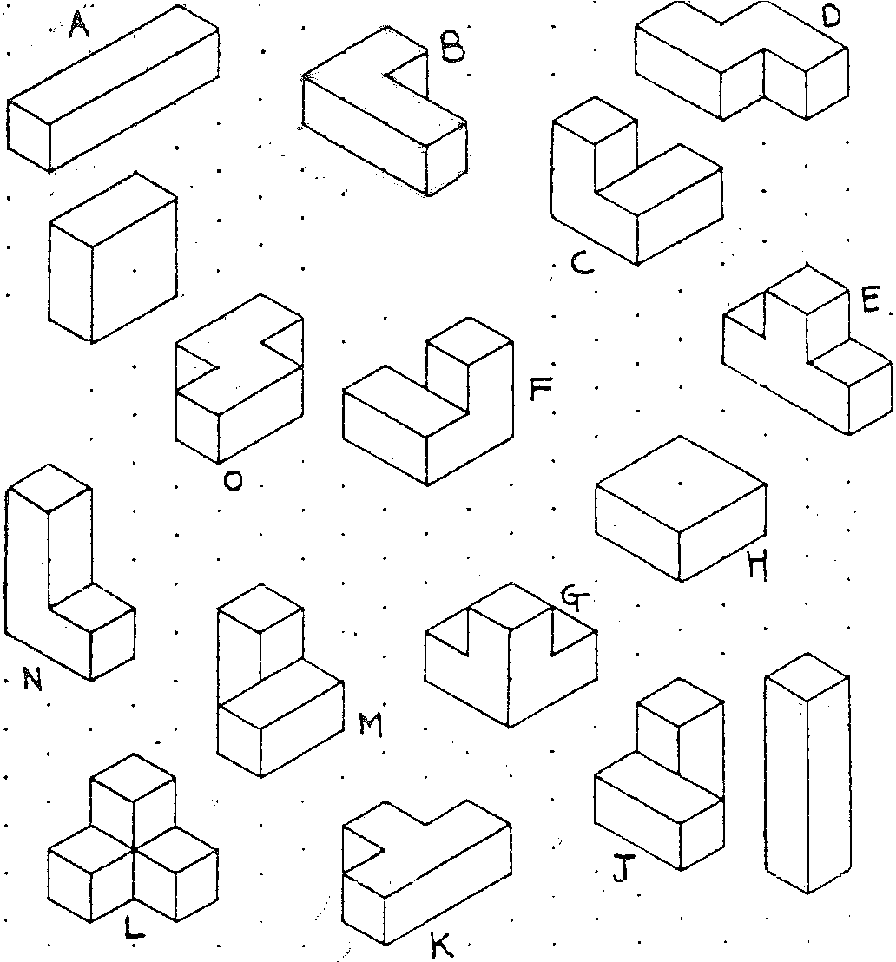··· i ,
. p
r.'

Harder Shapes

Now try these:

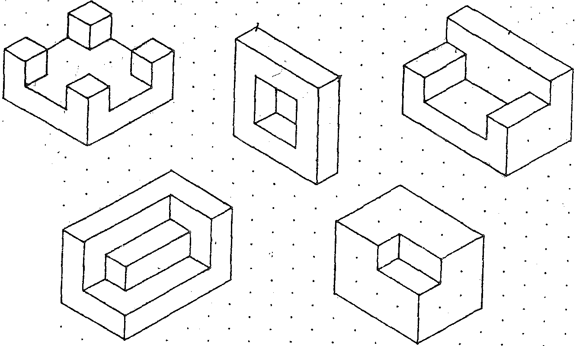
. ..:'·:
' ' .

Two Cubes Less ,

Draw what is left when the two cubes marked * are taken away f rom each one.

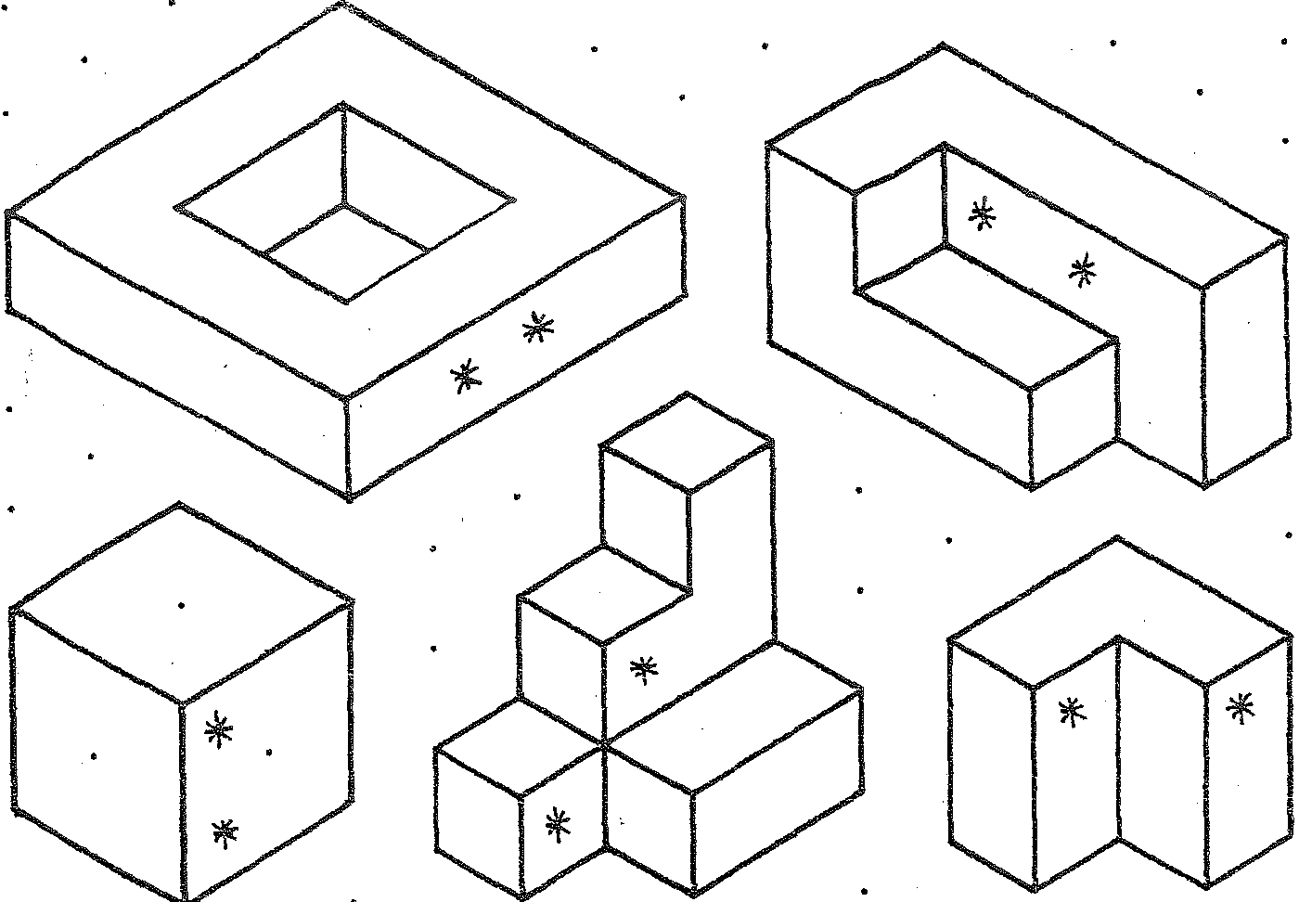

Two Cubes More

Add two more cubes to each where the shading is.
Draw both the original and new shapes.

