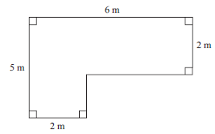
1. The diagram shows the plan of a living room

The floor is going to be covered with floor boards.
One pack of floor boards will cover 2.5m².

How many packs of floor boards are needed?

You must show your working.

2. A garden is in the shape of a rectangle.
Part of the garden is a patio in the shape of a triangle.
The rest of the garden is grass.

The grass needs fertilising.

One box of fertiliser is enough for 32m² of grass.

How many boxes of fertiliser will be needed?

You must show your working.

