Year 8 Autumn 2 Lesson 17: Exploring linear equations and inequalities
Objective | Consolidation of solving linear equations and inequalities
Aim | The aim of this activity is to practice solving equations and inequalities by finding the missing values. They should try to use their knowledge of the structure of equations to figure out which digits to use, although some students will resort to trial and improvement.
Resources | Powerpoint  Trial sheet

Activity 1:



Ask students as a class to different digits from 1-9 into this equation and to solve on their whiteboards.
Check whiteboards for errors.
Did they use any of the representations from the lessons?
Did they solve algebraically?
Choose different approaches and show the class different whiteboards.

Questions for progression | - Is this answer correct?  - How do you know?  - If it’s wrong – what have they done wrong?  - How could they improve their working out?  - For one that is correct – can you show me the answer using a different representation?

Activity 2:

Show slide 1

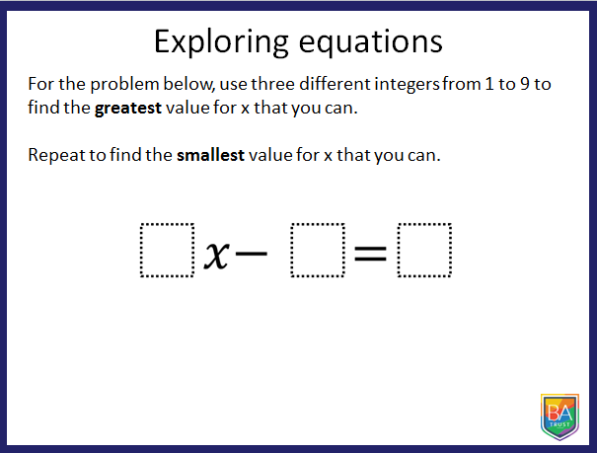

Ask students to work in their pairs to find the greatest value of x (and then the smallest value of x if they have finished and are convinced of their answer. They should record their trials on the worksheet, using what they have found in each trial to improve their answer.
Questions for progression | - Where do you want to put the 9?  - Where should the 1 go or NOT go?  - How do you know you have definitely got the highest/smallest number?  - Is there a representation that can help you convince me that your answer is the highest/lowest?  - Is there more than one solution?  - How do you know?

Bring the class back together to discuss. Do people have the same answers? If there are disagreements – can each pair convince the class of their solution? Have either pair made a mistake?

Activity 3:
Repeat with slide 2.

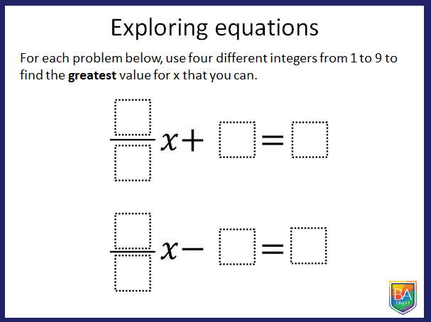
They should record their trials on the worksheet, using what they have found in each trial to improve their answer.
Little progress | The students are confused by the fractional coefficient of x
Questions for progression | - Can you choose four digits to put in the boxes?  - If you were to draw a bar representation, what would it look like?  - Can you remember this lesson? How did we deal with the fractions?  - What did we multiply the diagrams by?  - What equation did that leave us with?
Some progress | Has tried a few values but isn’t working strategically or thinking about the structure of the equation.
Questions for progression | - Think back to the first problem.  - What strategies did people try to find the greatest value for x?  - Where should the 9 go or not go? Why?  - Where should the 1 go or not go? Why?  - What have your trials shown?  - What if you only change one digit at a time? How does that change your answer?
Substantial progress | Has the answer of 56 for the highest answer for the first question and 135 for the second.
Questions for progression | - Are they the only solutions? How do you know?  (The second has two solutions)

Activity 4:
Repeat with slide 3.

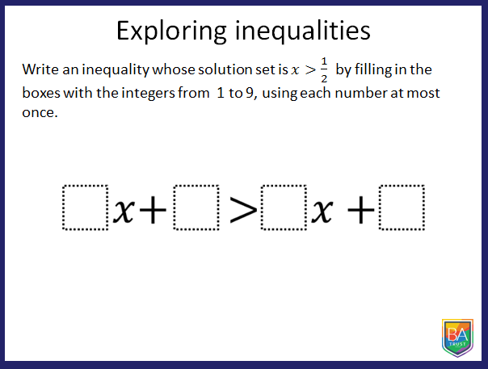

Little progress | The students are confused by the inequality
Questions for progression | - Can you choose four digits to put in the boxes?  - How did we solve inequalities like this last lesson?  - Can you look back in your book?
Some progress | Has tried a few values but isn’t working strategically or thinking about the structure of the equation.
Questions for progression | - How can you use the 1/2 to help you write an inequality?  - What final step would give you an answer of x > ½ ?  - How can you manipulate the x’s to give you that final step?
Substantial progress | Has a solution for the answer.
Questions for progression | - There are several answers to this question – can you find them all?  - How do you know you have got them all?  - Can you generalise?
Acknowledgements:
Problems and trials sheet taken from http://www.openmiddle.com/

Ask students to come to the front to explain their solutions.

