A florist makes bouquets with 18 flowers in each. If the florist has 2468 flowers, how many bouquets can be made?
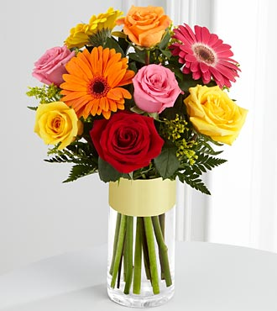
There are 13 players in a rugby team. How many teams could you form from 205 players?



459 children were going on a school trip. If 35 children can fit on a coach, how many coaches will they need?
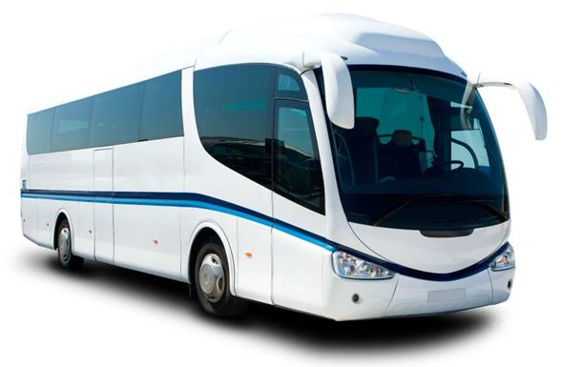
If I have 3400 ml of milk and like to drink a 125 ml glass of milk each day, how many days will I be able to drink a full glass of milk?
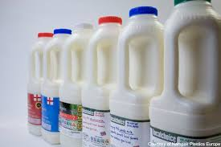
A school hall can fit 28 chairs in one row. How many rows are needed to seat 460 parents?
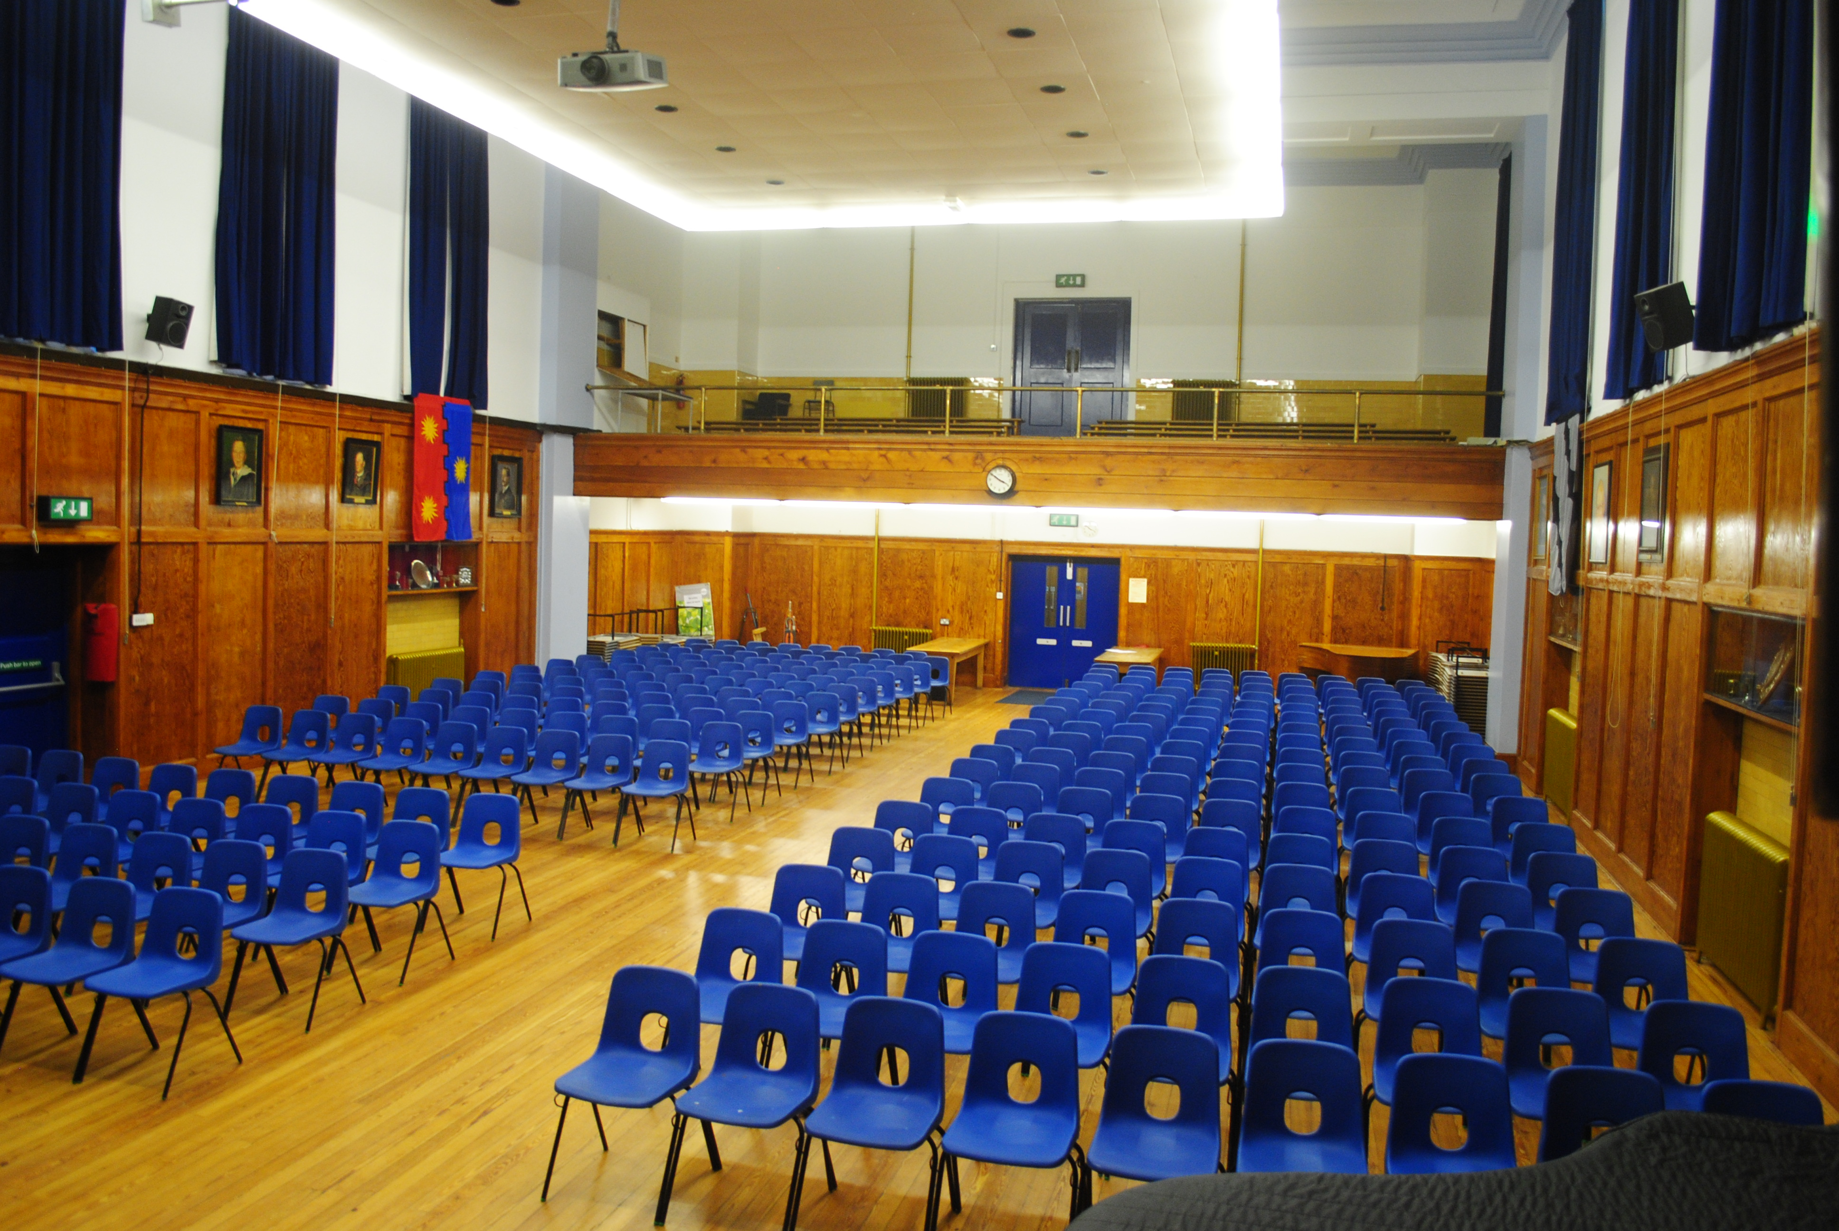
Felt tips are sold in packs of 12. How many packets can be made if there are 152 felt tips?

I love to bake cookies. I got carried away and made 1982 cookies. I can fit 9 cookies into each box. How many boxes can I fill?
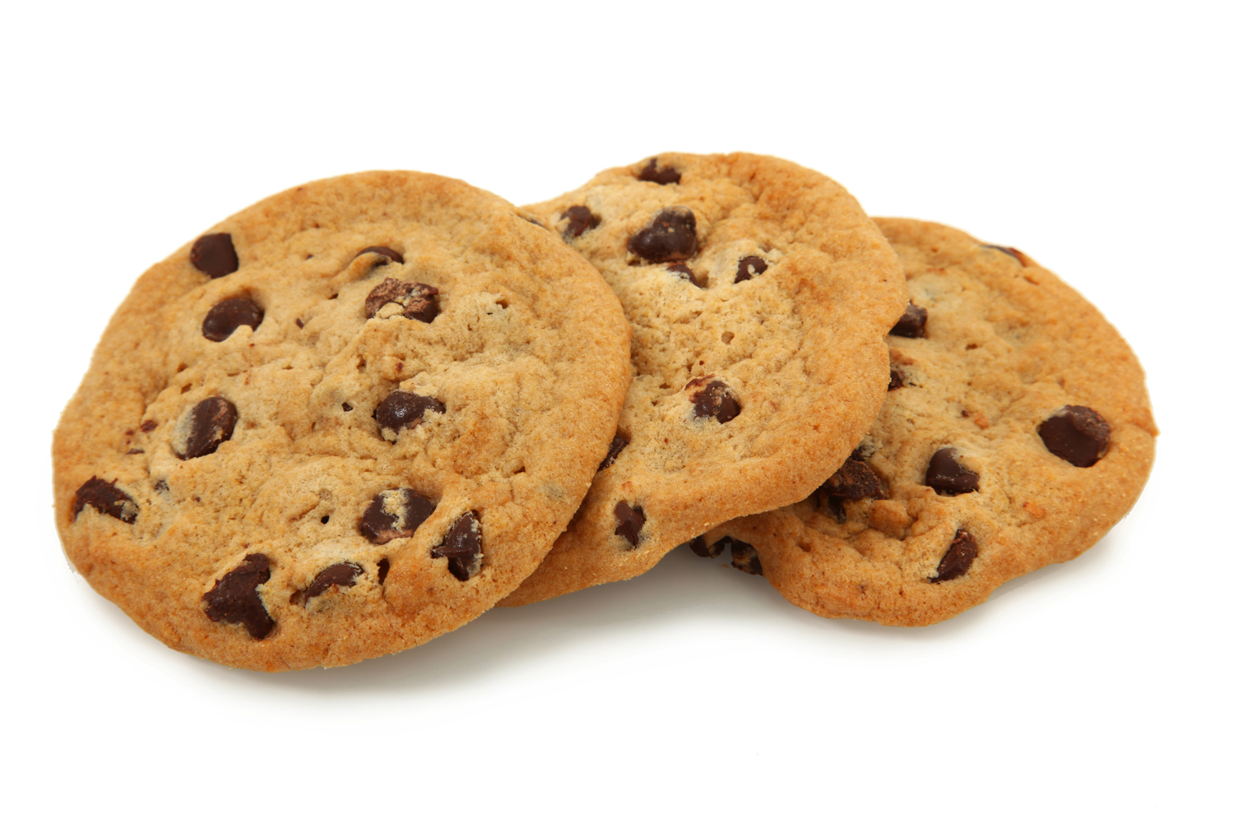
How many 7-a-side football teams can be formed from 95 players?

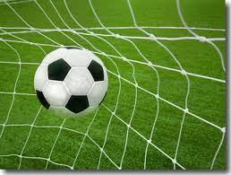
A farmer sells eggs from his chickens. He has 779 eggs which can be packed into boxes of 6. How many boxes will he need so that every egg is in a box?
