Christmas
Murder Mystery
Who
These 6 characters have each calculated how much they have spent on presents. They have given you some clues. The character who spent the least murdered the character who spent the most. Identify the murderer and victim.
Santa  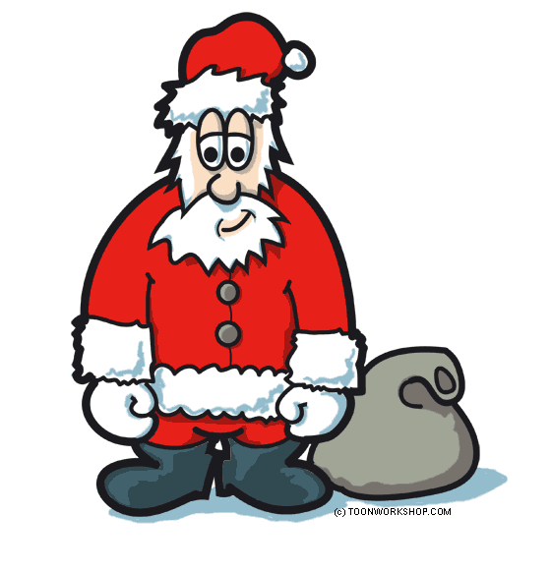I spent an average of £8.10  per present and I bought gifts for my wife, 5 nieces and 4 nephews. |  |  |  | Elf  I bought 4 presents. The cheapest was £15.50 then they increased by £4.50 each up to the most expensive. |  |  |  |  |  |  | Snowman  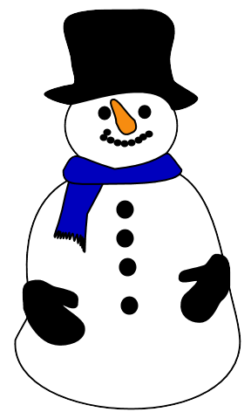  My average spend was £2.60 less than Santa’s but I bought 15 gifts,
Fairy  One of my gifts cost the same as the elf’s most expensive one. My other 4 cost an average of £13.25 |  |  |  | Reindeer  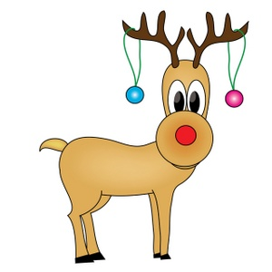I bought gifts for the 8 other reindeer. The shop was offering “Buy 3 get 1 free”. The usual price per item was £12.50 |  |  |  |  |  |  | Angel  My most expensive gift cost the same as the elf’s cheapest gift. The other 6 got progressively cheaper by £1.10 each.
When
Here is a calendar for December. Identify the date of the murder from these clues.
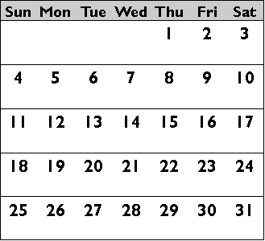 |  |  |  |  |  |  | - It happened on an even number date  - It wasn’t at a weekend  - It happened the day after a prime number  - The product of the digits in the date is 0  - It happened before Christmas
Where
This is a photo frame. Calculate its area (A) and its outer perimeter (P). The place of the murder is the one with both answers correct. (It is not drawn accurately)
20 cm
15 cm
9 cm

26 cm

At the North Pole if  A = 390cm² and P = 82cm |  |  |  |  |  |  |  | Behind the Christmas tree if  A = 210cm² and P = 70cm
In santa’s grotto if  A = 180cm² and P = 41cm |  |  |  |  |  |  |  | Out in the snow if  A = 210cm² and P = 82cm
Why
Calculate these, then round off the answers to the nearest whole number.
Use the letters to decode the message below
A |  | C |  |  |  | D |  |  | E |  |  |  | H
20.7 + 9.6 |  | 89.45 - 15.73 |  |  |  | 9.9 x 8 |  |  | 53.9 – 24.8 |  |  |  | 156.4 ÷ 5
L |  | M |  |  |  | N |  |  | O |  |  |  | P
49.38 + 23.41 |  | 80.68 – 18.19 |  |  |  | 3.78 x 10 |  |  | 82.56 ÷ 3 |  |  |  | 21.2 + 6.18
R |  | T |  |  |  | V |  |  | Y
60.1 – 23.01 |  | 11.1 x 7 |  |  |  | 39.45 + 40.46 |  |  | 12.84 x 6
31 | 29 |  | 28 |  | 27 |  |  | 29 |  | 38 |  | 29 |  | 79
62 | 77 |  | 30 |  | 79 |  |  | 80 |  | 29 |  | 38 |  | 78
74 | 30 |  | 73 |  | 29 |  |  | 38 |  | 79 |  | 30 |  | 37
Final Accusation
____________________________ murdered _____________________________

On (date)_______________________ at (where) ______________________________

Because (why)__________________________________________________________

Answer
The reindeer murdered the elf (Reindeer £75, Santa £81, Fairy £82, Snowman £82.50, Angel £85.40, Elf £89)
On 20th Dec
At “out in the snow”
Because “he opened my advent calendar”

