Aim | Build Amazing Fractal Christmas Trees!
Resources | Powerpoint for display  Christmas Tunes  Instructions + Koch Snowflake printed on yellow card  Sierpinski Tetrahedron printed on green card  Menger Sponge printed on red card  Scissors  Glue  Lots of patience
Lovely Geekiness | Research a bit more about fractal, just because you can.  Fractals worksheets

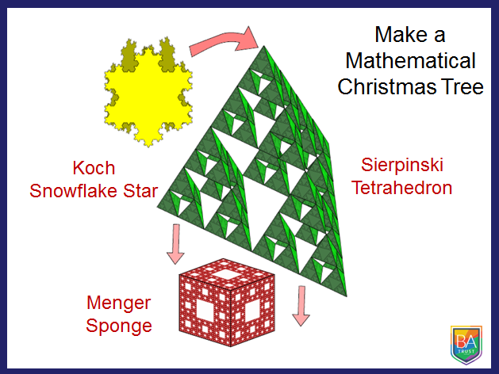

Acknowledgements:
Think Maths Build a 3D Fractal

