Year 7 Autumn 2 Lesson 9: Factors
Objective | To find factor pairs and factors of numbers, and to understand that numbers with exactly two factors are prime, and that numbers with and odd number of factors are square.
Aim | To use areas of rectangles with integer sides to identify factors. This also gives a visual image for prime numbers (1 x …) and square numbers.
Resources | Powerpoint  Squared paper (or squares in their books)  Factor race track (double sided in plastic wallets)  Print out of race (last two slides on 2 per page for write up)  NRich Factor Track

Key words: Factor, product, multiplicand, multiplier, prime, square

Settler: Numeracy Ninjas (max 10 mins)
Activity 1:

Whiteboard activity – students arrange 8 cm squares into rectangles.

They then repeat for 18, 16 and 13. Link to area of rectangles and arrays.
The multiplicand and multiplier are factors of the product.

Independent work –

In their books, students draw all the diagrams for the rectangles 1 – 20, highlighting all square and prime numbers. (They don’t have to make the 1 x … to scale for all the questions).

Bring class together as soon as one person have finished and is all correct so that noone is left doing nothing. – they should write down the square and prime numbers under 20 in their books.
Questions for progression | - What type of rectangle can you always make?  - What is special about 16? Why? Can you think of another number that would have that property? And another?  - What is special about 13? Why? Can you think of another number that would have that property? And another?  - How many factor pairs does a prime number have? Have many factors does it have? Why isn’t 1 a prime number?

Activity 2:
Factor track game – take time to explain the rules of the game and to make sure everyone understands. Use the slide to try a few goes as a class.

Students play on the small track and try to get round in as few goes as possible.

Once they have had a go, you could spend a short time discussing the reasons for their choices and ultimately the minimum number of moves that will take you round the track.

Move onto the advanced track.
Questions for progression | - Which times tables will you find this number in?  - What are the factors of that number?  - Can you think of any more? How do you know you've thought of all the factors?  - How can you convince your partner that it is a factor?  - How are you keeping track of the route you're taking?  - How do you know that you have found the best route?

Activity 3:
Come together to discuss the best and shortest route. Is there a consensus about the best moves to take?

Students write up their shortest route. They ust find a way to communicate their route.

Students should use their plastic wallets to display the route. Choose different presentations for students to critique.

Show this example

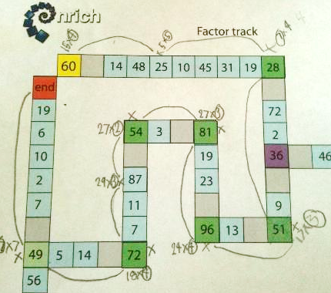

And compare it to the examples given.

Students then write up their own route in the way they think best explains their route on the printouts.

Questions for progression | - Which presentation do you think clearly shows the route?  - Does this presentation show which factor has been chosen?  - Has anybody got a shorter route than this one?  - What is wrong with this route? (Doesn’t land on green square) How can you change the route to fix this?  - Which presentation do you think is the best? Why?

Acknowledgement:

NRich Factor Track

