Simple Training Track

 | 60 |  | 14 | 48 | 25 | 40 | 31 | 10 | 19 | 28
End
19 |  |  |  |  |  |  |  |  |  | 72
6 |  |  |  |  |  |  |  |  |  | 2
10 |  |  |  |  |  |  |  |  |  | 24
7 |  |  |  | 36 | 3 |  | 24
2 |  |  |  |  |  |  |  |  |  | 9
 |  |  |  | 7 |  |  | 14 | 13 |  | 18
14 | 5 |  |  | 32

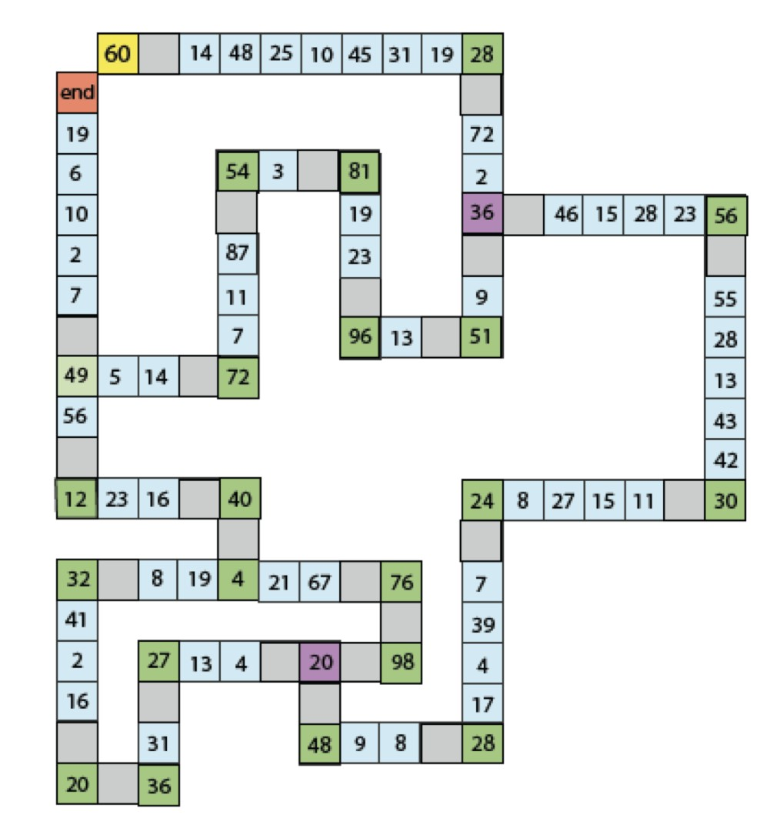

Rules:
You can move any factor, except 1, of the number you are on.
You start on the [yellow] 60 and make your way round to the [red] ‘end’ square.
You may not go round corners so you must get exactly to a green square.

