Year 8
HOMEWORK 9 – Using ratio tables to compare prices
Answer all questions to the best of your ability. Don’t forget to come to Maths Clinic (Monday, Tuesday, Thursday & Friday in IT04 from 12:30-13:00) if you need some help!
Please answer questions on the sheet. Do not use your calculator unless specified.
Make sure you show your working!
Example
Number of bars | 14 | 7 | 1
Cost | £8.40 | £4.20 | £0.60
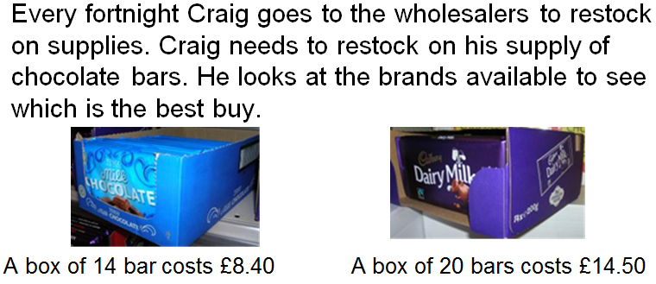

Number of bars | 20 | 10 | 1
Cost | £14.50 | £7.25 | £0.725

Question 1

Leo wants to buy a pack of Sharpies.

Pack 2

20 pack
£12.75

Pack 1

12 pack
£7.50

Which pack gives the best value for money?

Number of pens
Cost

Number of pens
Cost

Pack _____ is better value because _______________________
__________________________________________________________

Question 2

Sainsbury’s: 650g of onions costs £1.04
Tesco: 1.5kg of onions costs £2.10

Which supermarket offers the best value?

Question 3
Lemonade is on offer at Aldi and Lidl.
Aldi: 24 cans (330ml each) costs £7.20
Lidl: 2 litre bottles on offer, 4 for £7.15
Which is better value for money?

Name: _________________________________________________


Initials: ______ Date: _________
WWW  What went well | € You can complete a ratio table to find the cost of a single item when given the price of more than one  € You can use ratio tables to compare the cost of two products  € You can calculate which product offers the best value of money when given costs for different sized packs
NYM  Now you must | Revise: completing ratio tables for simple problems (e.g. 500ml of orange juice costs 80p. Show how much it would cost to buy 100ml, 200ml or1000ml of orange juice)  Try: highlighting key words in the problem  Try: thinking about how to divide or multiply the known values to give other values that can be used to answer questions (e.g. If you know the price of 100g, it would probably be helpful to know the 50g price and 10g price to start with)  Make sure that you: check your working / show your working out / include any units  Use: MyMaths.co.uk or come to Maths Clinic (Mon, Tues, Thurs & Fri lunchtime – IT04).  Please complete:  Pack 1: 12 packs for £8.90  Pack 2: 5 packs for £3.75  Pack 3: 6 packs for £4.55  - What is the lowest common multiple of 12, 5 and 6?  - Why would it be helpful to calculate the cost of this number of packs?  - Which offers the best value?
AT
Action taken

Mark Scheme
Print homeworks in this format. Use one A4 sheet per homework:
Assessment sticker page, which when folded will form front of booklet
Blank page for sticking into book
Homework page 1
Homework page 2
and on the reverse

Question 1
Number of pens | 12 | 6 | 4 | 3
Cost | £7.50 | £3.75 | £2.50 | £1.875

Number of pens | 20 | 10 | 5 | 4
Cost | £12.75 | £6.375 | £3.1875 | £2.55
Pack 1 is better value for money because (accept any correct explanation):
- 4 pens costs £2.50 in Pack 1 and £2.55 in Pack 2
- 1 pen costs 62.5p in Pack 1 and 63.75p in Pack 2
Question 2
Sainsbury’s
Weight (g) | 650g | 50g
Cost | £1.04 | £0.08

Tesco
Weight (g) | 1500g | 50g
Cost | £2.10 | £0.07

The Tesco onions offer the best value for money.
Question 3
Aldi: 24 cans = 24 x 330ml = 7,920ml for £7.20
Lidl: 4 bottles = 4 x 2 litres = 8 litres or 8000ml for £7.15

The bottles (Lidl) are better value.
Challenge question (from assessment sticker)
- The LCM of 12, 5 and 6 is 60.
- Finding the cost of 60 gives an easy direct comparison.
- Pack 1: 12 packs for £8.90, x 5 60 packs for £44.50
Pack 2: 5 packs for £3.75, x 12 60 packs for £45.00
Pack 3: 6 packs for £4.55, x 10 60 packs for 45.50

