Year 8
HOMEWORK 8 – Using ratio tables to calculate value for money
Answer all questions to the best of your ability. Don’t forget to come to Maths Clinic (Monday, Tuesday, Thursday & Friday in IT04 from 12:30-13:00) if you need some help!
Please answer questions on the sheet. Do not use your calculator unless specified.
Make sure you show your working!
Example
Number of bars | 14 | 7 | 1
Cost | £8.40 | £4.20 | £0.60
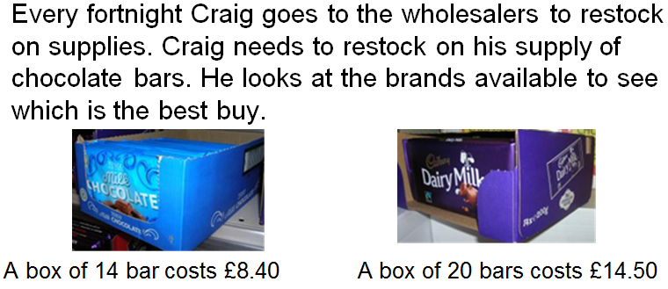

Number of bars | 20 | 10 | 1
Cost | £14.50 | £7.25 | £0.725

Question 1
DEAL 1
Go on any 6 rides for £3.00
DEAL 2
Go on any 8 rides for 3.60
David sees a sign at Goose Fair.
Which offer gives the best value
for money?
Use the ratio tables below to
work it out.
Number of rides | 6 | 3
Cost | £3.00

Number of rides | 8 | 4
Cost | £3.60

Deal ______ is better value because _______________________
__________________________________________________________
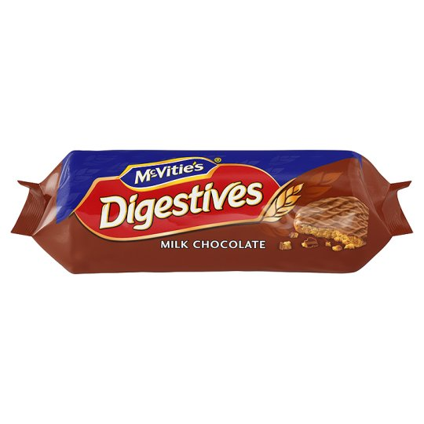
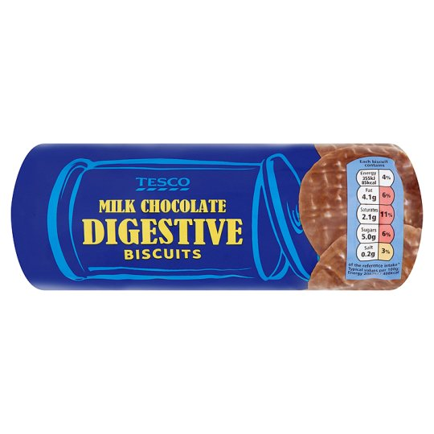
Question 2
Which packet of biscuits offers better value?

21 biscuits for 70p 18 biscuits for 66p
Show how you work it out using the ratio tables below. You do not have to use every column.
Tesco Digestives
Number of biscuits | 21
Cost | 70p
McVitie’s Digestives
Number of biscuits | 18
Cost | 66p

The ____________________ biscuits give the best value for money
Question 3
Cola is sold in 150ml, 600ml and 1 litre bottles. Calculate which is better value for money.
150ml costs 42p 600ml costs £1.62 1 litre costs £2.75

The _______ bottle gives the best value for money because ___________
_____________________________________________________________

Name: _________________________________________________


Initials: ______ Date: _________
WWW  What went well | € You can complete a ratio table to find the cost of a single item when given the price of more than one  € You can use ratio tables to compare the cost of two products  € You can calculate which product offers the best value of money when given costs for different sized packs
NYM  Now you must | Revise: completing ratio tables for simple problems (e.g. 100g of bird seed costs £2. Show how much it would cost to buy 50g, 200g or 500g of bird seed)  Try: highlighting key words in the problem  Try: thinking about how to divide or multiply the known values to give other values that can be used to answer questions (e.g. If you know the price of 100g, it would probably be helpful to know the 50g price and 10g price to start with)  Make sure that you: check your working / show your working out / include any units  Use: MyMaths.co.uk or come to Maths Clinic (Mon, Tues, Thurs & Fri lunchtime – IT04).  Please complete:  Packs of party balloons cost £5 for 12, £7.40 for 18 or £3.70 for 8.  Mustafa needs 144 balloons for a party he is having.  - Which pack of balloons offers the best value for money?  - How many packs of balloons will Mustafa have to buy if he chooses the pack size that offers the best value for money?  - How much will Mustafa spend on balloons?
AT
Action taken

Mark Scheme
Print homeworks in this format. Use one A4 sheet per homework:
Assessment sticker page, which when folded will form front of booklet
Blank page for sticking into book
Homework page 1
Homework page 2
and on the reverse

Question 1
Number of rides | 6 | 3 | 2 | 1
Cost | £3.00 | £1.50 | £1.00 | £0.50

Number of rides | 8 | 4 | 2 | 1
Cost | £3.60 | £1.80 | £0.90 | £0.45
Deal 2 is better value for money because (accept any correct explanation):
- 1 ride costs 45p which is 5p cheaper than Deal 1
- 2 rides costs 90p which is 10p cheaper than Deal 2
- 24 rides costs £12 in Deal 1 compared to £14.40 in Deal 2
Question 2
- Tesco Digestives
Number of biscuits | 21 | 3
Cost | 70p | 10p
McVitie’s Digestives
Number of biscuits | 18 | 9 | 3
Cost | 66p | 33p | 11p
The Tesco biscuits give the best value for money (because 3 biscuits cost 10p compared to 3 biscuits for 11p for McVitie’s)
Question 3
- Students may have chosen to complete their table with different values
150ml bottle
Volume (ml) | 150ml | 50ml | 100ml
Cost (£) | £0.42 | £0.14 | £0.28

600ml bottle
Volume (ml) | 600ml | 300ml | 100ml
Cost (£) | £1.62 | £0.81 | £0.27

1 litre bottle
Volume (ml) | 1000ml | 500ml | 100ml
Cost (£) | £2.75 | £1.375 | £0.275

The 600ml bottle gives the best value for money because 100ml costs just 27p compared to 28p for the 150ml bottle and 27.5p for the litre bottle.
Challenge question (from assessment sticker)
Students should find the cost of a comparable number of balloons, such as the cost of 1 or 2 balloons (some may choose to go the other way and find the cost of 144 straight away)
£5 for 12 = 41.7p (1dp) per balloon
£7.40 for 18 = 41.1p (1dp) per balloon
£3.70 for 8 = 46.25p per balloon.
- The 18 pack of balloons gives the best value for money.
- Mustafa will have to buy 8 packs of balloons
because 8 x 18 = 144
- Mustafa will spend £7.40 x 8 = £59.20

