Year 8 CALCULATOR PERMITTED
HOMEWORK 13 – Using multipliers to find percentage decrease
Answer all questions to the best of your ability. Don’t forget to come to Maths Clinic (Monday, Tuesday, Thursday & Friday in IT04 from 12:30-13:00) if you need some help!
Please answer questions on the sheet. Do not use your calculator unless specified.
Make sure you show your working!
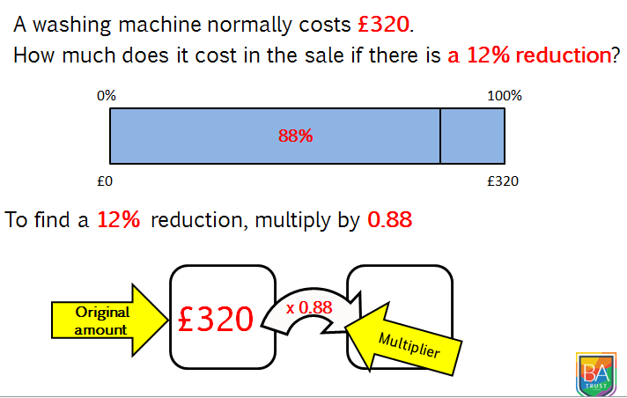
Example

The new price is
320 x 0.88 = £281.60

Question 1
Klaudia has a voucher for 10% off the price of a meal at Pizza Hut.
The meal costs £25.00 before any discount.
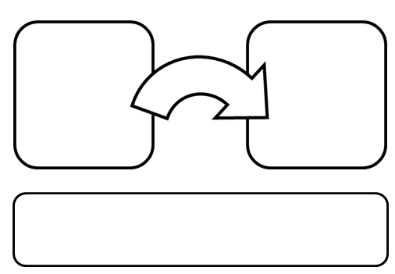

- Complete the first diagram to show the original amount, multiplier, and amount after discount

- Complete the bar model to show the 10% reduction

Question 2
Example: Finding a 10% reduction is the same as finding 90% which is the same as multiplying by 0.9
Complete these sentences:
Finding a 20% reduction is the same as finding _______ % which is the same as multiplying by _________.
Finding a 35% reduction is the same as finding _______ % which is the same as multiplying by _________.
Finding an 8% reduction is the same as finding _______ % which is the same as multiplying by _________.
Finding a 73% reduction is the same as finding _______ % which is the same as multiplying by _________.
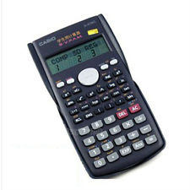
Question 3
Ali earns £560 a month. Before she receives her wages, the tax office takes off 15% tax and Ali receives the rest of the money. Ali then spends 60% of what she receives and puts the rest in a savings account.
Spending reduction
Tax reduction
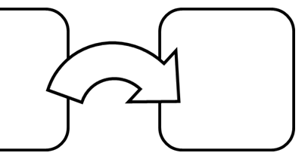


- Complete the diagram to show the two percentage decreases.

- Calculate how much money Ali saves.

Name: _________________________________________________


Initials: ______ Date: _________
WWW  What went well | € You can draw a bar model for a simple percentage reduction problem  € You can identify multipliers to quickly calculate percentage decrease  € You can calculate two consecutive percentage decreases (one after another)
NYM  Now you must | Revise: drawing bar models with simple percentage problems (e.g. Andrew pays 20% of his wages in tax. He earns £1000. How much money does he receive after tax?)  Try: highlighting key words in the problem  Try: thinking about using tenths to help you split your bar model. If a bar is split into ten equal parts, then each part equals 10%.  Make sure that you: check your working / show your working out / include any units  Use: MyMaths.co.uk or come to Maths Clinic (Mon, Tues, Thurs & Fri lunchtime – IT04).  Please complete:  Use multipliers to calculate the following:  - Reduce £192 by 31%  - Reduce £90.75 by 83%  - Reduce £2.56 by 9.5%
AT
Action taken

Mark Scheme
Print homeworks in this format. Use one A4 sheet per homework:
Assessment sticker page, which when folded will form front of booklet
Blank page for sticking into book
Homework page 1
Homework page 2
and on the reverse

Question 1
- 
X 0.9
£22.50
£25.00

2.5

Question 2
a)
Finding a 20% reduction is the same as finding 80% which is the same as multiplying by 0.8
Finding a 35% reduction is the same as finding 65% which is the same as multiplying by 0.65
Finding an 8% reduction is the same as finding 92% which is the same as multiplying by 0.92
Finding a 73% reduction is the same as finding 27% which is the same as multiplying by 0.27

Question 3
X 0.4
£190.40
X 0.85
£476
£560

Challenge question (from assessment sticker)
- £192 x 0.69 = £132.48

- £90.75 x 0.17 = £15.4275 = £15.43

- £2.56 x 0.905 = £2.3168 = £2.32

