Year 8
HOMEWORK 11 – Applying ratio to real life contexts
Answer all questions to the best of your ability. Don’t forget to come to Maths Clinic (Monday, Tuesday, Thursday & Friday in IT04 from 12:30-13:00) if you need some help!
Please answer questions on the sheet. Do not use your calculator unless specified.
Make sure you show your working!
Example

 | 1 person | 2 people | 10 people
Hydrogen peroxide | 25ml | 50ml | 250ml
Ammonia | 35ml | 70ml | 350ml
Pigmented colour cream | 40ml | 80ml | 400ml
This recipe produces enough hair dye to colour one person’s medium length hair.

Hydrogen peroxide 25ml
Ammonia 35ml
Pigmented colour cream 40ml

Question 1

Christian knows that to mix one cubic metre of cement, he needs the amounts below. Complete the ratio table for the different amounts given.

 | 1m³ | 4m³ | 7m³ | 500,000 cm³
Cement (kg) | 320
Sharp sand (kg) | 600
Gravel (kg) | 1200
Water (litres) | 176
1m³ concrete

320kg cement
600kg sharp sand
1200kg gravel
176 litres water

Question 2
Christian needs to mix concrete enough to fill the following cube. Calculate the quantities required.
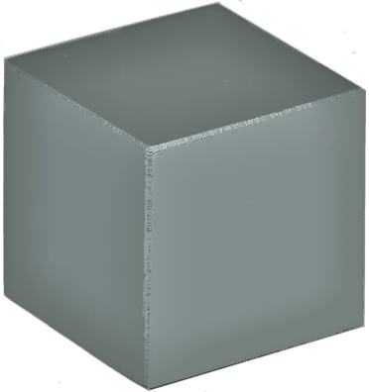
Cement (kg)
Sharp sand (kg)
Gravel (kg)
Water (litres)

2m

2m
2m

Question 3
Christian has a choice of suppliers. Calculate the cost of filling his cube of concrete. Where should he buy his ingredients to get the best value?
 | Construction Warehouse | Building Superstore
Cement | 160kg for £15 | 128kg for £11
Sharp sand | 60kg for £5.50 | 96kg for £9
Gravel | 80kg for £7.50 | 200kg for £19.25

 | Construction Warehouse | Building Superstore
Cement
Sharp sand
Gravel
TOTAL

Christian should buy his supplies from ________________________________

Name: _________________________________________________


Initials: ______ Date: _________
WWW  What went well | € You can complete a ratio table to convert recipes for different numbers of people (when the numbers of people are factors or multiples of those in the original recipe)  € You can complete a ratio table to convert recipes for any number of people
NYM  Now you must | Revise: completing ratio tables for simple problems (e.g. A milkshake requires 180ml syrup to make a drink for 6 people. How much syrup do you need to make milkshakes for 2 people, 8 people or 20 people?)  Try: highlighting key words in the problem  Try: thinking about factors and how a recipe for 8 cakes, for example, can be easily divided by 2, 4 or 8 to find the amounts for 4, 2 or 1 cake  Make sure that you: check your working / show your working out / include any units  Use: MyMaths.co.uk or come to Maths Clinic (Mon, Tues, Thurs & Fri lunchtime – IT04).  Please complete:  - Icing sugar costs £2.42 per kilo. Gemma’s recipe requires 40g of icing sugar per cupcake, and she wishes to make 75 cupcakes. What will the cost of the icing sugar be?  - For every 750g of icing sugar she buys, Gemma receives an additional 2% off the total price, so if she buys 750g she gets 2% off, if she buys 1500g she gets 4% off, and so on. How much will the icing sugar cost her after this offer has been used?
AT
Action taken

Mark Scheme
Print homeworks in this format. Use one A4 sheet per homework:
Assessment sticker page, which when folded will form front of booklet
Blank page for sticking into book
Homework page 1
Homework page 2
and on the reverse

Question 1
 | 1m³ | 4m³ | 7m³ | 500,000 cm³
Cement (kg) | 320 | 1280 | 2240 | 160
Sharp sand (kg) | 600 | 2400 | 4200 | 300
Gravel (kg) | 1200 | 4800 | 8400 | 600
Water (litres) | 176 | 704 | 1232 | 88

 | 8m³
Cement (kg) | 2560
Sharp sand (kg) | 4800
Gravel (kg) | 9600
Water (litres) | 1408
Question 2
The volume is 8m³

Question 3
 | Construction Warehouse | Building Superstore
Cement | £240 | £220
Sharp sand | £440 | £450
Gravel | £900 | £924
TOTAL | £1580 | £1594

Christian should buy his supplies from Construction Warehouse.
Challenge question (from assessment sticker)
- 40g x 75 cupcakes = 3000g or 3kg
£2.42 x 3 = £7.26

- 750g x 4 = 3000g
Gemma earns 8% off

100% cost = £7.26
10% cost = £0.726
1% cost = £0.0726
8% cost = £0.0726 x 8 = £0.5808
£7.26 - £0.58 = £6.68

