Year 8
HOMEWORK 7 – Using ratio tables to solve problems involving direct proportion
Answer all questions to the best of your ability. Don’t forget to come to Maths Clinic (Monday, Tuesday, Thursday & Friday in IT04 from 12:30-13:00) if you need some help!
Please answer questions on the sheet. Do not use your calculator unless specified.
Make sure you show your working!
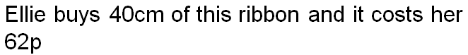
Example
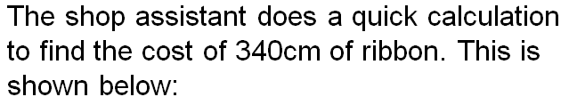

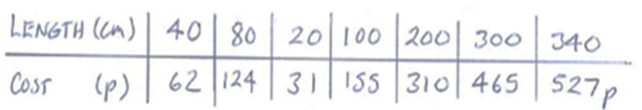

Question 1
Lloyd buys 200g of liquorice allsorts for £1.60.
- Complete the ratio table below.
Weight (g) | 25g | 50g | 100g | 200g | 400g | 500g
Cost (£) |  |  |  | £1.60
- Use your table to help you calculate the cost of:

  - 50g of liquorice allsorts

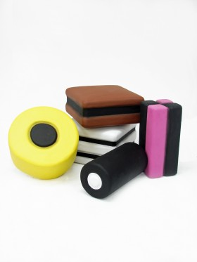
  - 125g of liquorice allsorts

  - 1kg of liquorice allsorts

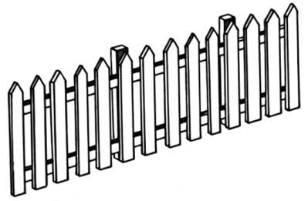
Question 2
Fencing costs £12 per 8m.
- Complete the ratio table below. Some lengths have been left out of the table. Choose sensible lengths to put in these boxes to help you answer the questions below.
Length (m) | 1m |  | 8m |  | 64m
Cost (£)
- Use your table to help you calculate the cost of:

  - 16m of fencing

  - 3m of fencing

  - 128m of fencing
Question 3
Adam is training for a race. He runs 5 kilometres in 27.5 minutes.
- Complete the ratio table below. The distances have been left out of the table. Choose sensible distanes to put in these boxes to help you answer the questions below.
Distance (km)
Time (mins)

- How long would it take Adam to run 26 kilometres if he maintains the same speed?

Name: _________________________________________________


Initials: ______ Date: _________
WWW  What went well | € You can complete a ratio table  € You can use ratio tables to solve problems involving direct proportion
NYM  Now you must | Revise: completing ratio tables for simple problems (e.g. 100g of bird seed costs £2. Show how much it would cost to buy 50g, 200g or 500g of bird seed)  Try: highlighting key words in the problem  Try: thinking about how to divide or multiply the known values to give other values that can be used to answer questions (e.g. If you know the price of 100g, it would probably be helpful to know the 50g price and 10g price to start with)  Make sure that you: check your working / show your working out / include any units  Use: MyMaths.co.uk or come to Maths Clinic (Mon, Tues, Thurs & Fri lunchtime – IT04).  Please complete:  10g of truffles costs £56. Calculate the cost of:  - 1.5g of truffles  - 33g of truffles  - 0.2g truffles
AT
Action taken

Mark Scheme
Print homeworks in this format. Use one A4 sheet per homework:
Assessment sticker page, which when folded will form front of booklet
Blank page for sticking into book
Homework page 1
Homework page 2
and on the reverse

Question 1
a)
Weight (g) | 25g | 50g | 100g | 200g | 400g | 500g
Cost (£) | £0.20 | £0.40 | £0.80 | £1.60 | £3.20 | £4.00
- £0.40 or 40p
- £1
- £8.00
Question 2
- Students may have chosen to use different values
Length (m) | 1m | 4m | 8m | 16m | 64m | 128m
Cost (£) | £1.50 | £6 | £12 | £24 | £96 | £192
- £24
- £4.50
- £192

Question 3
- Students may have chosen to complete their table with different values
Distance (km) | 1 | 2 | 5 | 10 | 20 | 50
Time (mins) | 5.5 | 11 | 27.5 | 55 | 110 | 275

- 26 kilometres takes 110 + 27.5 + 5.5 minutes = 143 minutes
Challenge question (from assessment sticker)
a) 1.5g costs £8.40
b) 33g costs £184.80
c) 0.2g costs £1.12

