HOMEWORK 1 – Using the bar model to solve word problems
Answer all questions to the best of your ability. Don’t forget to come to Maths Clinic (Monday, Tuesday, Thursday & Friday in IT04 from 12:30-13:00) if you need some help!
Please answer questions on the sheet. Do not use your calculator unless specified.
Make sure you show your working!

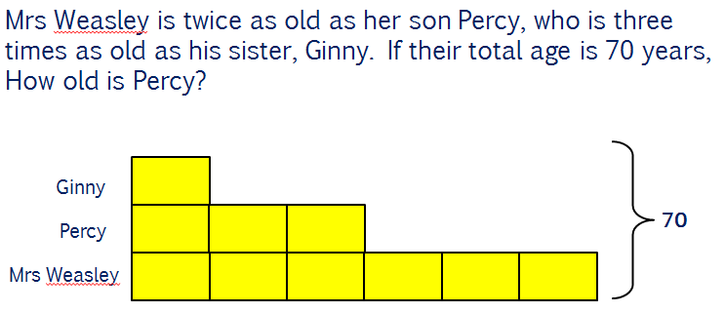
Example

Question 1
James has three times as many sweets as Adam, who has twice as many as Tanvir. In total, they have 63 sweets.
- Draw a bar model to illustrate this problem.

- How many sweets does Adam have?

- How many more sweets does James have than Tanvir?

Question 2
Jake, Karolina and Erin have £117 between them. Karolina has five times more than Erin and Jake has £12 more than Erin.
- Draw a bar model to illustrate this problem.

- Whose bar did you draw first? Why?

- How much money does Jake have?
Question 3
A bar of dark chocolate costs twice as much as a bar of milk chocolate. A bar of milk chocolate costs 40p less than a bar of white chocolate. Two bars of dark chocolate, two bars of milk chocolate and two bars of white chocolate costs £6 in total.
- Draw a bar model to illustrate this problem.

- How much does a bar of white chocolate cost?

- How much would three bars of dark chocolate, two bars of milk chocolate and one bar of white chocolate cost in total?


Initials: ______ Date: _________
WWW  What went well | € You can draw a bar model when given a written problem  € You can use your bar model to answer questions relating to a problem  € You are beginning to draw more complex bar models with additional features such as blocks representing a known quantity
NYM  Now you must | Revise: drawing bar models with simple problems (e.g. Abdul has £3 more than Jane. Together they have £13. Draw this bar model and calculate how much Jane has)  Try: highlighting key words in the problem  Try: figuring out who has the smallest amount so you can use this person as your starting point for drawing the model  Make sure that you: check your working / show your working out / include any units  Use: MyMaths.co.uk or come to Maths Clinic (Mon, Tues, Thurs & Fri lunchtime – IT04).  Please complete:  - Three bags of compost, two hanging baskets and a wheelbarrow cost £28.40. A hanging basket costs four times as much as a bag of compost. Two bags of compost costs £5.65 less than one wheelbarrow. Find the cost of one wheelbarrow.
AT
Action taken

Mark Scheme
Print homeworks in this format. Use one A4 sheet per homework:
Assessment sticker page, which when folded will form front of booklet
Blank page for sticking into book
Homework page 1
Homework page 2
and on the reverse

Question 1
a)
Tanvir
Adam
James
b) Each block represents 7 because 63 ÷ 9 = 7. 7 x 2 = 14
c) James has 7 x 6 = 42. Tanvir has 7 sweets. 42 – 7 = 35 sweets.
Question 2
a)
Erin
12
Jake
Karolina
b) Erin’s bar was drawn first because she has the smallest amount. All the other amounts are based upon Erin’s amount.
c) Each block represents £15 because
£117 - £12 = £105 and £105 ÷ 7 = £15.
Jake has £15 + £12 = £27

Question 3
- 1 bar of each 2 bars of each
40
Milk
40
40
White
Dark
Either diagram is acceptable.
- 8 blocks plus £0.80 = £6.00 £6.00 - £0.80 = £5.20
£5.20 ÷ 8 = £0.65 or 65p so each block represents 65p.
White chocolate bars cost £0.65 + £0.40 = £1.05
- Dark chocolate = 2 x £0.65 = £1.30
3 bars of dark chocolate = £1.30 x 3 = £3.90
Milk chocolate = £0.65
2 bars of milk chocolate = £0.65 x 2 = £1.30
White chocolate = £1.05

£3.90 + £1.30 + £1.05 = £6.25

Challenge question (from assessment sticker)

Compost
Hanging Basket
Wheelbarrow
£5.65

£28.40 - £5.65 = £22.75 £22.80 ÷ 13 = £1.75
A bag of compost costs £1.75
(£1.75 x 2) + £5.65 = £9.15 (cost of wheelbarrow)

