Year 7
HOMEWORK 4 – Calculating the perimeter of compound shapes
Answer all questions to the best of your ability. Don’t forget to come to Maths Clinic (Monday, Tuesday, Thursday & Friday in IT04 from 12:30-13:00) if you need some help!
Please answer questions on the sheet. Do not use your calculator unless specified.
Make sure you show your working!
Example
Calculate the perimeter of the shape on the right, which is made up of identical smaller rectangles
4cm
4 + 2 + 4 + 2 + 2 + 4 + 2 = 20cm
2cm

Question 1

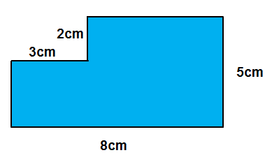
Calculate the perimeter of this shape.

Calculation

Answer

Question 2
Calculate the perimeter of the compound shape on the right, which is made up of rectangles like the smaller one on the left.
8cm
3cm

Answer

Calculation

Question 3
Write an algebraic expression for the perimeter of the compound shape on the right, which is made up of rectangles like the smaller one on the left.
Hint: Don’t forget to include the inner perimeter of the shape
y
x

Answer

Calculation

Name: _________________________________________________


Initials: ______ Date: _________
WWW  What went well | € You can calculate the perimeter of a simple shape given the dimensions  € You can calculate the perimeter of a compound shape when given the dimensions of its parts  € You can calculate the perimeter of a compound shape when given the dimensions of its parts, in algebraic terms
NYM  Now you must | Revise: finding the perimeter of simple shapes, such as rectangles  Try: labelling all the dimensions you know on the diagram, to help you calculate the perimeter  Try: completing a MyMaths task on algebraic expressions if you need to revise how to simplify expressions  Make sure that you: check your working / show your working out / include any units  Use: MyMaths.co.uk or come to Maths Clinic (Mon, Tues, Thurs & Fri lunchtime – IT04).  Please complete:  x  y  Look back at Question 3.  You are told that y = 2x.  Can you rewrite your answer for the perimeter of the compound shape in Question 3:  - In terms of x?  - In terms of y?
AT
Action taken

Mark Scheme
Print homeworks in this format. Use one A4 sheet per homework:
Assessment sticker page, which when folded will form front of booklet
Blank page for sticking into book
Homework page 1
Homework page 2
and on the reverse

Question 1
3 + 52 + 5 + 5 + 8 + 3 = 26cm
Or
(8 + 5) x 2 = 26cm if students recognise that the perimeter is unchanged from the original large rectangle
Question 2
8 + 3 + 3 + 3 + 8 + 3 + 3 + 3 + 8 + 3 + 3 + 8 + 3 + 8 + 3 = 70cm
Or
(5 x 8) + (10 x 3) = 70cm
Question 3
x + y + x + y + x + y + y + x + y + x + y + x + y = 6x + 7y
or (x x 6) + (7 x y) = 6x + 7y
Challenge question (from assessment sticker)
- 6x + 14x = 20x
- 3y + 7y = 10y

