Year 7
HOMEWORK 3 – Completing magic squares containing integers, decimals and algebraic expressions
Answer all questions to the best of your ability. Don’t forget to come to Maths Clinic (Monday, Tuesday, Thursday & Friday in IT04 from 12:30-13:00) if you need some help!
Please answer questions on the sheet. Do not use your calculator unless specified.
Make sure you show your working!
Example
In a magic square, the numbers add up to the same total in every direction, horizontally, vertically and diagonally.
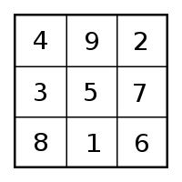

Question 1
- Use the numbers 0 to 8 to complete the magic square so that every row (vertically, horizontally and diagonally) adds up to 12.

Question 2
Complete the magic square so that every row (vertically, horizontally and diagonally) adds up to 2.

0.7 | 1.4
 | 1.0
1.1

Question 3
Complete the magic square so that every row (vertically, horizontally and diagonally) adds up to the same total.
Hint: You can find what the total of each row needs to be by totalling the one completed diagonal row
 | 0 | 4a + 1
 | 3a + 1
2a + 1

Name: _________________________________________________


Initials: ______ Date: _________
WWW  What went well | € You can use your understanding of addition and subtraction to complete a magic square using integers  € You can use your understanding of addition and subtraction to complete a magic square using decimals  € You can use your understanding of addition, subtraction and algebra to complete a magic square using algebraic expressions
NYM  Now you must | Revise: completing column addition calculations for simple problems which include carrying over from the units to the tens column (e.g. 5 + 9)  Try: making a list of the combinations of numbers you could use to reach the required total  Try: using column addition methods to check the totals of each row  Make sure that you: check your working / show your working out / include any units  Use: MyMaths.co.uk or come to Maths Clinic (Mon, Tues, Thurs & Fri lunchtime – IT04).  Please complete:  Complete the magic square using the numbers 1 to 16
  4 |  |  | 1
   | 7 |  | 12
  5 |  | 10
   | 2 |  | 13
AT
Action taken

Mark Scheme
Print homeworks in this format. Use one A4 sheet per homework:
Assessment sticker page, which when folded will form front of booklet
Blank page for sticking into book
Homework page 1
Homework page 2
and on the reverse

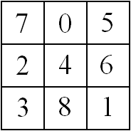
Question 1

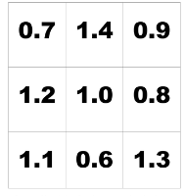
Question 2

Question 3
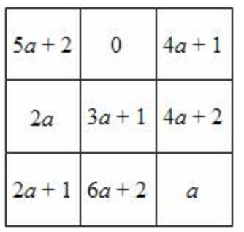

Challenge question (from assessment sticker)
